Getting Started With FinishLynx

Introduction
This “Getting Started” document was written as a guide for the new FinishLynx Timing System user. When you unbox all of your new equipment, the first thought is “where do I start?” Well, you can start right here.

This guide covers most of the technical aspects of setting up the computer system and the camera. When you have completed this, you should be able to capture, evaluate and print race results.

There are some things this guide does not cover. Installing the software is not covered. Aligning the camera with the finish line is not covered – there are excellent guides on the FinishLynx.com website that help here. Also, finish line management issues – once the finishers cross the finish line, what do you do with them, what and how information is collected, etc. – is not discussed here. The assumption is that you will develop your own finish line procedures that work best in your situation. And additional software packages such as FieldLynx, Hy-Tek Meet Manager and others are not discussed here. Maybe in a future version…

This document makes suggestions for many of the various settings and configuration parameters that are available in FinishLynx. These are just that – suggestions. But they are suggestions that are known to work in a basic environment. As you become more familiar with the FinishLynx environment, you will undoubtedly want to change some of these parameters to meet your specific needs.

Thanks
And a short note of thanks to those who have helped bring this guide to life: Kelly and Jenny at Saratoga High as they were learning to use their new system; Hank Lawson at Lynbrook High for his many accuracy reviews and countless suggestions for improvement; and the parents at Los Altos High who always ask “and how do you do this again?”

Changes, Corrections and Improvements
Comments are always welcome. Please send your comments, suggestions and feedback to the author, Jim Clark at jim_clark@pacbell.net

System Overview
The FinishLynx Timing system can be set up in a number of configurations. The configuration presented here uses two computers – one to perform the “capture” function – taking the picture of the runners as they cross the finish line, and a second computer to do the “evaluate” function. Evaluation is the process of looking at the captured picture and assigning finish results to each runner in the race.

The reason for using two computers is simple: it separates the work at the finish line into logical areas. One person can do the “capturing”, and a second person can do the “evaluating.” In addition to spreading the work out, this can actually help keep your race on time – once the “capture” person has captured and saved the picture from one race, they simply set up for the next race and they are ready to go. Evaluation can now take as long as needed. If this were done on one system, you would have to capture the picture, evaluate the results, possibly type in names and school information, wait for any disqualification information and finally print the results. Once this is done, you can then get ready for the next race. While doing all of this on one computer is possible, it sometimes helps to have someone share in your misery at the finish line!

Setup

Overview of the environment

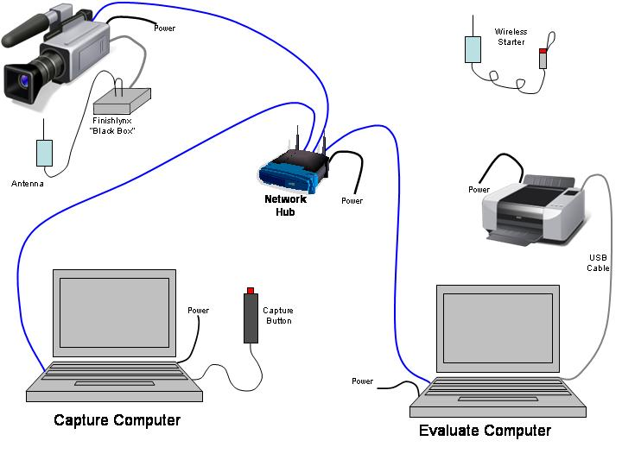
Figure 1 - Cabling Overview

How it Works
When properly set up, the Capture computer is used to record the results of a race. After a race is complete, the results are saved in a file that is stored on the Evaluate computer. Once the race results are saved, the Capture system can be set up for the next race.

Once the results are saved, the Evaluate computer will open that race file and the results will be evaluated. Once all the times have been recorded, the results are printed, and the file is saved.

Using two computers like this allows the meet to continue without having to wait for each race to be evaluated. Delays in evaluation may occur because of an extremely close race, a runner may have been disqualified, or several other reasons.

Setting Up

Supplies Needed
In addition to the equipment shown above, you may need the following:
- Heavy-duty extension cord, 50 or 100 ft.
- Power strip with at least 6 plugs on it
- Table, chairs, pencils
- Paper for the printer, spare toner cartridge
- Air horn for false start signal (some schools use a second gun)
- Red/white flag to signal ready/not ready
- “Shadow boxes” to shade PCs from sunlight.
- Caution tape and pylons to mark off areas around camera and the timing table

Network Configuration Information
Note: These steps can be performed once, prior to any meet. It is suggested that these steps are done before the season starts.

Overview
The computers and the camera transfer information between themselves over the network. To accomplish this, each device needs to be configured with an IP address. Because our network is small, we will be using “static IP addresses.” You may be familiar with the term of “dynamic IP addresses” – this works at home and the office, but static works best for the track environment.

We will assign network addresses to the computers. The camera obtains its network address automatically from the Capture computer. The address that is used for the camera is one greater than the IP address assigned to the Capture computer. Because of this, we must be careful not to assign sequential numbers to the two computers. Recommended IP address numbers to use are:

Capture System | 192.168.1.10 –or – 192.168.2.10
Evaluate System | 192.168.1.15 –or – 192.168.2.15

Choose either the first set or the second set of IP addresses. For example, do not use 192.168.1.10 for the Capture system and 192.168.2.15 for the Evaluate computer – they will not be able to communicate. The first three sets of numbers must be the same. In the configuration screens below, we have decided to use the second set of numbers (with the .2 in the third position of the address). Using this numbering scheme, the camera will use an IP address of 192.168.2.11 which will not interfere with the other system on the network.

In our sample environment, we will use both a Windows XP system and a Windows Vista system. The Vista system will be used as our evaluate system, and the XP system will be used for capture. The examples below use IP addresses that correspond to this sample environment. If your network differs, then change the network parameters as necessary.

Network Parameters For XP Systems
Click on Start->Control Panel->Network Connections. You will see a screen similar to that in the figure below.
Note that your may have different devices defined on your system, so do not panic if your screen looks slightly different than this picture. On this system, there are three network connections:
- 1394 Connection – you can ignore this
- Wireless Network Connection 2
- Local Area Connection

This system (shown in figure 2) is configured to use the wireless LAN adapter, but this won’t work for us. We need to use the hard-wired LAN because wireless LANs sometimes will lose information and this would have disastrous results for us. We need to disable the wireless connection and enable the wired connection, and we will do them in this order: disable the wireless first, and enable the wired connection second.

If your system is already configured to use the hard-wired LAN connector, skip to the “Configuring the IP Address” section.
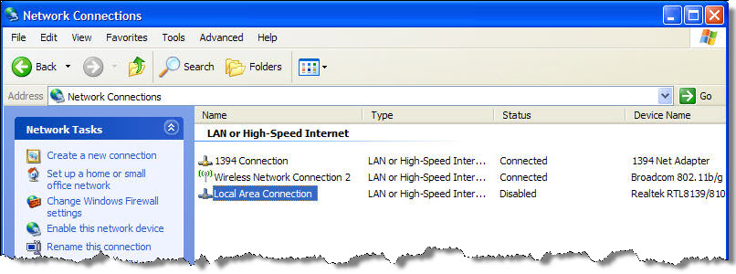
Figure 2

To disable the wireless connection, right-click on it and choose “Disable” from the pop-up menu. This is shown in the next figure.

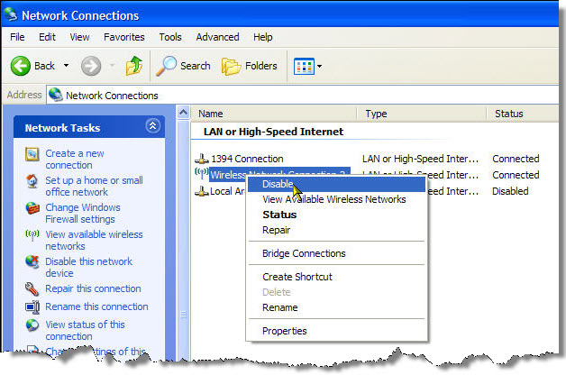
Figure 3

Wait about 30 seconds and the status will change to “Disabled”.
Next, right-click on the wired connection and choose “Enable” from the pop-up menu. This is shown in the next figure.

Figure 4
Wait about 30 seconds and the status for the wired connection should say either “Connected” or “Network Cable Unplugged.” If you get the “cable unplugged” message, check your cabling and make sure the hub is turned on. The next figure shows the network connections after the above steps have been performed.

Figure 5

Configuring the IP Address
Right-click on the wired LAN connection and choose “Properties”. A window similar to the next figure will appear.
Figure 6

Highlight (click once) the “Internet Protocol (TCP/IP) entry, then click on “Properties” as shown here:

Figure 7
A screen like this will open:

Figure 8

Note: if this system is used on another network, you might want to write down the configuration information on this screen before changing anything. You can use this information later to restore the configuration.

On this screen choose the following options:
- Click on the “Use the following IP address”
- Enter the appropriate IP address (see the table earlier). We will use 192.168.2.10 in our example
- Enter the Subnet mask as 255.255.255.0 (it should default to this)
- Enter the Default gateway to 192.168.2.254 (you can actually leave this blank if you want to)
- Enter a DNS Server address of 192.168.2.254 (you might be able to leave this blank)
- Click on the “OK” button to save your changes.

Network Parameters for Vista Systems
- Click on Start->Network
- In the window that pops up, choose “Network and Sharing Center” from the menu bar, as shown below.

Figure 9

- In the new window that pops up, choose “Manage network connections” from the menu items listed to the left of the window. This is shown in the next figure.
Figure 10

- Enable and disable the wireless and wired connections as necessary. Right-click on the appropriate LAN connection and choose “Enable” or “Disable”.
Figure 11

- To enter an IP Address, right-click on the wired connection and choose “Properties”
Figure 12

- Highlight (click once) the Internet Protocol Version 4 entry, and choose “Properties.”
Note: if this system is used on another network, you might want to write down the configuration information on this screen before changing anything. You can use this information later to restore the configuration.

Figure 13

- On this screen, make the following settings:
- Click on “Use the following IP address:
- Enter the appropriate IP address. We will use 192.168.2.15 in our example.
- Enter the subnet mask as 255.255.255.0 (should default to this).
- Enter the Default gateway as 192.168.2.254
- If required, set the DNS server address to 192.168.2.254
- Press OK to save your entries.

Figure 14

Setting Up the Evaluation System
One-Time Setup Steps
These steps can be done once, but should be verified before each race.
- Create a folder that will hold all of your race results for the entire year. A folder name such as “Track 2009” can be used.
- In that folder, create a folder for each meet that you will time. (This can be done just before the meet, and the steps to do this are listed in that area as well). You can use the names of the schools or the dates involved as folder names. A sample folder setup is shown in figure 3.

Figure 15

- Share the top folder – in this example that is the Track 2009 folder. To do this, right-click on the folder and choose “Sharing and Security…”. See Figure 4.

Figure 16

- The window in figure 5 is displayed. Be sure to check the “Share this folder to network” and “Allow network users to modify my files” options, and then click on “OK”

Figure 17

- When you are done, a little hand is displayed underneath the original folder indicating that this folder is now shared on the network. This is shown in Figure 6.

Figure 18

The above steps allow the Capture computer to save the race files to this system (The Evaluation system).

Configuring FinishLynx on the Evaluation System
The settings below are recommended and have worked at other setups. As you become more familiar with the system, you can customize these settings to match your environment.

- In FinixhLynx, click on File->Options in the menu bar. This will bring up the Options menu. It should also place you on the General tab. If not, click on the tab to bring it to the front. See figure 7.

Figure 19

Enter the name of the Meet in the “Competition Name” field. Examples are “Cupertino at Saratoga” or “Wilcox vs. Saratoga”.
- You can leave the “Competition Sponsor” blank. (This information prints at the bottom of printed reports)
- Capture Button: this can be ignored.
- Hardware Type: choose “None.” This will stop this computer from looking for the camera.
- Click on the Event tab. Set the fields on this tab:
  - Window Layout – choose the first option
  - Single Event Mode: On. For beginners, this is a good thing. The opposite (OFF) means that you can have multiple events open at the same time which can lead to confusion as to which one is doing the capturing, which one is doing the evaluation, etc. Start with this setting in the ON position and then experiment later.
  - Event Template: None
  - Default Template: leave blank
  - Default Event name: Event Title
  - Event Directory: click on the “Browse…” button and find the appropriate folder such as the Track 2009 folder
  - Backup Directory: click on the “Browse…” button and find the appropriate folder. (You can also “copy and paste” the path from the Event Directory – highlight the entire path in the first window and press CTRL+C. Then click in the “Backup Directory” window and press CTRL+V).

Figure 20

- Click on the Image tab and set the following:
  - Toolbar: click them all – it doesn’t hurt.
  - Lane Bar: Both
  - Time Tracking: All Cameras
  - Hash Color: Choose a nice color (this is the line that is displayed on the screen when you are evaluating for time. Choose a color that contrasts nicely so you can see your work.)
  - Show Lines: Choose a nice color. This setting will leave a line on the screen so you can tell who has been evaluated.
  - Splits: Off
  - Print Lines: - your choice. This is the color printed when you print the picture. Obvoiously if your printer is a black and white laser…
  - Selected by default: not checked
  - Time Gap Lines: Off
  - Image Export: 100 (maximum) (If you key a large number like 500 and click on OK it will tell you what the maximum size is)(this is used when you save images for printing.)

Figure 21

- Click on the Results tab and set the following options:
  - Tool Bar: check all options – it doesn’t hurt
  - Fields: click on the down-arrow and select Pl, Id, Ln, First Name, Last Name, School, Seed Mrk, Time, Delta Time.
  - Log Breaks: Off
  - Print Breaks: Off
  - Default Precision: Hundredths
  - Pace Distance: 0
  - Round Method: Round

Figure 22

- Click on the Database tab and set the following:
  - Data Source: Files
  - Code Set: Single Byte
  - Time Precision: Ten Thousandths (Note: the <on screen> option means to use whatever setting was configured on the Results tab.)
  - Input Directory: use the same directory that you used on the Event tab
  - Output Directory: use the same directory that you used on the Event tab
  - Serial Port: None
  - Write LIF File: On (this is set to OFF for the capture system)
  - LIF File Prefix: your choice – normally left blank
  - LIF Code Set: Single Byte

Figure 23

- Press “OK” to save your work.
Note: The Scoreboard, Wind and LapTime tabs can be left alone.

Setting Up the Capture Computer
(This is the Windows Vista System at Saratoga)
Some of these steps need to be done in coordination with the Evaluation system. Please refer to that section for setting up the Evaluation system.

- Make all connections as illustrated in the diagram
- In Windows, Click on “Computer”. Towards the top of the window you should see an entry that says “Map Network Drive…” Click on this. Use the controls necessary and navigate to the Evaluation System and the “Track 2009” folder. Use the Z drive, or at least remember the drive for later.
- Make sure the Capture Button is plugged into the right USB port.
- Start Finishlynx.
- If you get the message “Capture button serial port unavailable; keyboard capture will be used”, this means that either the capture button is connected to the wrong USB port, or it is improperly configured in Finishlynx. This is discussed later in this document.
- If the network is connected and the camera is turned on, you should see the “loading camera” status bar in the lower right corner of the screen. If you do not see the green status bar in the lower right corner but the “Looking for EtherLynx Cameras” message is still being displayed, check your network connections and make sure the power is turned on to the camera.

Figure 24

- In FinixhLynx, click on File->Options in the menu bar. This will bring up the Options menu. It should also place you on the General tab. If not, click on the tab to bring it to the front. See figure 7.
Figure 25

Enter the name of the Meet in the “Competition Name” field. Examples are “Cupertino at Saratoga” or “Wilcox vs. Saratoga”.
- You can leave the “Competition Sponsor” blank. (This information prints at the bottom of printed reports)
- Capture Button: use this to match the Com port where the capture button is plugged into. When you get this setting right, the nasty “capture button serial port unavailable” message will go away when Finishlynx is started.
- Hardware Type: choose “Detect.”
- Click on the Event tab. Set the fields on this tab:
  - Window Layout – choose the first option
  - Single Event Mode: On
  - Event Template: None
  - Default Template: leave blank
  - Default Event name: Event Title
  - Event Directory: click on the “Browse…” button and find the appropriate folder in the “Z:\Track 2009” folder. (notice this is using the Z: drive)
  - Back Directory: click on the “Browse…” button and find the appropriate folder in the “Z:\Track 2009” folder (notice this is using the Z: drive). (You can also “copy and paste” the path from the Event Directory – highlight the entire path in the first window and press CTRL+C. Then click in the “Backup Directory” window and press CTRL+V).

Figure 26

- Click on the Image tab and set the following:
  - Toolbar: click them all – it doesn’t hurt.
  - Lane Bar: Both
  - Time Tracking: All Cameras
  - Hash Color: Choose a nice color (this is the line that is displayed on the screen when you are evaluating for time. Choose a color that contrasts nicely so you can see your work.)
  - Show Lines: Off
  - Splits: Off
  - Print Lines: - your choice. This is the color printed when you print the picture. Obvoiously if your printer is a black and white laser…
  - Selected by default: not checked
  - Time Gap Lines: Off
  - Image Export: 100 (maximum) (If you key a large number like 500 and click on OK it will tell you what the maximum size is)(this is used when you save images for printing.)

Figure 27

- Click on the Results tab and set the following options:
  - Tool Bar: check all options – it doesn’t hurt
  - Fields: click on the down-arrow and select Pl, Id, Ln, First Name, Last Name, School, Seed Mrk, Time, Delta Time.
  - Log Breaks: Off
  - Print Breaks: Off
  - Default Precision: Hundredths
  - Pace Distance: 0
  - Round Method: Round

Figure 28

- Click on the Database tab and set the following:
  - Data Source: Files
  - Code Set: Single Byte
  - Time Precision: Ten Thousandths (Note: the <on screen> option means to use whatever setting was configured on the Results tab.)
  - Input Directory: use the same directory that you used on the Event tab
  - Output Directory: use the same directory that you used on the Event tab
  - Serial Port: None
  - Write LIF File: OFF (this is set to On for the Evaluation system)
  - LIF File Prefix: your choice – normally left blank
  - LIF Code Set: Single Byte

Figure 29

- Press “OK” to save your work.
Note: The Scoreboard, Wind and LapTime tabs can be left alone.

Camera Setup
- In FinishLynx, click on the blue “I” symbol on the left of the screen. See figure 12. This brings up the “Camera Settings” window.
Figure 30

- Click on the “Setup” tab and set the following:
Figure 31
  - Name: Camera 1 (the default). You can rename this if you want – it helps when using more than one camera
  - Image orientation: left or right. This determines the orientation of the image. If the runners are coming from your left, choose “left” and the image on the screen will resemble what is actually happening. (Note: it does not matter which way this option is set – you can set it so that the image appears the way you want it to on the screen. It does not affect timing.)
  - Identify By:
- If you are doing a simple meet with no configuration files, choose “Nothing”.
- If you have assigned competitor numbers and are using files, choose “ID”
- If you have seeded your race and you know who is in what lane, choose “Lane”.
- Lanes: enter the number of lanes on your track
  - Reverse Lane Order: click this if the lane bars on the edge of the picture are numbered upside down.
  - White Balance: leave this alone, or set it to 0,0,0.
- Click on the Parameters tab and set the following:
  - Compression: On
  - Minimum: 65
  - Frame Rate: 500
  - Frame Density: 500
  - Frame offset: Center (only option)
  - Gain Method: AGC (Automatic). Once you are comfortable, you can set this to manual and control the gain numbers yourself.
  - AGC Parameters:
  - Brightness: 60 or leave alone
  - Frequency: 10 or leave alone
  - Maximum Gain: 150
  - Auto Iris: either checked or unchecked.
- Click on the “Inputs” tab and set the following:

Figure 32
- Start Sensor: if you are using just the wireless starter, set this to None. If your wireless start isn’t working, plug the “wired” start sensor into the black control box and set this to the value that is on the sensor at the end of the cable. This will be either normally open or normally closed. Do not use Internal.
- Photo Eye: leave everything unchecked
- Click on the Serial Wireless tab and set the following:

Figure 33
- Port: Connection Box. (Set to Off if you are not using the wireless starter
- Start Mask: click on the down-arrow and make sure that Start000 is selected.
- None/Start Sensor/Photo Eye: choose Start Sensor.
- Name: Start 000
- Active Time: leave blank
- Click on the capture tab and set the following

Figure 34
- Capture Method: Manual
- Leader and Trailer: 25
- Object Detection threshold: 10
- Click on OK to save your work

At this point you are ready to capture race results.

Testing Your Configuration
It is always wise to capture a “test race” to make sure that everything is working properly.
- Open a new event by clicking on the left-most icon in the navigation bar. See figure xx.

Figure 35

- Enter a name for this practice “race.”
- Tap on the end of the remote start sensor. This should send a start signal to FinishLynx and the clock should start running.
- Have someone walk/run across the finish line. Press the capture button as they cross the line.
- Click on File->Close to save the race. The system will ask if you want to save the results. Answer “Yes” and verify the name of the file is correct. Press OK to save the “race.”
- On the Evaluation system, open the test race.
- Evaluate the person(s) as they cross the finish line.
- Print the results.
- Close and save the race file.
- Using Windows, go to the folder that holds the race results and delete the 3 files associated with this test race. Be sure NOT to delete the lynx.EVT and lynx.ppl files (described later).
If everything worked, you’re a happy camper and you are ready to start the meet. If not, troubleshoot the areas that aren’t working and try again.

Capturing a Race

A Basic Race
In FinishLynx, do one of the following:
- click on the left-most icon in the navigation bar (see figure 17)
- choose File->New from the menu options
- Press CTRL+N (short cut key for File->New)
Figure 36
This will open a new race and give it a name consisting of a bunch of numbers.
Click in the box just under the “Event” heading and type the name of your race. Be sure to press the Enter key when you are done typing otherwise it will erase your typing! Figure 18 shows this as VB Boys 100 Meters

Figure 37

You are ready to capture!

Notes:
You can receive a “false start” signal at any time. This is usually caused by the starter accidently hitting the start sensor. No need to panic. Just click on the “Traffic Signal” with the big green light to reset everything.

If you miss resetting a false start, still don’t panic. But…this is when you delay the start of the next race until you get the times right. This is because the following steps have to be done on the capture computer before the file is saved.
1. Drag your cursor across the first finisher and notice the time that would be assigned to them. It should be way off from what is expected.
2. In the “starts” window (to the left of the traffic signal), click on a time that is higher in the list – you can compare the start time that is listed in the event area with the times in the window and choose one time earlier. Now click the “multiple traffic signal” (just to the left of the traffic signal that you use for false starts). This will assign this time as the start time for the race.
Drag your cursor over the runner again and notice the time difference.

Setting Up a Schedule
One of the files that FinishLynx can use is called an event file. It is named LYNX.EVT and is stored in the directory with the other files. You can use this file to “pre-load the system with a known set of races. This is handy since most all meets follow the same schedule of events.

A single line in the LYNX.EVT file defines a one race. Each line is made up of several fields, and each field is separated by a comma (,). The format of the file is:

event number, round number, heat number, event name
event number, round number, heat number, event name
…
Event Number: the number of the event. This is NOT the number of the race. Use the same number of digits in all event numbers such as 001, 002. This will help files soft into the right place.
Round Number: not used – set to one.
Heat Number: indicates which heat. Usually 1, but if multiple races of the same type are run (such as 100 meter dash where several heats are run), this number moves up as necessary.
Event Name: the name of the event. Use a common naming system because this is also the name of the file that the system will generate.

A sample LYNX.EVT file might look like this:
001,1,1,VG-400R
002,1,1,VB-400R
003,1,1,JVG-400R
004,1,1,FSB-400R
005,1,1,VG-1600
006,1,1,VB-1600
007,1,1,JVG-1600
008,1,1,FSB-1600
009,1,1,VB-110H
009,1,2,VB-110H
010,1,1,FSB-65H
010,1,2,FSB-65H
010,1,3,FSB-65H
…

Notes on the above file:
    - It is obviously not complete – there are 40 different races in a meet

- Notice that there are two heads for Varsity Boys 110 Hurdles and 3 heats for FS Boys 65 Hurdles. These are “place holders” in case you need to run these races. Our track meets allow the runners to decide if they will run a race all the way up to race-time, so you never know if you will run multiple heats of a race or not – it depends on who shows up at the start line. As a Timer, you have to be ready to either use one of the “place holders” or skip it and move on to the next event. Argh.

- When you have your event file set up (and it probably won’t change for the entire season), you can then use the “card files” to move from race to race. This is shown in figure 19.

Figure 38

If you need to skip over a given heat (such as heat 3 of the FSBoys 65 Hurdles), you can just click on the “next” button, or click on the “choose” button (the middle one) and navigate as needed. Note that when you do this, Finishlynx will give you a warning that says “Event xxxx has changed. Do you want to save it?” Since you haven’t captured anything, the answer is “No.”

Using Competitor Numbers to Enhance Your Racing Experience
A second file that is used by FinishLynx is called the “people file.” It lists all of the competitors in the meet. For our meets, this file lists all competitors, even if they think they won’t run a race. It is much easier to have someone in the file than try to add them later. We’ll see that.

The name of the people file is LYNX.PPL. Like the event file, it is made up of single lines. Fields within each line are separated by a comma (,). A .PPL file could look like this:

1001,Anderson,Tyler(11),Los Altos
1002,Bapa(9),Aksai,Los Altos
1003,Biondi(12),Alysa,Los Altos
4001,Akimoto (9),Kirk,Lynbrook
4002,Brady (11),Ethan,Lynbrook
. . .

Notes:
- The first field is the competitor number. This can be any size of number, 3 digits, 4 digits or more, but 4 digits seems to work pretty good. Using a 4-digit number you can use the first digit to represent the school (in this case 1= Los Altos and 4=Lynbrook), then use the last three numbers as a sequential number. To do this, just get a list of competitors from the coaches and assign them numbers. It doesn’t matter what numbers you use as long as each competitor ends up with a unique number. Note: be sure to ask the opposing coaches for their roster about a week in advance of your meet – they aren’t the quickest at getting back to you!
- The numbers in parenthesis () are the grade of the runner. For most meets, this is not necessary, but this is used when trials and finals are used at the end of the season.
- You only need to assign your own school numbers once. Just use the same set of numbers for each race. The kids will finally catch on that their number is the same as before.
- Print out 3 or 4 copies of the number list for both teams. Ask the runners to write their competitor number on their hand in ink. Tell the kids if their name isn’t on the list to come see you at the finish line.
- To add a runner, simply assign them the next number in sequence. Use notepad or Textpad to edit the .PPL file.
- Put the LYNX.PPL file in the same directory that you are running the race from.
- When you are using a PPL file, you need to change the configuration in the camera. Click on the blue “I” and to go the Setup tab. Change “Identify By:” to “Id.”
- The evaluation of the competitor is slightly different. Instead of pressing return after you have put the evaluation line in the right spot, do the following:
- Line up the line as before
- Key the 4-digit competitor number and press enter. The name info should be displayed in the results window.
- When entering competitor numbers, it is easy to look at the picture and tell if you have the right school by looking at the first digit of the competitor ID.
- It is a good idea to leave a few extra numbers at the end of each school just in case. The “just in case” is for the students whose name wasn’t on the roster given to you (happens at least one or twice per school), and just in case you are given a bogus number. Kids will either forget their number, won’t write it on their hand, or sometimes just make up a number at the finish line, or possibly the number gets written down incorrectly. In these situations, you can type one of these “just in case” numbers and then fill in the names manually later.
- It is also a good idea to use the 001 number (1001, 2001, etc.) as a “school competitor”. Instead of entering a student’s name, enter the name of the school. Use these numbers for relays. You can also use the 999 number for the “B” relay team in case the school decides to run a second team. Or a third…
- Note that you cannot enter the same competitor number twice in a single event. If you enter 1001 twice, the computer will complain and won’t take it the second time.

References and other Resources

