2nd Annual SBHS Dry River Run Invite
September 3, 2016
1220 Monterey Street, Hollister, CA 95023

Schedule
Open Public Race 7:30 am (USATF Sanctioned)


11Girls Middle School 8:00 am (USATF Sanctioned)
Boys Middle School 8:30 am (USATF Sanctioned)
Girls HS Freshman 9:00 am
Boys HS Freshman 9:25 am
Girls HS Sophomores 9:50 am
Boys HS Sophomores 10:15 am
Girls HS Junior 10:40 am
Boys HS Juniors 11:05 am
Girls HS Seniors 11:30 am
Boys HS Seniors 11:55 am

COURSE: 2.0 miles, located 2 miles from the famous San Andreas Fault. The course begins and ends in Andy Hardin Stadium. Dirt paths, down hills, flats, moderate climbs are all included in the picturesque course overlooking and crossing over the San Andreas Fault Basin. This is a great opportunity to use this event as a time trial for your team.

TEAMS: All divisions are unlimited entries per team.
Note(*): If registration in a division reaches 100 entries, a second race may be added and the race day schedule will be adjusted.

SCORING (HS RACES): Top 5 finishers in each race will count toward the team score, 6th & 7th finishers will be tie-breakers. No runners past the 7th runner will be entered in the team scoring. For the overall team meet champion, you will earn points based on your team placing in each race. Points will be broken down in the following format for the team champion: 1st=10 pts., 2nd=8 pts., 3rd=6 pts., 4th=4 pts., 5th=2 pts, 6th=1 pt.
AWARDS: Top 10 finishers will be awarded medals in each division for boys and girls. Top 3 teams overall will receive a plaque of recognition for their teams’ performance.
OTHER: Please park in football stadium parking lot. The Baler snack shack will be open with some snacks and drinks available. Morgan Hill Running Shop will be back to sell shoes and equipment again this year!
MIDDLE SCHOOL/OPEN: The open race and the middle school race will be non-scoring but medals will be given to the top 5 finishers overall in each gender. These open races require no fee (they are free! But donations gladly accepted) but they do require a signed waiver (included below or available at the race) signed by someone over 18 yrs. old. Sign-ups for the middle school and open divisions will be on athletic.net (links on the next page). To sign-up for a spot in the open race, please make a free unattached account on athletic.net, and find our meet (2nd Annual SBHS Dry River Run MS/Open). Make sure to sign-up for the MS/Open meet, not the high school meet! Sign-ups will be allowed the day of.
CONTACT: Coach Leanna Morgan 831-637-5831 ext. 288 or lmorgan@sbhsd.k12.ca.us
REGISTRATION/ENTRY FEES: Registration will close on August 29th at 10pm on athletic.net. High schools must be signed up for the meet prior to this date. Make checks payable to San Benito High School. Send to Leanna Morgan, San Benito High School, 1220 Monterey Street, Hollister, CA 95023. You can also hand deliver the check to the meet.
$5.00 per Individual, $200.00 Maximum

Race Links
2nd Annual Dry River Run Invite High School Races
http://www.athletic.net/CrossCountry/Results/Meet.aspx?Meet=118745#1188


2nd Annual Dry River Run Invite Middle School and Open Races
http://www.athletic.net/CrossCountry/Results/Meet.aspx?Meet=119274#1188


Waiver for MIDDLE SCHOOL AND PUBLIC race ONLY! High school athletes do not need a signed waiver.
San Benito High School
Cross Country

Invitational Waiver
PLEASE PRINT AND SIGN THIS WAIVER FOR THE OPEN AND MIDDLE SCHOOL RACES ONLY! HIGH SCHOOL RUNNERS DO NOT NEED THIS!!!! Bring it to the race. (There will be blank waivers there also if needed)

I know that running in a cross country race is a potentially hazardous activity. I should not enter and run unless I am medically able and properly trained. I assume all risks associated with running in the 2nd Annual Dry River Run Invite on September 3rd, 2016 , including but not limited to personal health issues, falls, contacts with other participants, the effects of the weather including high heat and/or humidity, low temperature, traffic and conditions of the trail/road, all risks being known and appreciated by me. Having read this release and knowing these facts and in consideration of your accepting my entry, I for myself and anyone entitled to act on my behalf or on behalf of my estate, waive and release Leanna Morgan, San Benito High School District, and all sponsors of the race, officials, agents, servants, employees, and their successors and assigns of each and every of the above from all claims or liabilities of any kind arising out of my participation in the run even though the liability may arise out of negligence or carelessness on the part of the persons referred to in this waiver.

__________________________ __________________________ ___________
Signature of Participant Parent/Guardian (if under 18) Date

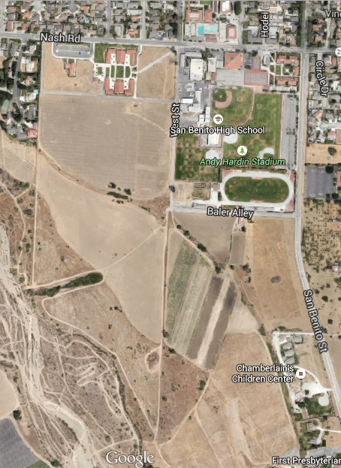
0251672576111Course Map
Start
Finish
1 Mile
Parking

