The Central Park Invitational will be held on Tuesday, September 27, 2016. The cost per team will be $100. An invoice is located at the end of the document. Please have your entries in by Sat., Sept. 24 on athletic.net.
This year there will be 7 races to prevent overcrowding: Varsity Boys and Girls, VB-2, VG-2, Soph. Boys, Frosh Boys and F/S Girls. Please follow guidelines for number and race times for entries. Here is the time schedule with entry requirement for each race:
3:15pm Frosh Boys (All Freshmen Boys except Varsity Runners) (25 minutes)*
3:40pm Varsity Boys Race (8 runners) (20 minutes)
4:00pm Varsity Girls Race (8 runners) (20 minutes)
4:20pm Soph. Boys Race (All Soph. Boys except Varsity Runners)* (20 minutes)*
4:40pm Varsity Boys 2 Race (All Remaining Boys) (25 minutes)*
5:05pm F/S Girls (12 runners) (25 minutes)*
5:30pm Varsity Girls 2 Race (All Remaining Female Athletes)
*Make sure your athlete can run this time or better, otherwise please put them in the Varsity Boys’ or Girls’ ‘2’ races. We are on a tight schedule due to a softball league later in the evening. We must have the softball area cleaned up by 6:30pm.
We will run ahead of schedule if possible, so please have your athletes report to the start as the last race is winding down. Thanks.
Race Course
The course will be similar to previous years. The terrain is flat and consists of grass and asphalt paths. A course map and link is located near the end of the document. It is approximately to 2.3 miles. Once racing has started, athletes should not use the course for warm ups or cool downs. Please keep your athletes off the elementary school field until 3pm. If they are walking the course, they should skip that portion of the course. Please remind your runners that this is a public park so there may be park users on the course. We will have course monitors in areas of high usage to hopefully prevent any problems but ultimately the racers will need to watch for obstacles: people, animals or objects.
The athletes should follow the chalk line as closely as possible, no cutting corners. There will be bright green flags and big red cones around the big field area. The runners should keep the flags on their right. As they enter the softball field to the finish, there will be small red cones directing the way to the finish line.
The dirt infields of the softball fields are off limits.
Starting line and Finish Chute
At the meet, coaches will need to pick up their bibs and garbage bag. This year, all athletes will receive a bib number. Remember to bring you own pins.

Reminder your athletes that there is a gate about 185 yards from the start line and to be careful going through it. They will circle the outside of the softball fields approximately 1½ times before heading out towards the Pavilion.

After the 2mile mark, they will turn right at the softball fields and run back to the same access gate to the finish line. Remember to tell your kids to jog through the chute, stay in order and to tear off the bottom portion of their bib #. Also, have personnel in the area in case your athlete goes down in the chute.

Rest Room Facilities
The Community Recreation Center, including restrooms, is off limits to the athletes. There are restrooms near the start: the swimming pool and tennis court restrooms. There are also 2 other restrooms located within the park. Please remind the runners to stay away from the rec. center and please keep an eye on your team so that they do not damage the facilities. Also, stay away from the elementary school and their restrooms.
Recyclables and Litter
You will be given a garbage bag when you receive your athletes’ bibs. When you leave the park, please take recyclables with you. All garbage bags can be thrown in the dumpster located by the creek near the softball fields. You are responsible to pick up your litter in your team area. Thank you.
Parking
Teams coming by personal cars can park on the side of the park opposite Kiely Blvd at the Swim Center Parking Lot or in the surrounding neighborhood.
School buses should drop off at the Pavilion Parking Lot, on Kiely Blvd, near the creek and mile mark on the course (see picture on next page). Under no circumstances should busing go in the CRC parking lot. Due to the size of the Pavilion Parking lot, no buses should park there. Buses, arriving for pick up, should park at Santa Clara High School’s bus circle until they receive a call from the coach that the team is ready to be picked up.
The pavilion picnic area should be used as a gathering point prior to boarding the buses for departure. Once your team has all arrived, you should call your bus to come from SCHS to pick you up.
Central Park Elementary School
Please tell your runners the large grass area by Kiely Blvd between the CRC building and Central Park School is off limit for warm ups and jogging of the course. Central Park School is in session until 3:00 PM and first race is scheduled to start at 3:15pm. They are new to the site so we do not want to cause them any problems. If your runners walk the course, please have them avoid that area by cutting the course at the end of the rec. center parking lot. The school grounds and buildings are off limits.
Here is a link to the course map:
http://www.gmap-pedometer.com/?r=6954485
Invoice located on last page.
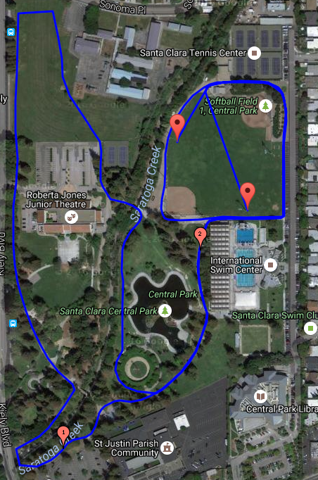

INVOICE

Santa Clara Track Club
c/o Julie L’Heureux
3374 Princeton Ct.
Santa Clara, CA 95051

SCVAL School:_________________________

Event: Central Park Invitational
Date: September 27, 2016

Meet Fee: $100.00
Make check payable to Santa Clara Track Club and send to above address. This is a school account.

Julie L’Heureux
Santa Clara Head Cross Country Coach
Meet Director – Central Park Invitational

