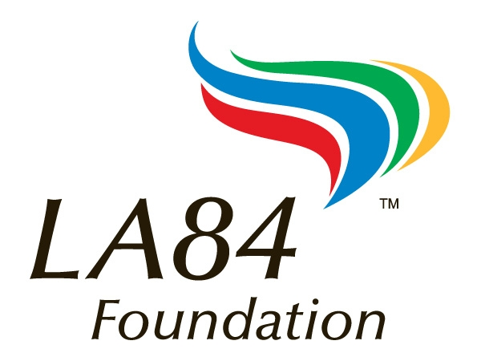
1111 LA84 Foundation
August 25, 2013, Mt. SAC Cross Country Clinic Agenda
There will be two series offered at today’s clinic featuring one presentation from each series being offered at every session during the day.
Track 1: Beginning Series. This series is designed for the beginning or inexperienced coach. It is recommended for coaches with five years or less of experience. Topics include the basic physiology of training a high school distance runner, how to construct a season long training plan, how to recruit and build your team, and all the things you need to know as a head coach to stay one step ahead of the CIF, your AD, and the principal.
Track 2: Advanced Series: This series is designed for the experienced coach who understands the basic physiology of training distance runners and who already has organizational and recruiting skills. Speakers will be presenting sessions that are specific and assume a common level of knowledge and a common vocabulary specific to the sport.

Time Session Topic Location
8:00 - 8:40 Registration and Lunch Sign-ups LA84 Foundation Courtyard

8:40 - 9:00 Opening Welcome and Clinic Directions Ziffren Center

9:00 - 10:00 101 Great Tips To Recruit Runners & Build Your Program Into a Powerhouse Tim O’Rourke Ziffren Center

10:15 - 11:15 Basic Physiology and Training Principles for Coaching a
Successful High School Cross Country Team Ken Reeves & Bill Tokar Ziffren Center

11:30 - 12:30 The Things You Must Know To Keep Your Principal
And AD and the CIF Happy Tim O’Rourke Ziffren Center

12:30 - 1:30 Lunch: Clinicians will be available throughout the lunch hour in the courtyard area for informal discussions.

1:30 - 2:30 Summer to November: The Basics of Building a Successful
Season Long Training Program Ken Reeves & Bill Tokar Ziffren Center

2:45 - 3:45 The Difference Between Good and Great. All of the Little Things That
Will Take Your Program To the Next Level - Hands on Development
of Training Program Ken Reeves & Bill Tokar Ziffren Center
3:45 Turn in Your Completed Evaluations and Receive Your Certificate of Completion and
Your Free LA84 Foundation Cross Country Coaching CD!

