Saratoga & Lynbrook XC Presents

5th Annual Old School Mile

Date: Saturday, December 12, 2009  Time: 1:00 (we’ll have multiple heats)  Cost: $5 (pre-reg only get T-Shirt), Race Day reg is OK  Make payable to: Saratoga XC  Send to: Old School Mile  12375 Farr Ranch Rd, Saratoga, CA, 95070  Place: Saratoga HS Track (20300 Herriman & S’toga-S’vale Rd)  Info: www.LYNBROOKSPORTS.com (408) 460-6785 | 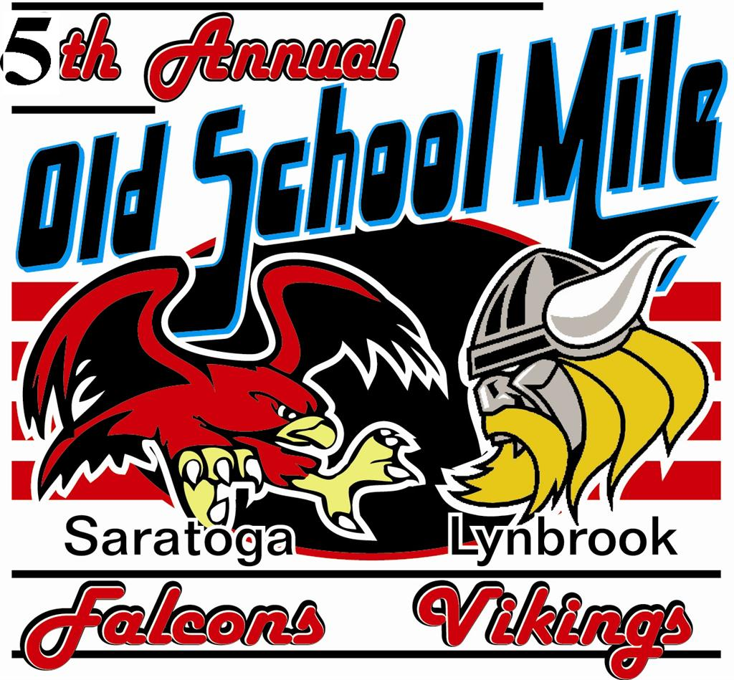

Age Group Records (Male):  Alexis Pineda 7:38.72 7 ‘06  Isarel Berardo 6:55.18 10 ‘08  Christian Pedro 5:36.82 11 ‘06  Christian Pedro 5:12.23 12 ‘07  Christian Pedro 5:04.85 13 ‘08  Luca Signore 4:53.94 14 ‘06  Vince Rodriguez 4:35.71 15 ‘06  Luca Signore 4:38.99 16 ‘08  Matthew Petrillo 4:32.66 17 ‘06  Alan Menezes 4:40.40 18 ‘08  Scott Surrette 5:24.60 20 ‘07  Steve Surrette 5:45.31 21 ‘07  Christian Ochoa 5:19.99 22 ‘08  Alex Daniels 5:24.20 23 ‘04  Luke Anderson 5:17.84 24 ‘04  Jeff Billing 5:02.77 25 ‘04  Steve Sherer 4:13.44 26 ‘08  Brent Woodcock 5:08.96 36 ‘07  Rob Nast 5:02.45 41 ‘04  Tom Surrette 5:54.89 42 ‘04  Rick Schumacher 5:37.07 43 ‘06  Mustafa Veziroglu 6:26.89 47 ‘07  Joe Zingman 6:07.34 48 ‘06  Rob Nast 5:07.76 49 ‘08  Jim Bordoni 5:22.06 53 ‘06  Jim Bordoni 5:15.91 54 ‘07  Jim Bordoni 5:25.08 55 ‘08  Danny Moon 5:56.02 61 ‘08 | Age Group Records (Female):  Mia Berardo 7:43.72 7 ‘08  Caitlin Palacio 6:11.82 10 ‘08  Rebecca Hatton 6:18.16 11 ‘07  Michelle Pouquette 5:54.11 12 ‘07  Lila Haba 5:48.11 13 ‘08  Karen Wai 5:40.41 14 ‘06  MayC Huang 5:28.97 15 ‘04  Karen Wai 5:36.20 16 ‘08  Alicia Follmar 5:01.84 17 ‘04  Sue Dvorak 10:34.01 41 ‘04

First |  |  |  |  |  |  |  |  |  |  |  |  |  |  |  |  | Last

Street |  |  |  |  |  |  |  |  |  |  |  |  |  |  |  |  |  |  |  |  |  |  |  |  |  | City

 |  |  |  |  |  |  |  |  |  |  |  |  |  |  |  |  |  | - |  |  |  |  |  |  | M | / | F
St |  |  |  | Zip |  |  |  |  |  |  | Phone |  |  |  |  |  |  |  |  |  |  |  |  |  |  |  |  |  |  |  | Age |  |  | Shirt Size (S,M,L,X)
Email (for results and a reminder for next years race) School

_______________________________________________ | ___/___/___ | ________________________________________________
Signature of Athlete | Date | Signature of Parent (if under 18)

WAIVER: I waive for myself, my heirs and assign all rights and claims for damages against anyone associated with the race: Saratoga & Lynbrook HS, and its officers, officials, boards, commissions, employees and volunteers. Saratoga/Los Gatos School District, promoters, sponsors, officials and the Saratoga & Lynbrook XC Teams. I also certify that I am physically fit and can participate in this event at my own risk.

