From: Bill Daskarolis, Aragon High School, Meet Director
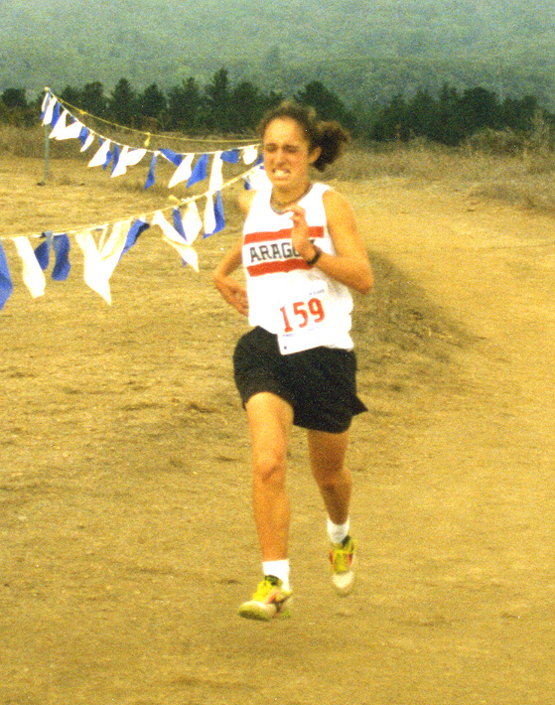
CCS Athlete of the Year
Aragon’s Nicole Portly
Aragon High School
invites you to come run the
2ØØ9 Center Meets.
To: Cross Country Coaches
Subject: Organizing the 2ØØ9 Center Meets
Dates: Thursday, October 15th…races begin at 3:15 p.m.; see the order of events on page 2.
Thursday, October 22nd…races begin at 3:15 p.m.; see the order of events on page 2.
Thursday, October 29th…races begin at 3:15 p.m.; see the order of events on page 2.
Directions:
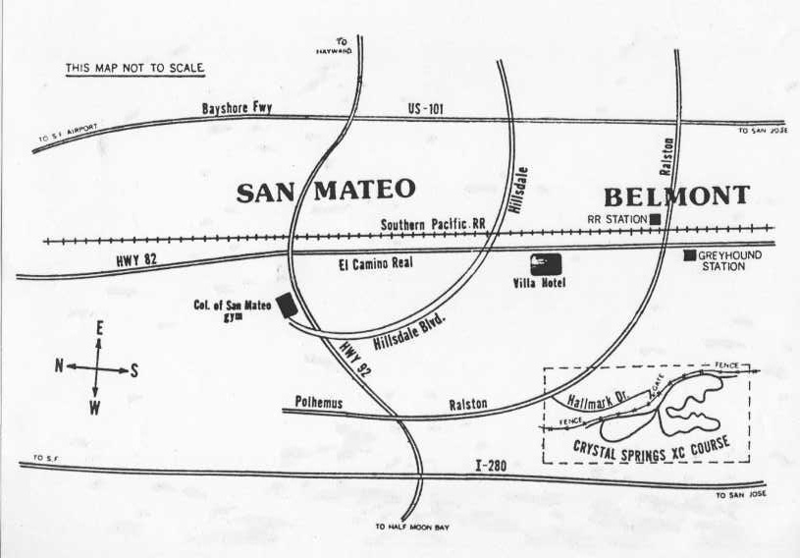
Borrowed from the Lynbrook.com site
Crystal Springs/CSM Cross Country Complex
- West on Highway 92
- Exit 92 at Ralston (yes I know you can get to Ralston from 101 in Belmont, but I don’t).
- South on Ralston to your first right turn (Hallmark)
- West again, the only way you can go, for a mile. The course/park is on the right.
* Buses must go around the corner on Hallmark and not double park before they unload their athletes. This is the same area where buses are to pick up their athletes.
* There is an entry to the cross-country course between the fifth and sixth houses from the telephone booth.
* People who drive in cars should park legally! Illegal parking will result in parking tickets.
Entry Fee $$: There is a $20.00 facility fee per school. This money goes to the College of San Mateo for course upkeep and the outhouse services.
* There is an individual entry fee of $3.50 per individual…rounded down to the nearest dollar.
* Both fees are due before the races begin.
* You will make our life easier if you bring the check with you and DO NOT MAIL THE CHECK TO THE SCHOOL.
* Teams who simply show up at the meet without prior entries will NOT be accepted!
* Individual adjustments in your entries will be made only if time allows and will cost $3.00 per change. These fees must be paid in cash at the time of entry.
Entry Fee $$…per meet: Make checks payable to Aragon Cross Country.
***The race course is 2.95 miles long.
Entries Due: Your entries are due on the following schedule…on DirectAthletics…see directions on page #3.
For Center Meet #1, Thursday, October 15th, your entries are due by 11:59 p.m., Monday, October 12th.
For Center Meet #2, Thursday, October 22nd, your entries are due by 11:59 p.m., Monday, October 19th
For Center Meet #3, Thursday, October 29th, your entries are due by 11:59 p.m., Monday, October 26th.
You pay for what you enter…enter with care!
Submitting Entries: We are using Direct Athletics to collect our entries. Please see page three that explains how you should get to Direct Athletics, and how to create your account, if you do not already have one, and how to submit your entries. If you have computer questions about entries….E-mail your questions to Jim Hume at jcdhume@sbcglobal.net. In an emergency, Jim Hume’s home telephone number is (650) 571-5913. Bill Daskarolis’ home phone is (510) 657-7592. Do not telephone either in the evening after 9:55 p.m.
Course management concerns: 1) It is the responsibility of each coach to arrive with their own first aid kit and the cards from their school that authorizes an athlete’s medical treatment in the event of a medical emergency. When you sign in you will be asked to sign in and certify that you are in compliance. We will do our best to have a trainer present. Meet management will supply ice for injuries.
This is the time schedule for the Center Meets. All races are 2.95 miles long.
The order of events and the 20 minutes between races are designed to limit the number of races which overlap. The official clock will be turned off at 33 minutes. If you have a slower athlete, it is your responsibility to collect the tag and time your own athlete. If you turn in the tag and time, we will do our best to get the performance in the final results.
The Freshmen Boys and the Sophomore Boys are separated in order to give us a field size we can manage. If the number of entries indicates Freshmen Boys and Sophomore Goys should run together, you will receive an e-mail and the race will be run at the time for the Sophomore Boys.

Thursday, October 15th Thursday, October 22nd Thursday, October 29th

Center Meet #1 Center Meet #2 Center Meet #3
3:15 — Freshmen Boys Freshman Boys Freshmen Boys

(Unlimited entries…scored) (Unlimited entries…scored) (Unlimited entries…scored)
3:35 —Sophomore Boys Sophomore Boys Sophomore Boys

(Unlimited entries…scored) (Unlimited entries…scored) (Unlimited entries…scored))
3:55 —Frosh/Soph Girls Frosh/Soph Girls Frosh/Soph Girls

(Unlimited entries…scored) (Unlimited entries…scored) (Unlimited entries…scored)
4:15 — Varsity Girls Varsity Girls Varsity Girls

(Fastest 7 athletes…scored) (Fastest 7 athletes…scored) (Fastest 7 athletes…scored))
4:35 —Varsity Boys Varsity Boys Varsity Boys

(Fastest 7 athletes…scored) (Fastest 7 athletes…scored) (Fastest 7 athletes…scored)
4:55 — Junior Varsity Boys Junior Varsity Boys Junior Varsity Boys

(Unlimited entries…scored) (Unlimited entries…scored) (Unlimited entries…scored)
5:15 Junior Varsity Girls Junior Varsity Girls Junior Varsity Girls

(Unlimited entries…scored) (Unlimited entries…scored) (Unlimited entries…scored)
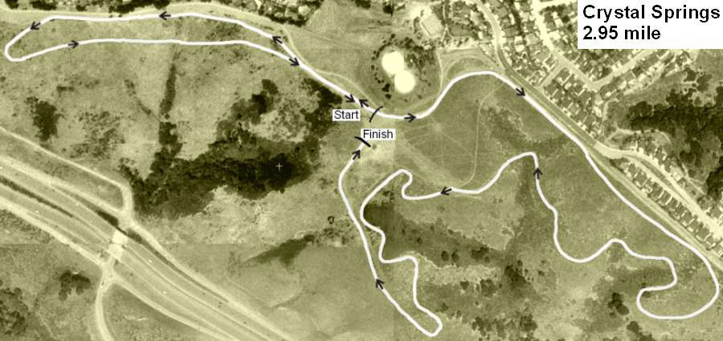
Borrowed from the Lynbrook.com site
Entry organization:
- On the day of the race, when you sign in, you will pay for and receive a Cross Country Chest Number for each athlete who will race. Hand out your chest numbers with care. Each number has a tag with a name.
- Instruct your athlete to NOT crumple their number. Numbers where the bar code can not be read will lead to disqualification. Crumpled bar codes can not be easily read.
- The bottom portion of the bib number will be collected after the finish line. Computer magic will be applied.
- After the race, the results will be posted ASAP.
- Somewhat later, that night if all goes according to plan, results will be sent by e-mail to all interested parties. If you have parents who are interested, we simply need their e-mail addresses. Results will also be posted on DirectAthletics, where you submitted your entries and will be to Hank Lawson at Lynbrook High (www.Lynbrooksports.com.).

If you already have an account you DO NOT need to create a new account.
How to Submit Online Entries
**1-2-3 Guide to Entering a Meets Online**
- Create an Account (or login with an existing account…keep reading to discover how to add cross country as a sport to your account)
- Setup your Roster
- Submit your Roster/Entries to Each Meet
STEP 1—Access your DirectAthletics Account…use your PC computer (not a Mac) and go to www.directathletics.com.
Each coach must have a DirectAthletics username and password for his/her school. If you don’t know your username and password, you will be able to create one or retrieve your existing account by following the instructions below.
If you already have a DirectAthletics account for your school team, and know your username and password…. | If you do NOT know your username and password….Create your own!
- Go to www.directathletics.com  - In the login box, enter your username and password and click Login.  - (Remember that your password is case-sensitive) | - Go to www.directathletics.com  - Click on the link “New User? Click HERE”.  - Follow onscreen instructions. You will be able to create an account online or retrieve forgotten information for an existing account.
Notes About Accounts: IF you already have a school account from the track season, when you sign in and use the pull down menu to switch to the sport of “Cross Country”, you might get the following message…
“Your account does not control any teams in this sport. Please email (click on the link and you get a chance to e-mail…support@directathletics.com to request access. Include: Your Username, Team Name, Sport you wish to add…You will receive an email reply verifying access approval ASAP.
Most coach accounts control a school’s Men’s AND Women’s team. You control only one gender at time, so you will complete the below steps for your Men, and then switch to your Women’s team and repeat the process (or vice versa). The team you are controlling is listed on the blue navigation bar across the top of your account, for example:
Sport: Cross Country Team: Aragon (M)
This indicates that you are controlling the Aragon MEN’S team (M=MEN). To switch to your Women’s team, you would select “Aragon (W)”.
STEP 2—Edit/Set up Your Online Roster
Before entering an athlete into a meet, you must add all attending athletes to your roster. If an athlete is already on your roster (from previous seasons) you do not need to add him/her again. Most schools will just need to add new athletes and delete athletes no longer on the roster.
- Upon logging in, click the TEAM tab. (New Users will be forced to set up their rosters before they can proceed)
- If you have used Direct Athletics before, you will see last year’s roster. School years have automatically been moved forward one year. You can click “Import Track Roster”. You will be able to add athletes from your Track roster to your Cross Country roster. If you do not see this link or you are new to Direct Athletics, skip to Step 3.
- Click the green “Add Athletes” link under the Team Roster header. Select an approximate number of athletes you would like to add (you can add more at any time).
- Enter your athletes First Name, Last Name and School Year (all other information is NOT necessary) and click “Submit”
- You may add, edit or delete athletes on your Team Roster at anytime by click the TEAM tab.
STEP 3--Submit Online Meet Entries

Once your athletes are added to your roster, you must declare your entries to each meet you are attending.
- In the HOME tab (under Upcoming Meets) or in the SCHEDULE tab, click the green Register button next to the meet you wish to enter.
- Check off the box for each athlete you wish to enter. You can check the “All” box to select (or un-select) your entire roster.
- When you have completed your entries, click “Submit”. You MUST click “Submit” to submit your entries.
- You will see your current, submitted entries on the “View Entries” page. At any time before the entry deadline, you may edit your entries by clicking the “Edit Entries” link.
- For entry confirmation, simply print the “View Entries” page or click the Email Confirmation link at the top of the “View Entries” page. An Email Confirmation will be sent to the email address in your account.
* You need to send entries for each Center Meet you run. You pay for what you enter!
Aragon High School
Meet Director 2ØØ8 Center Meets
^{C/O} Bill Daskarolis,
39677 Benavente Avenue,
Fremont, CA 94539
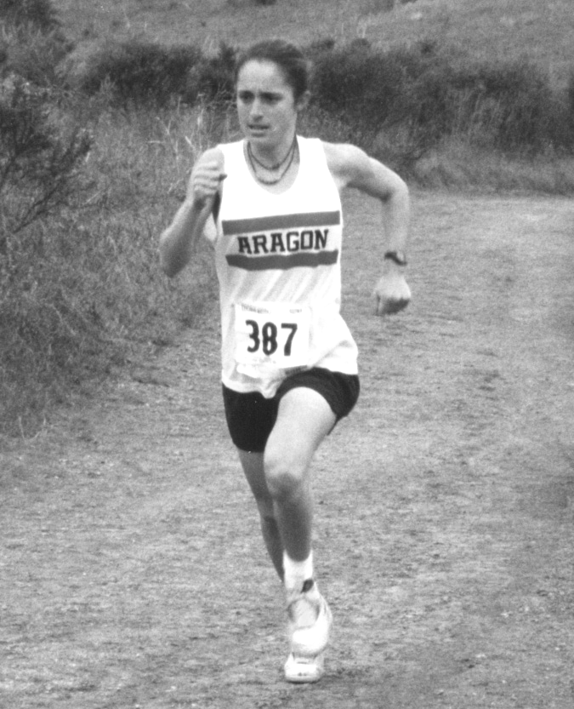
Aragon High School invites you to come and run the 2ØØ9 Center Meets.
To:

