Saratoga High School XC Presents  6th Annual Marshall Clark 4 Miler  Cross-Country Kick Off |  | 
Date: Saturday, August 23rd, 2008  Time: 8:00 (4 miler)  Cost: $20 ‘til Aug 19th, $25 after (w/T-Shirt)  ($15 each for a family of 4 or more)  Make payable to: Saratoga XC  Send to: Marshall Clark 4 Miler  12375 Farr Ranch Rd, Saratoga, CA, 95070  Place: Saratoga HS Track (20300 Herriman & S’toga-S’vale Rd)  Awards: 3 deep in eight age groups (M & F)  12 & under, 13-15, 16-18, 19-29, 30-39, 40-49, 50-59, 60+  Info: www.LYNBROOKSPORTS.com (408) 460-6785 | 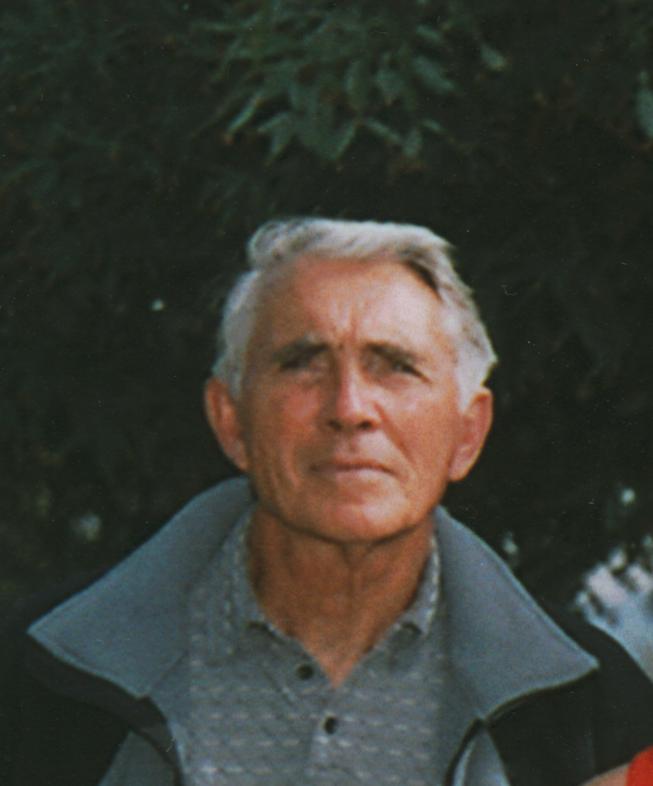  Course Map – Course Description

Course Records:  BENTON. DUSTIN 26:29.8 00-12 6:37 ’07  WOLFSMITH. LANCE 21:10.9 13-15 5:17 ‘07  IYER. HARI 20:40.9 16-18 5:10 ‘06  IYER. HARI 20:30.7 19-29 5:07 ‘07  SEALY. KENRICK 20:54.3 30-39 5:12 ‘06  SHAVER. JEFF 21:35.0 40-49 5:23 ‘04  BORDONI. JIM 25:01.5 50-59 6:15 ‘07  FELDMAN. BOB 34:00.0 60+ 8:30 ‘03  SPEEDY. AMANDA 29:47.0 00-12 7:26 ’04  PASCALE. HAYLEY 24:04.4 13-15 6:01 ‘06  FOLLMAR. ALICIA 24:08.0 16-18 6:02 ‘05  FOLLMAR. ALICIA 23:12.5 19-29 5:48 ‘06  PARK. CHRISTINA 23:51.5 30-39 5:58 ‘06  NAST. LIZ 27:21.0 40-49 6:50 ‘03  FOLLMAR. DEBBIE 28:16.8 50-59 7:04 ‘06  WIEBE. PAT 59:42.0 60+ 14:55 ‘05 | Last Years Top 3:  IYER. HARI 20:30.7 M 1 19-29  WOLFSMITH. LANCE 21:10.9 M 2 13-15  BANKS. KIAN 21:53.7 M 3 16-18  FOLLMAR. ALICIA 23:31.4 F 1 19-29  HABATMU. REBECCA 24:20.5 F 2 16-18  NAST. KATIE 25:12.4 F 3 16-18  Previous Winners:  2007 – IYER. HARI 20:30.7 M  FOLLMAR. ALICIA 23:31.4 F  2006 – SILLER. HARREL JR 20:37.1 M  FOLLMAR. ALICIA 23:12.5 F  2005 – IYER. HARI 21:41.0 M  FOLLMAR. ALICIA 24:08.0 F  2004 – SHAVER. JEFF 21:35.0 M  FOLLMAR. ALICIA 24:20.0 F  2003 – SUBRAMANIAM. HARI 22:42.0 M  KRIEGE. BECKI 24:40.0 F

First |  |  |  |  |  |  |  |  |  |  |  |  |  |  |  |  | Last

Street |  |  |  |  |  |  |  |  |  |  |  |  |  |  |  |  |  |  |  |  |  |  |  |  |  | City

 |  |  |  |  |  |  |  |  |  |  |  |  |  |  |  |  |  | - |  |  |  |  |  |  | M | / | F
St |  |  |  | Zip |  |  |  |  |  |  | Phone |  |  |  |  |  |  |  |  |  |  |  |  |  |  |  |  |  |  |  | Age |  |  | Shirt Size (S,M,L,X)
Email (for results and a reminder for next years race)

_______________________________________________ | ___/___/___ | ________________________________________________
Signature of Athlete | Date | Signature of Parent (if under 18)

WAIVER: I waive for myself, my heirs and assign all rights and claims for damages against anyone associated with the race: Saratoga HS, and its officers, officials, boards, commissions, employees and volunteers. Saratoga/Los Gatos School District, promoters, sponsors, officials and the Saratoga XC Team. I also certify that I am physically fit and can participate in this event at my own risk.

