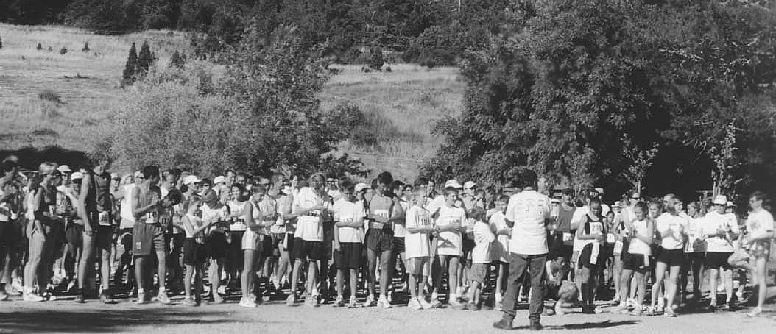
5th Annual
Cross-Country
Summer Boot Camp
MIKE DUDLEY'S

(July 2nd-August 12th)
Do you want FASTER TIMES, to GET INTO SHAPE,
and to have tons of FUN???
-------------------------------------------------------------------------------------------------------------------------
Another year has gone and another year is before us.
The work you did last year has put you where you are today.
--------------------------
For some of you, that’s a good place. For others, it’s a place that will make you think about what you could have done better.
Either way, this is where it begins, your personal journey to accomplish whatever it is that makes you each strong, confident, young people.

Each year I provide you with the perfect location and conditions to grow as athletes.
More importantly, each year I provide you with the perfect conditions and locations to grow as quality people.
---------------------------
THIS Camp is the PERFECT Cross-Training and Conditioning Program
FOR EVERY SPORT!!!
--------------------------
It’s time to lace ‘em up and continue our journey.
For those of you returning to the “FAMILY”, welcome back!!!!
For those of you finding us for the first time, this will be an experience you will not soon forget.
Just ask anyone who has done the camp before.
The training, the bonding, and most importantly, THE FUN cannot be matched!!!
-----------------------------
The work is hard, but the rewards are worth it, I promise!!!! There is no better feeling than completing Mike Dudley’s Cross-Country Summer Boot Camp, participating in The Dammit Run 5 miler, and then starting your school sports seasons ready for anything!!!



***(CAMP INCLUDES)***:
- 6 weeks of Summer training(5 days a week,M-T,Th-Fri-Sat)

- Running program, race strategies,
workout program & weekend food and drink!!!

- FAMOUS Boot Camp “Survivor” T-Shirt!!!

- Entry into The Dammit Run at the completion of the Camp!!!

- As many new friends as you can handle!!!

- Remember, this Camp is open to any athlete 12 years old and up, boys and girls!!!

- Tell your brother, your sister, and your local feeder middle school to contact me!!!

- This Camp benefits EVERYONE, and is FUN, FUN, FUN!!!!

- Limited to the first (40) athletes!!!

- FIRST COME,FIRST SERVED!! Please register NOW to reserve your spot!
Cost: Only $200.00
(Make a deposit now to secure your spot,
and you don’t have to pay the balance until July 2nd!!!)
If you can’t start ‘til after July 4th, that’s fine too!!!
(Contact Mike for more info at: trackdudley@aol.com)
***(COACHES: PLEASE Contact Mike for multiple athlete DISCOUNTS!!!)***
(5) or MORE athletes from the same school gets each athlete a $25.00 discount!!!
The Best 6 Weeks You’ll Have All Summer!!!
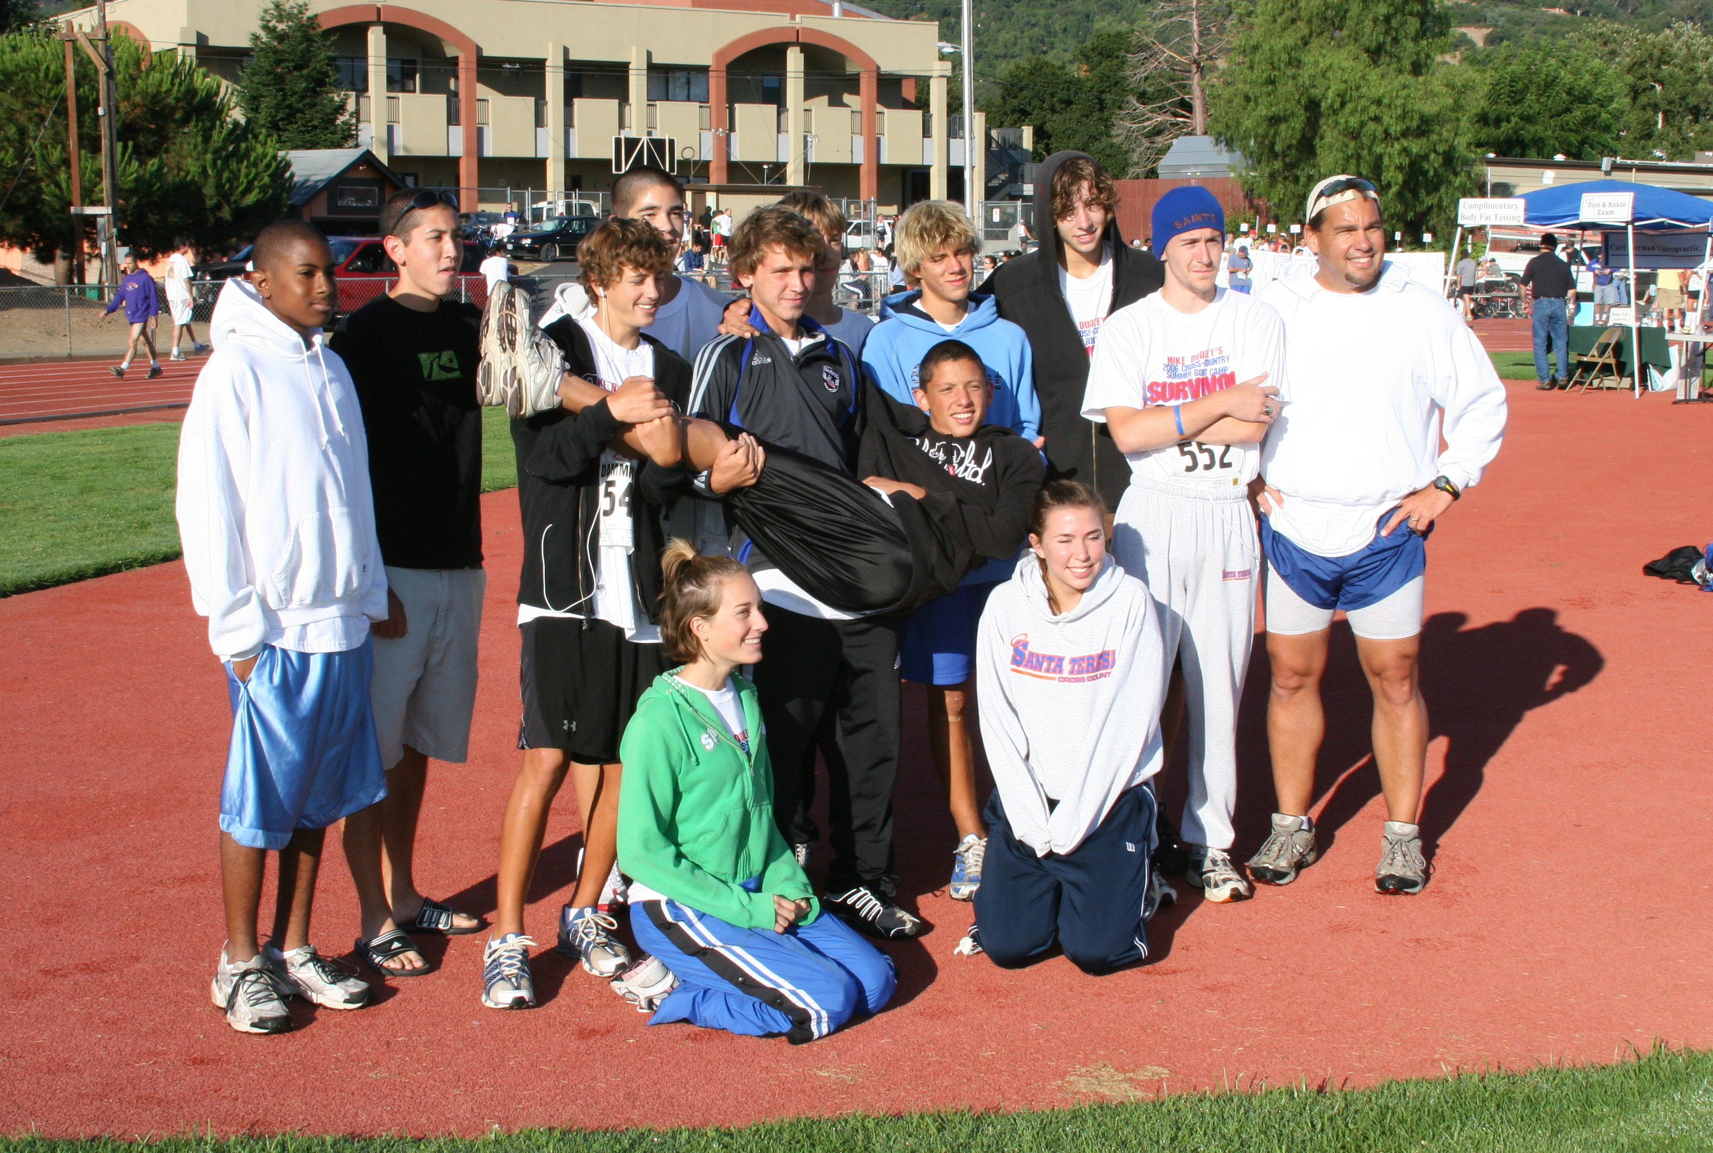

(photo courtesy of Mike Christensen)

