Saratoga High School XC Presents

4th Annual Marshall Clark 4 Miler

Cross-Country Kick Off

Date: Saturday, August 26th, 2006  Time: 8:00 (4 miler)  Cost: $15 ‘til Aug 20th, $20 after (w/T-Shirt)  Make payable to: Saratoga XC  Send to: Marshall Clark 4 Miler  12375 Farr Ranch Rd, Saratoga, CA, 95070  Place: Saratoga HS Track (Herriman & Saratoga-Sunnyvale Rd)  Awards: 3 deep in eight age groups (M & F)  12 & under, 13-15, 16-18, 19-29, 30-39, 40-49, 50-59, 60+  (Awards for 4 miler only)  Info: www.LYNBROOKSPORTS.com (408) 460-6785  Course Map – Course Description | 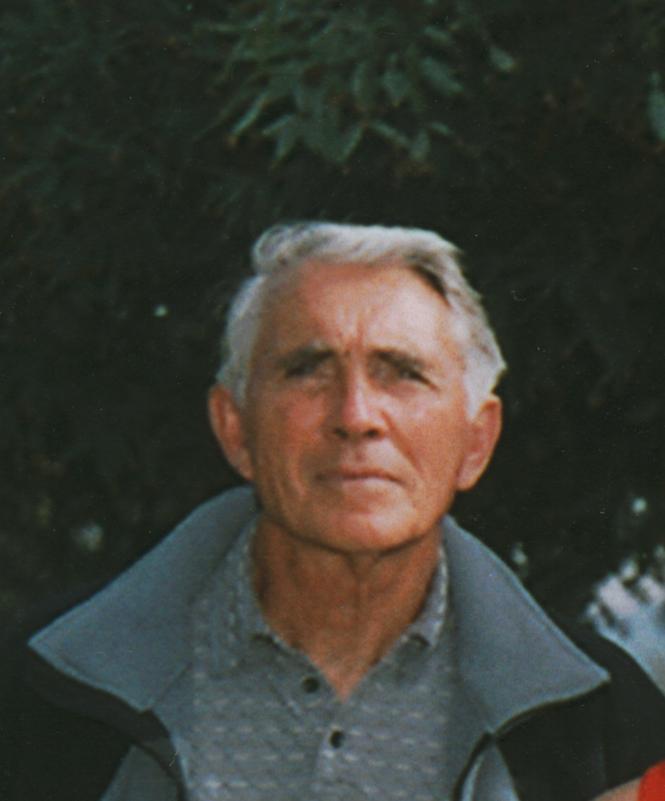

Course Records:  SMITH. RYAN 0:31:35 00-12 7:53 ’03  JACOBS. BRAD 0:22:53 13-15 5:43 ‘05  IYER. HARI 0:22:07 16-18 5:31 ‘04  SURRETTE. STEVE 0:24:54 19-29 6:13 ‘05  ALEXANDER.CHARLES 0:24:56 30-39 6:14 ‘03  SHAVER. JEFF 0:21:35 40-49 5:23 ‘04  CASILLAS. JOSE 0:27:24 50-59 6:51 ‘04  FELDMAN. BOB 0:34:00 60+ 8:30 ‘03  SPEEDY. AMANDA 0:29:47 00-12 7:26 ’04  NAST. KATIE 0:25:46 13-15 6:26 ‘05  FOLLMAR. ALICIA 0:24:08 16-18 6:02 ‘05  BARMEIER. JULIA 0:28:59 19-29 7:14 ‘05  KRIEGE. BECKI 0:24:40 30-39 6:10 ‘03  NAST. LIZ 0:27:21 40-49 6:50 ‘03  FOLLMAR. DEBBIE 0:29:13 50-59 7:18 ‘04  WIEBE. PAT 0:59.42 60+ 14:55 ‘05 | Last Years Top 3:  IYER. HARI 0:21:41 M 1 13-18  NAST. ROB 0:22:27 M 2 40-49  SHAVER. JEFF 0:22:40 M 3 40-49  FOLLMAR. ALICIA 0:24:08 F 1 13-18  NAST. KATIE 0:25:46 F 2 13-18  STRATMAN. ASHLEY 0:26:43 F 3 13-18  Previous Winners:  2005 – IYER. HARI 0:21:41 M  FOLLMAR. ALICIA 0:24:08 F  2004 – SHAVER. JEFF 0:21:35 M  FOLLMAR. ALICIA 0:24:20 F  2003 - SUBRAMANIAM. HARI 0:22:42 M  KRIEGE. BECKI 0:24:40 F

First |  |  |  |  |  |  |  |  |  |  |  |  |  |  |  |  | Last

Street |  |  |  |  |  |  |  |  |  |  |  |  |  |  |  |  |  |  |  |  |  |  |  |  |  | City

 |  |  |  |  |  |  |  |  |  |  |  |  |  |  |  |  |  | - |  |  |  |  |  |  | M | / | F
St |  |  |  | Zip |  |  |  |  |  |  | Phone |  |  |  |  |  |  |  |  |  |  |  |  |  |  |  |  |  |  |  | Age |  |  | Shirt Size (S,M,L,X)
Email (for results and a reminder for next years race)

_______________________________________________ | ___/___/___ | ________________________________________________
Signature of Athlete | Date | Signature of Parent (if under 18)

WAIVER: I waive for myself, my heirs and assign all rights and claims for damages against anyone associated with the race: Saratoga HS, and its officers, officials, boards, commissions, employees and volunteers. Saratoga/Los Gatos School District, promoters, sponsors, officials and the Saratoga XC Team. I also certify that I am physically fit and can participate in this event at my own risk.

