Saratoga High School Presents

1st Annual Marshall Clark
“Old School” Open Mile

Date: Saturday, November 20th, 2004  Time: 11:00 til heats are over  Cost: $3 (T-shirt guaranteed to pre-entries) – remember those days?  Make payable to: Saratoga XC  Send to: Marshall Clark Old School Open Mile  12375 Farr Ranch Rd, Saratoga, CA, 95070  Place: Saratoga HS Track (20300 Herriman & Saratoga-Sunnyvale)  Info: www.LYNBROOKSPORTS.com (408) 460-6785 HANKLAW@IX.NETCOM.COM  Timing: FAT (results will be posted on LynbrookSports.Com)  Heats: Will be run from Fastest to Slowest.  Uniforms: No High School uniforms are allowed. | 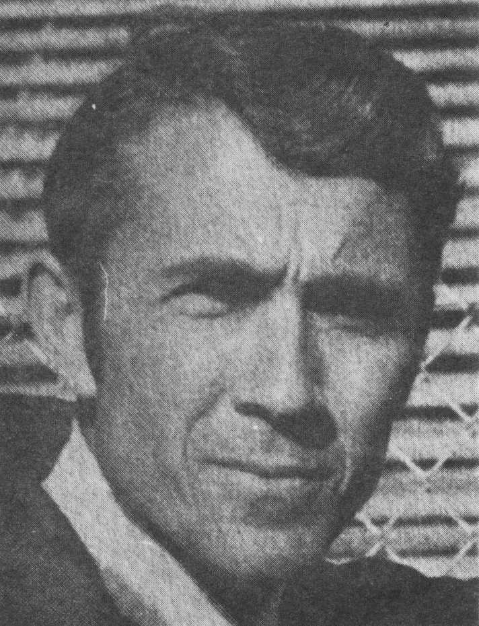

Course Records:  To be established | Last Years Top 3:  Previous Top Times:

First |  |  |  |  |  |  |  |  |  |  |  |  |  |  |  |  | Last

Street |  |  |  |  |  |  |  |  |  |  |  |  |  |  |  |  |  |  |  |  |  |  |  |  |  | City

 |  |  |  |  |  |  |  |  |  |  |  |  |  |  |  |  |  | - |  |  |  |  |  |  | M | / | F
St |  |  |  | Zip |  |  |  |  |  |  | Phone |  |  |  |  |  |  |  |  |  |  |  |  |  |  |  |  |  |  |  | Age |  |  | Shirt Size (S,M,L,X)
Email (reminder for next years race)

_______________________________________________ | ___/___/___ | ________________________________________________
Signature of Athlete | Date | Signature of Parent (if under 18)

WAIVER: I waive for myself, my heirs and assign all rights and claims for damages against anyone associated with the race: Saratoga HS, and its officers, officials, boards, commisions, employees and volunteers. Saratoga/Los Gatos School District, promoters, sponsors, officials and the Saratoga XC Team. I also certify that I am physically fit and can participate in this event at my own risk.

