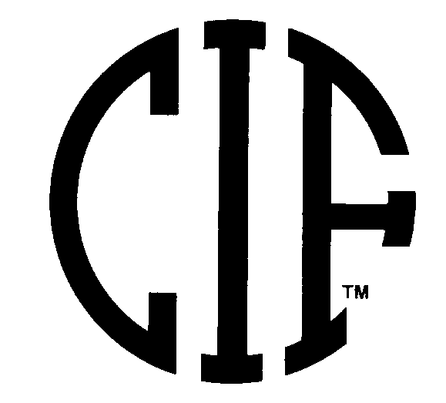
www.cifstate.org

STATE CIF CROSS COUNTRY/TRACK & FIELD ADVISORY COMMITTEE
Meeting Agenda
Tuesday September 13, 2005
State CIF Office Alameda, CA.

Members in Attendance: Jeanne Bingham , Roberta Chisam, Mike Cummings, Jim Deaver, Steve Filios, Brian Fitzgerald, Hal Harkness, Nancy Lambert, Amber Lessetter, Ernie Lee, Jerry Luzar, Marty Simpson, Meredith Smith, Brad Syth, Chairperson, Roger Blake, State CIF

1. Welcome: Following introductions, chairperson Brad Syth called the meeting to order at 10:00 a.m.

2. Approve Agenda.
ACTION: Motion by Jerry Luzar and Seconded by Steve Filios to approve the agenda without any additions. Approved 12-0

3. Approve Minutes of January 18, 2005 Meeting
ACTION: Motion by Jerry Luzar and Seconded by Amber Lassetter to approve. Approved 12-0

4. Role of Advisory Committee
Brad Syth reviewed the handout on State CIF Expectations of Committee Members and the role that all members play
in relaying information to their respective CIF Section Offices and track and cross country coaches within their sections.
ACTION: Members to share information with CIF Section Office and track and XC coaches.

5. State CIF Update
Roger Blake welcomed the committee members to the new CIF office in Alameda and distributed the CIF Constitution and Bylaws to all members. Also distributed were “Spirit of Sport” nomination forms.
ACTION: None

6. Cal Coaches Alliance Membership Review
Ernie Lee of the California Coaches Alliance reviewed with the committee the steps and actions that the CCA is taking to increase membership of Cross Country and Track coaches across the state. The concern is that the CCA, as a voting member of this committee, have a membership that is statewide and representative of the cross country and track coaches community. The State CIF offered to send out membership applications to all CIF schools during one of the regularly schedule State CIF mailings. ACTION: CCA will supply 1,400 membership applications to the State CIF to insert into a mailing.

7. 2005 – 2006 National Federation Rules Update
A. Hal Harkness, the State CIF Rules Interpreter reviewed with the committee several items that have been discussed at meeting in Indianapolis on June 27-28, 2005. Track Rule 7-5-3 calls for all participants in pole vaulting to meet the required standards for poles and that each state association to must implement a procedure that will ensure that the standards are met for all participants prior to vaulting.
ACTION: Steve Filios will author a standardized form for all committee members to review based on a form that the CCS used this past year. Steve will modify this form to meet statewide expectations. Upon approval of the committee, Roger Blake will forward the form to the CIF Section Commissioner and the State CIF Executive Committee for review and approval for use in the 2006 Track and Field season. This form will be used for all competitions including duel meets through invitational.

B. Beginning in 2006-07, Rule 6-4-5, 6-4-8 and 6-5-1 are modified to require all references and diagrams to reflect on standard sector at 34.92 degrees for shot put and discuss competitions. Even though the sector will be smaller, it was emphasized that the spectator and safety zones should remain will outside the area. The “OLD” toe boards with larger sectors will remain legal so that schools do not incur an added expense for new toe boards, however the sector must be mark with the new dimensions.
ACTION: Communication to schools by CIF and committee members.

CROSS COUNTRY ITEMS

9. Update 2005 Championship Meet
Marty Simpson reviewed with the committee the 2005 Cross Country bulletin and the committee made some recommendations and edits to help with the clarity of the publication.
ACTION: Bulletin Posted to the State CIF Web Site.

10. Review Section Qualifying Numbers
Roger Blake reviewed the State CIF Championship meet team entry numbers based on the mathematical equation that was approved two years ago and is posted in both the 2005 bulletin and the State CIF Constitution and Bylaws. ACTION: None

11. Review Section Individual Entry Procedure
Roger Blake reviewed with the committee the new individual entry procedure that was approved last spring by the Federated Council based upon the recommendation of this committee. The total number of individual entrees does not increase, however the section and divisional pools that the entrees can now qualify from varies based upon the number of team entrees.
ACTION: None

12. Other Cross Country Items for Discussion
a.) Uniform & Jewelry Rule Enforcement
Roger Blake asked that committee members again stress throughout the year that the NFHS uniform and jewelry rule must be enforced. There were less “incidents” and violations of this rule at last years cross country championship meet and it reflects the efforts of the committee to remind and inform coaches and athletes that this rule is to be enforced all year.
ACTION: Committee members are to again emphasis with coaches and meet directors to enforce this rule.

TRACK & FIELD ITEMS

13. Review 2005 Championship Meet in Sacramento
Roger Blake reviewed with the committee 2005 Track championship meet and shared the attendance and financial records with the committee. The meet was an outstanding event and the credit should go to the meet managers, Tom Crumpacker and Peter Sawyer. Committee members spoke to different aspects of the meet and a suggestion for future Hughes Stadium meets would be to include a “light rail” map in the bulletin as the coaches really appreciated the efforts of the meet directors to secure free light rail passes for the participants and coaches. ACTION: None

14. Date for 2008 Track and Field Championship State Meet
Roger Blake reported that for the first time since 1960, the state track and field championships will not be held on the first weekend in June in 2008. Due to a leap year and the normal rotation of the calendar days, the meet will be held on May 30-31, 2008. It is still week 48, the same week as every year but due to those two circumstances, the dates fall into May. Research showed that this same rotation and timing occurred in 1924 and will not occur again until after 2060. ACTION: None

15. Site for 2006 State Meet – Cerritos College
Hal Harkness reported to the committee that Cerritos College is still under consideration for the 2006 Track and Field Championship meet. Cerritos College has not yet established a timetable for stadium renovations that may preclude CIF from using the facility. Committee members reported that the track and field facilities are still in good shape, fast and appropriate for the state championships. Hal Harkness and Bob McGuire have reserved Mount San Antonio College as a back up to Cerritos in the case of the football field construction begins and forces the meet to move. Cerritos College has communicated to Hal that they hope to have the time table and priorities for construction established by late October so that we can finalize the meet location.
ACTION: Awaiting confirmation from Cerritos College, anticipated by the end of October.

16. 2006 At-large Entries
Hal Harkness handed out the “at-large” qualifying times and marks for the 2006 meet for review by the committee.
ACTION: Distribute to sections.

17. Section Entry Procedure
Hal Harkness reviewed with the committee regarding the entry process using the Hy-Tec system. The present process is working smoothly and needs no changes at this time. Any new school must be issued a four digit code by Hal Harkness and committee members were asked to have new schools contact Hal for the appropriate numbering.
ACTION: None

18. Other Track & Field Items for Discussion
a.) Steeple Chase Interest Report from Committee
Committee members reported that there are a handful coaches who would like to see the CIF make Steeple Chase an allowable event, however few if any high schools have the facilities to host. Due to the lack of facilities and a ground swell of interest, the recommendation of the committee is that the CIF take no action on this issue.
ACTION: None
ACTION: None – Steeple chase, hammer and javelin are still prohibited events under CIF rules.
b.) Saturday Track and Field Program Insert
At future State Track and Field Championships, coaches will be issued a ticket to present for a free “updated” event and lane assignment sheet that is sold as a program insert on Saturday.
ACTION: None

Next Cross Country/Track & Field Advisory Committee Meeting: DATE: January 10, 2006
TIME: 10am State CIF Office Alameda, CA.

Respectfully Submitted, Approved by,

Roger Blake Brad Syth
Assistant Executive Director Chairperson

