From: Rich Wheeler, Mills High School, Meet Director
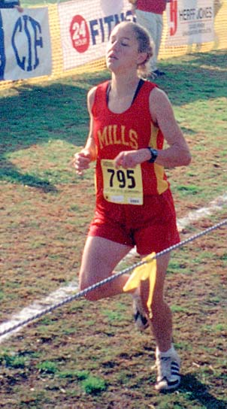
Mills High School
invites you to come run the
2ØØ4 Center Meets.
To: Cross Country Coaches
Subject: Organizing the 2ØØ4 Center Meets
Dates: Thursday, October 14th…races begin at 3:15 p.m.; see the order of events on page 2.
Thursday, October 21st…races begin at 3:15 p.m.; see the order of events on page 2.
Thursday, October 28th…races begin at 3:15 p.m.; see the order of events on page 2.
Directions: West on Highway 92
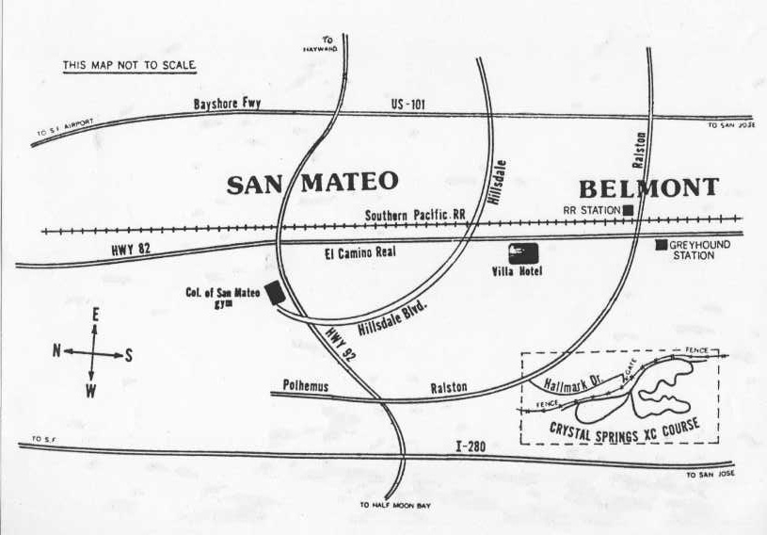
Borrowed from the Lynbrook.com site
Crystal Springs/CSM Cross Country Complex
- Exit 92 at Ralston (yes I know you can get to Ralston from 101 in Belmont, but I don’t).
- South on Ralston to your first right turn (Hallmark)
- West again, the only way you can go, for a mile. The course/park is on the right. If you don’t see a small telephone booth, you are in the wrong place.
- Buses must go around the corner on Hallmark and not double park before they unload their athletes. This is the same area where buses are to pick up their athletes.
- There is an entry to the cross-country course between the fifth and sixth houses from the telephone booth.
- People who drive in cars should park legally! Illegal parking will result in parking tickets.
Entry Fee: There is a $15.00 facility fee per team. This money goes to the College of San Mateo for course upkeep and the outhouse services. If bus, parking and medical emergency problems require the hiring of police to direct traffic, this fee will go up.
- •There is an individual fee of $2.00 per individual entry.
- Both fees are due before the races begin.
- Teams who simply show up at the meet without prior entries will be accepted only if there is time to create their labels, and they will be charged double ($4.00 per individual who races) the entry fee. Facility fee and entry fee will have to be paid by cash.
Entry Fee $$…per meet: Make checks payable to Mills Cross Country.
  - Distinctive Center Meet Ribbons will be awarded at the finish line.
  - The racecourse is 2.95 miles long.
Entries Due: Your entries are due on the following schedule…on DirectAthletics.
For Center Meet #1, Thursday, October 14th, your entries are due by 11:59 p.m., Monday, October 11th.
For Center Meet #2, Thursday, October 21st, your entries are due by 11:59 p.m., Monday, October 18th
For Center Meet #3, Thursday, October 28th, your entries are due by 11:59 p.m., Monday, October 25th.
You pay for what you enter…enter with care!
Submitting Entries: We are using Direct Athletics to collect our entries. Please see page three that explains how you should get to Direct Athletics, and how to create your account, if you do not already have one, and how to submit your entries. If you have questions….E-mail your questions to Jim Hume at jcdhume@sbcglobal.net or to Meet Director Rich Wheeler at wheeler-rick@sbcglobal.net. In an emergency, Coach Wheeler’s telephone number is (650) 697-34666 at home in the evenings. Do not telephone in the evening after 8:55 p.m.
Course management concerns: 1) It is the responsibility of each coach to arrive with their own first aid kit and the cards from their school that authorize an athlete’s medical treatment in the event of a medical emergency. When you sign in you will be asked to sign in and certify that you are in compliance. There will be a trainer present and meet management will supply ice for injuries.
This is the time schedule for the Center Meets. All races are 2.95 miles long.

Thursday, October 14th Thursday, October 21st Thursday, October 28th

Center Meet #1 Center Meet #2 Center Meet #3
3:15 —Frosh/Soph Girls Frosh/Soph Girls Frosh/Soph Girls
(Unlimited entries…scored) (Unlimited entries…scored) (Unlimited entries…scored)
3:30 — Frosh/Soph Boys Frosh/Soph Boys Frosh/Soph Boys
(Unlimited entries…scored) (Unlimited entries…scored) (Unlimited entries…scored)
3:45 —Varsity Girls Varsity Girls Varsity Girls
(Fastest 7 athletes…scored) (Fastest 7 athletes…scored) (Fastest 7 athletes…scored))
4:00 — Varsity Boys Varsity Boys Varsity Boys
(Fastest 7 athletes…scored) (Fastest 7 athletes…scored) (Fastest 7 athletes…scored))
4:15 —Junior Varsity Girls Junior Varsity Girls Junior Varsity Girls
(Unlimited entries…scored) (Unlimited entries…scored) (Unlimited entries…scored)
4:30 — Junior Varsity Boys Junior Varsity Boys Junior Varsity Boys
(Unlimited entries…scored) (Unlimited entries…scored) (Unlimited entries…scored)
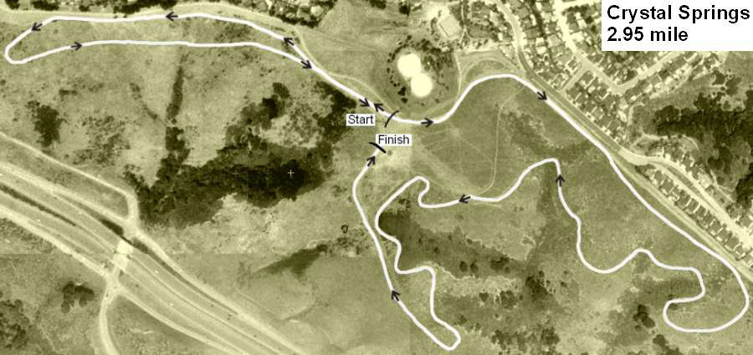
Borrowed from the Lynbrook.com site
Entry organization:
- On the day of the race, when you sign in, you will pay for and receive a Cross Country Chest Number for each athlete who will race.
- Hand out your chest numbers with care. Each number has a tag with a name.
- The bottom portion of the bib number will be collected after the finish line. Computer magic will be applied.
- After the race, the results will be posted ASAP.
- Somewhat later, that night if all goes according to plan, results will be sent by e-mail to all interested parties. If you have parents who are interested, we simply need their e-mail addresses. Results will also be sent on the Lynbrook www site – www.Lynbrooksports.com …and of course to DirectAthletics. DirectAthletics will keep a database of performances from all the Center Meet and from the PAL championship meet. If, next year, more schools use DA…the database will be larger.

How to Submit Online Entries
**1-2-3 Guide to Entering a Meets Online**
- Create an Account (or login with an existing account…keep reading to discover how to add cross country as a sport to your account)
- Setup your Roster
- Submit your Roster/Entries to Each Meet
STEP 1—Access your DirectAthletics Account…use your PC computer (not a Mac) and go to www.directathletics.com.
Each coach must have a DirectAthletics username and password for his/her school. If you don’t know your username and password, you will be able to create one or retrieve your existing account by following the instructions below.
If you already have a DirectAthletics account for your school team, and know your username and password…. | If you do NOT know your username and password….Create your own!
↓ Go to www.directathletics.com  ↓ In the login box, enter your username and password and click Login.  (Remember that your password is case-sensitive) | - Go to www.directathletics.com  - Click on the link “New User? Click HERE”.  - Follow onscreen instructions. You will be able to create an account online or retrieve forgotten information for an existing account.
Note About Accounts: IF you already have a school account from the track season, when you sign in and use the pull down menu to switch to the sport of “Cross Country”, you might get the following message…
“Your account does not control any teams in this sport. Please email (click on the link and you get a chance to e-mail…support@directathletics.com to request access. Include: Your Username, Team Name, Sport you wish to add…You will receive an email reply verifying access approval ASAP.
Most coach accounts control a school’s Men’s AND Women’s team. You control only one gender at time, so you will complete the below steps for your Men, and then switch to your Women’s team and repeat the process (or vice versa). The team you are controlling is listed on the blue navigation bar across the top of your account, for example:
Sport: Cross Country Team: Aragon (M)
This indicates that you are controlling the Aragon MEN’S team (M=MEN). To switch to your Women’s team, you would select “Aragon (W)”.
STEP 2—Edit/Set up Your Online Roster
Before entering an athlete into a meet, you must add all attending athletes to your roster. If an athlete is already on your roster (from previous seasons) you do not need to add him/her again. Most schools will just need to add new athletes and delete athletes no longer on the roster.
- Upon logging in, click the TEAM tab. (New Users will be forced to set up their rosters before they can proceed)
- If you have used DirectAthletics before, you will see last year’s roster. School years have automatically been moved forward one year. You can click “Import Track Roster”. You will be able to add athletes from your Track roster to your Cross Country roster. If you do not see this link or you are new to DirectAthletics, skip to Step 3.
- Click the green “Add Athletes” link under the Team Roster header. Select an approximate number of athletes you would like to add (you can add more at any time).
- Enter your athletes First Name, Last Name and School Year (all other information is NOT necessary) and click “Submit”
- You may add, edit or delete athletes on your Team Roster at anytime by click the TEAM tab.
STEP 3--Submit Online Meet Entries

Once your athletes are added to your roster, you must declare your entries to each meet you are attending.
- In the HOME tab (under Upcoming Meets) or in the SCHEDULE tab, click the green Register button next to the meet you wish to enter.
- Check off the box for each athlete you wish to enter. You can check the “All” box to select (or un-select) your entire roster.
- When you have completed your entries, click “Submit”. You MUST click “Submit” to submit your entries.
- You will see your current, submitted entries on the “View Entries” page. At any time before the entry deadline, you may edit your entries by clicking the “Edit Entries” link.
- For entry confirmation, simply print the “View Entries” page or click the Email Confirmation link at the top of the “View Entries” page. An Email Confirmation will be sent to the email address in your account.
- You need to send entries for each Center Meet you run. You pay for what you enter!
Mills High School
Meet Director 2ØØ4 Center Meets
% Rich Wheeler,
400 Murchison Drive,
Millbrae, CA 94403
Mills High School invites you to come run the 2ØØ4 Center Meets.
To:

