
1st Annual Soquel High
’Knights Invite’
Varsity Track and Field Invitational
Saturday March 19th 2016

PLACE: Soquel High School, Santa Cruz County
401 Soquel San Jose Road
Soquel, CA 95073

Meet Director Matt Ryan: ryanm@sutterhealth.org

STARTING TIMES:
Running Events: 10:00 am
4 x 100m relay, 1600m, 100/110m hurdles, 400m, 100m, 800m, 300m hurdles, 200m, 3200m, 4x 400m relay
Field Events: 10:00am
Shot Put, Discus, Long Jump, Triple Jump, Pole Vault, High Jump

FACILITY: Soquel High School- Track Facility

DIVISIONS: Varsity Girls, Varsity Boys

ENTRY LIMITS: *Four entries per event (except relays) per division per school. Certain events may have an entry number cap depending on number of entries per event; top12 marks will be accepted for girls and boys pole vault.
* Relays may enter “A “and “B” teams.
*Field Events: 4 attempts for Shot Put, Discus, Long Jump, Triple Jump

AWARDS: Custom LARGE medals for Top 3 places from each event.

TROPHIES: Trophies will be awarded to the Team Champion in both Division.

TIMING: Finish Lynx Automatic Timing System will be used.

CONCESSIONS: Soquel HS concessions stand will be open.

ENTRY DEADLINE Entries can be made on www.athletic.net with the deadline at midnight on Saturday March 12th.

FEES: $5.00 per entry per event and $10.00 per relay team.
No additions are to be made on meet day, only substitutions.
Meet will be held Rain or Shine.

PLEASE MAKE CHECKS OUT TO:

Soquel High Track and Field
Attention: Stu Walters, Athletic Director
401 Soquel San Jose Road
Soquel, CA 95073

Track Events: 10:00 am (Rolling Schedule; there will be a ½ lunch break for officials)
Girls Varsity 4x100 Relay
Boys Varsity 4x100 Relay
Girls Varsity 100m Hurdles
Boys Varsity 110m Hurdles
Girls Varsity 1600m Run
Boys Varsity 1600m Run
Girls Varsity 400m Dash
Boys Varsity 400m Dash
Boys Varsity 100m Dash
Girls Varsity 100m Dash
Girls Varsity 800m Run
Boys Varsity 800m Run
Girls Varsity 300m Hurdles
Boys Varsity 300m Hurdles
Girls Varsity 200m Dash
Boys Varsity 200m Dash
Girls Varsity 3200m Run
Boys Varsity 3200m Run
Girls Varsity 4x400 Relay
Boys Varsity 4x400 Relay

Field Events 10:00 am; warm ups start @ 9:00am

(4 attmepts SP, D, LJ, TJ; entry ht determined for PV and HJ at meet )

10:00am Girls Varsity Discus
Boys Varsity Shot Put
Girls Varsity Triple Jump
Boys Varsity Long Jump
Boys Varsity Pole Vault
Girls Varsity High Jump

1:00pm Boys Varsity Discus
Girls Varsity Shot Put
Boys Varsity Triple Jump
Girls Varsity Long Jump
Girls Varsity *Pole Vault
Boys Varsity High Jump

* Girls vault will following completion of boys vault

Welcome to the first annual Soquel High School ‘Knights Invite’ varsity track invitational! The track meet will take place at the Soquel High state of the art facility that includes a brand new throws complex for the shot put and discus.
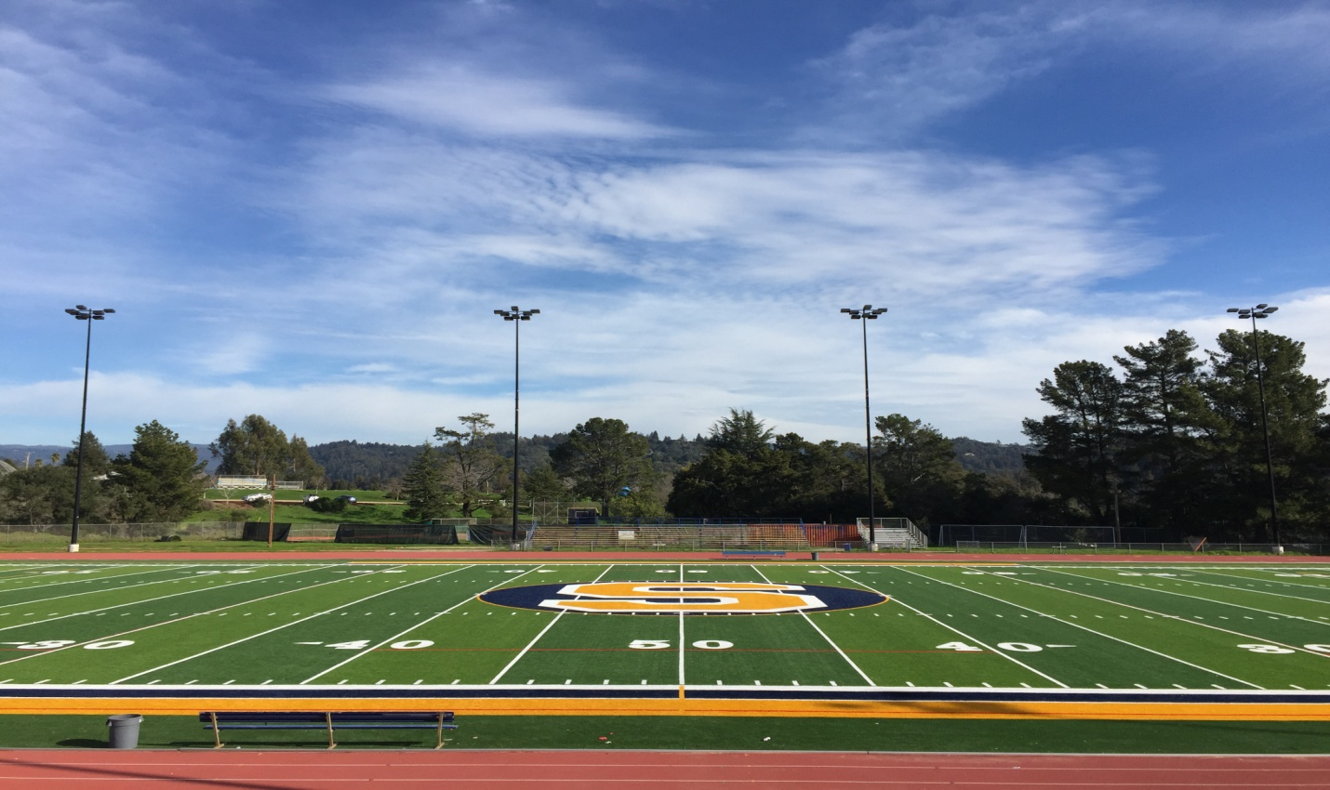
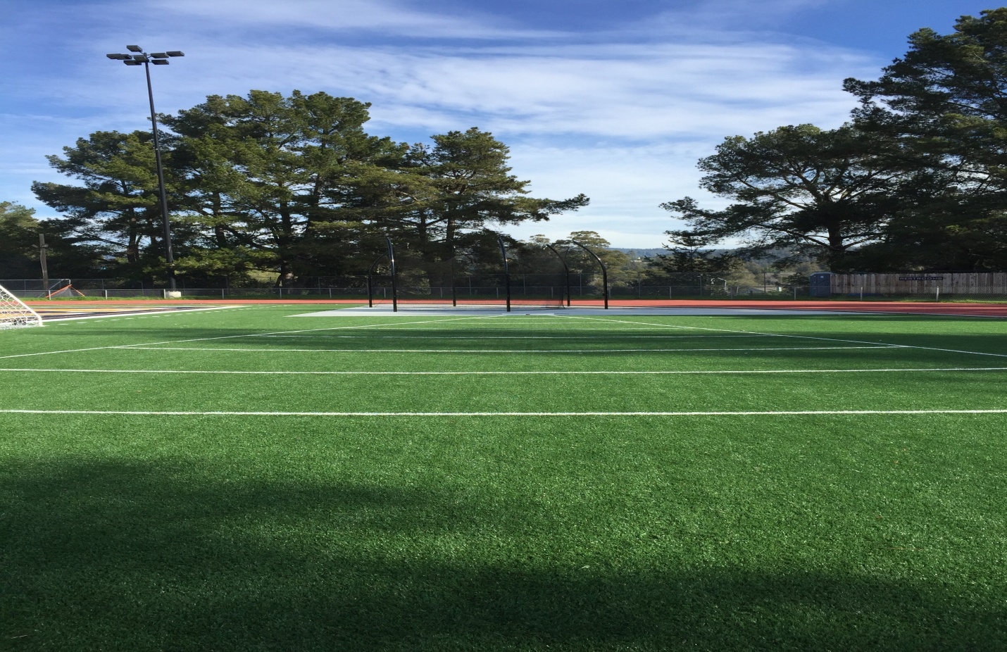

This meet will have entry limits based on the top number of times as shown below:

Girls Varsity 4x100 Relay 16
Boys Varsity 4x100 Relay 16
Girls Varsity 100m Hurdles 16
Boys Varsity 110m Hurdles 16
Girls Varsity 1600m Run 16
Boys Varsity 1600m Run 16
Girls Varsity 400m Dash 16
Boys Varsity 400m Dash 16
Boys Varsity 100m Dash 32
Girls Varsity 100m Dash 32
Girls Varsity 800m Run 24
Boys Varsity 800m Run 24
Girls Varsity 300m Hurdles 16
Boys Varsity 300m Hurdles 16
Girls Varsity 200m Dash 32
Boys Varsity 200m Dash 32
Girls Varsity 3200m Run 24
Boys Varsity 3200m Run 24
Girls Varsity 4x400 Relay16
Boys Varsity 4x400 Relay 16
Girls Varsity Discus 15
Boys Varsity Shot Put 15
Girls Varsity Triple Jump15
Boys Varsity Long Jump 15
Girls Varsity High Jump 15
Boys Varsity Pole Vault 12
Boys Varsity Discus 15
Girls Varsity Shot Put 15
Boys Varsity Triple Jump 15
Girls Varsity Long Jump 15
Boys Varsity High Jump 15
Girls Varsity Pole Vault 12

THE ENTRY DEADLINE FOR THE ENTRIES WILL BE AT MIDNIGHT ON SATURDAY MARCH12th ON WWW.ATHLETIC.NET

THE ACCEPTED ENTRIES WILL BE POSTED ON ATHLETIC.NET AND ON THE LYNBROOK SITE BY TUESDAY, MARCH 15TH .

You may bring your team’s entry payment on the day of the meet or send a check to:
Soquel High Track and Field
Attention: Stu Walters, Athletic Director
401 Soquel San Jose Road
Soquel, CA 95073
(checks will need to arrive to this address by Friday, March 18^{th;} if you do not think that this will happen, please bring your fee to the meet)

