Postseason SCVAL Track Meeting 2015

The meeting was held on Tues., May 26 and started at 5:11 pm at Los Altos.

Attendance

The following people were in attendance: Julie L'Heureux (SC), Paul Jones (PA), Kelsey Feeley (PA), Paul Armstrong (C), PattiSue Plumer (G), Ernesto Salinas (LG), Mark Shields (F), Kirk Flatow (MV), Jake White (L), Jim Wilks (W), Curtis Liang (G), Bridget Hall (M) and Hank Lawson (website).

League Representatives

Julie L’Heureux and Ernesto Salinas will remain the league representatives for the El Camino Division and the De Anza Division, respectively.

League Championships

The following teams won league titles:

DA League El Camino League
VB Los Gatos Wilcox
VG Los Gatos Cupertino
F/S Lynbrook Homestead
JVG Gunn Homestead

No one requested SCVAL certificates except for Wilcox. They would like the certificates for the school only.

League Finals Evaluations

The host schools were Mt. View/Lynbrook and Monta Vista for the De Anza and El Camino Division Meets respectively. The El Camino meet was very organized and Kirk did a good job. Due to Mt. View inexperience, schools needed to step up to get the meet done. Help was needed to set up the meet.

There was a discussion on alternates for the finals. Do alternates need to show up to the finals to be considered for the entries to the SCVAL Championship Meet? This discussion will be addressed at the preseason meeting.

Past and Future League Meets

League Meet Host School Host School
DeAnza El Camino
Past
Year DAL ECL
2007 Los Gatos Saratoga
2008 Monta Vista Santa Clara
2009 Milpitas Homestead/SC
2010 Palo Alto Saratoga/SC
2011 Gunn Santa Clara
2012 Los Altos Fremont
2013 Lynbrook Cupertino
2014 Gunn Wilcox
2015 Mt. View/Lyn. Monta Vista
Future
2016 Los Gatos Saratoga
2017 Milpitas Santa Clara
2018 Homestead Fremont
2019 Palo Alto Cupertino
2020 Los Altos Wilcox
2021 Lynbrook Mt. View
2022 Gunn Monta Vista

Start Time for League Meets – next year

Coaches are concerned about next year’s start times of the Divisions and Championship Meets. Here is the schedule for AP testing 2016:

Mon., May 2 – Psychology
Tues., May 3 – Art History, Physics 1
Wed., May 4 – Japanese, Physics 2
Thurs., May 5– Chinese, AP Seminar
Fri., May 13 - Latin

Coaches should determine how many of their athletes are impacted by AP testing and relay the information to their meet director. Meet directors can take this into consideration but also needs to consider the finish time of the meet. Any adjustment in the time schedule should be made well in advance to give the coaches time to discuss the pros and cons.

Also, athletes should consider applying to take the AP test at the school location of the meet(s) or different date.

A committee was formed to address a change in the schedule due to AP testing. Committee head is PattiSue Plumer. The committee is composed of the following coaches: Bridget Hall, Paul Jones, Mark Shields, Curtis Liang, Hank Lawson, Kelsey Feeley, and Julie L’Heureux. Any changes to the 2017 schedule should happen before mid May of 2016 for implementation the following year. Also, the BOM will need to sign off on it. Changes in schedule could be double dual meets, tri-meets, start the season a week earlier for example.

SCVAL Championship Meet Evaluation

The meet was held at Santa Clara and the meet directors were Julie L’Heureux and Ernesto Salinas. Overall the meet went smoothly and was well managed.

Adjust the time schedule for next year so that the meet has minimal pauses in the meet. Ernesto and Curtis have already addressed these changes.

Make announcements for turn judges 10 minute prior to shift change.

There is a request to increase the number of alternates available for the meet.

SCVAL Championship Meet – May 13, 2016
Site – Los Gatos
Meet Director – Ernesto Salinas, Co-Meet Director – Julie L’Heureux

League Realignment

Homestead – DAL
Mt. View – ECL

See appendix for full calculations.

League Schedules

Preliminary schedules were handed out. The athletic directors and BOM will approve them at a later date.

Should the postseason meeting date and time be changed? People would like to change the start time to 5:30pm. Will address this at the preseason meeting next year.

Honor Coaches

Ernesto Salinas and Kirk Flatow were nominated for CCS Honor Coach.

Congratulations to PattiSue Plumer, 2015 Honor Coach Award Recipient.

Previous award winners are Hal Daner (’96), Paul Abbott (’99), Marshall Clark (’00), Chuck Kappen (’02), Hank Lawson (’03), Julia Widstrand (’06), Walt Van Zant (’08), Jason Fung (’09) and Paul Armstrong (’11).

CCS Meet Evaluations

- Take pictures of CCS Medalists – high definition
- Concessions – healthy food
- Sell spikes, equipment
- CCS did a good job with signage at the meet and keeping the rails cleared of spectators.
- Coaches are happy having the meet at SJCC.
- Have more clearance from the spectators at the Discus Cage.

By-Law Changes

PattiSue made a motion to up the number of alternates allowed at the SCVAL Championship meet from 4 to 6. It was seconded by Jake White. The vote was 7 for, 3 abstained. This will be discussed further at the preseason meeting.

Other

There was a discussion to request that senior girls be allowed to compete at the JV level. There was some support but no further action was taken.

Meeting adjourned at 7pm.

Appendix

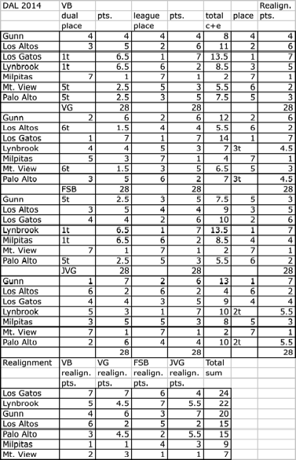
11

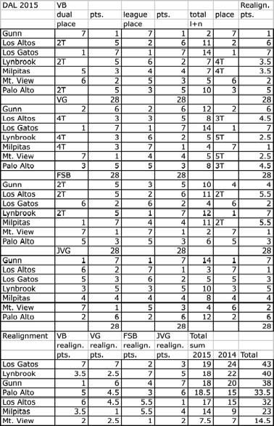
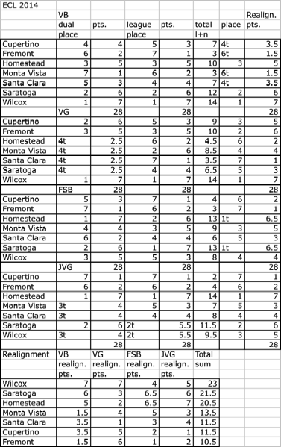
1111

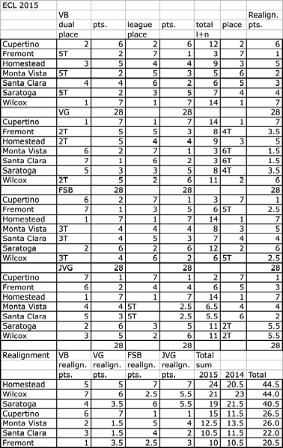
11

