Coaches:

Here are the instructions for the meet tomorrow.

1) The scratch meeting is at 3:45pm. No heats will be reseeded, alternates will
take the empty lane.

2) Head Field Judge for each field events should be there by 3:45 for final instructions. Please forward this email to them.

3) All field athletes for the first group of field events should be there by 4pm. Weigh ins start at 3:45pm. Competition starts at 4:30pm. When checking in, the Field Judge should determine if they have any events that will interfere with the competition and note it on the field sheet.

4) Attached is the time schedule for the meet with times for VG and VB. The Field Judges will use this schedule for excusing athletes. Field athletes can only check out 10 minutes before their running events. They should return
immediately to their field events but have 10 min. from the end of their running events to recover. The Field Judge should note the time of check out on the field sheet.

5) Field athletes can take multiple attempts or compete out of order. Here is the rule from NFHS Track Rules Book Rules 3-10:

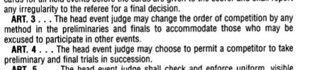

6) For HJ or PV athletes, the bar can be raised if all competitors have completed that height while they are at a different event. I suggest that the bar is only raised 1 height as long as the checked out athlete is within the
allotted time frame ruled by the Field Judge. Here are some case studies from
the NFHS Case Book:

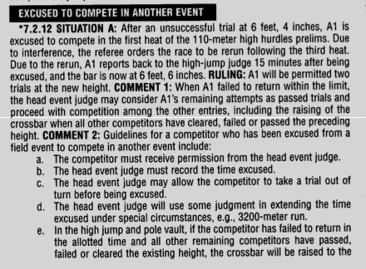

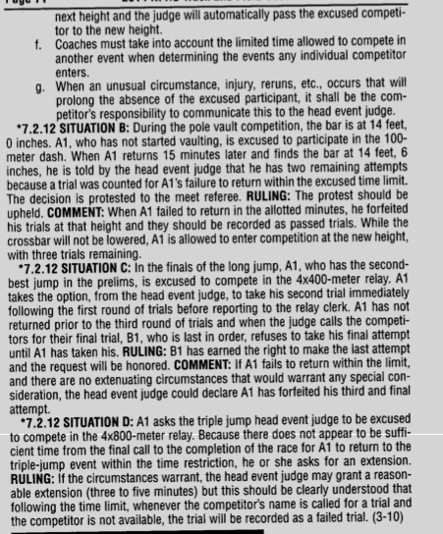

7) If there is a tie for 6th place in the HJ, there will be a jump-off.
8) Field athletes, checking out for another field event, should be given a time limit for returning. The high jump official cannot hold the jumpers at that event and prevent them from going to other field events.

9) For the HJ and PV, athletes can state their starting height. They don’t need to be there to pass each height. It is their responsibility to be back there when that height is reached.

10) The meet will run no more than 5 minutes ahead of schedule.

11) Athletes should check in at least 15 minutes before their scheduled race. Same for alternates.

12) Warm ups should be done in the warm up area not the infield.

13) Electronic devices are not allowed on the infield, unless they are being used by officials to communicate with each other. No video should be shown to a competitor until their competition is over.

14) Coaches should stay off the infield.

15) Here is the rule for the 4x400 relay hand-offs from the NFHS Track
Officials Manual Pg. 24-25.

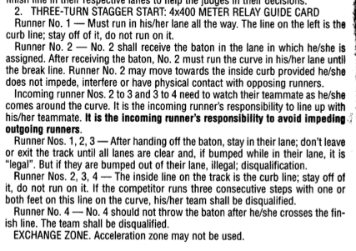

16) 800m will be 2 heats, 1 turn stagger in lanes

17) 1600m – will be run in 2 alleys, same for the 3200m

Hopefully, I have covered everything and the meet will run smoothly.

Any questions?

Julie

Meet Director: Julie L’Heureux, Co-Director: Ernesto Salinas
Location: Santa Clara High School, May 15
Job Assignments:
Starter: Dino Certa
Timer & Results: Jim Clark
Announcer: Los Gatos – Mike Dudley (confirmed)
Field Event Result Checker: Julie L’Heureux, Colette L’Heureux / Santa Clara
Field Judges: Paul Fuller – throws, Reed Kappen - jumps
Clerk of the Course: Margaret Demorest, TBD (Santa Clara)
Jury of Appeals: Hal Daner (G), Bridget Hall (M), Michael Strek-Woodard (Mt.V) Alternates: Mark Shields (F) and Kelsey Feeley (PA)
Starting Clerk: Mark Foyer (not confirmed)
Finish Line: Gunn
Weigh in: Los Altos
Blocks: Mt. View
Events:
Pole Vault: Santa Clara / Los Gatos
Hurdles: Palo Alto
Shot: Homestead
Discus: Milpitas
TJ: Cupertino
HJ: Lynbrook
LJ: Wilcox
Turn Judges:
1st half (400m relay - 100m) Lynbrook (2) turn 1, Fremont (2) turn 2, Los Altos (1) & Gunn (1) turn 3, Cupertino (1) & Milpitas (1) homestretch & finish line

2nd half (800m - 1600m relay) Saratoga (2) turn 1, Monta Vista (2) turn 2, Wilcox (1) & Homestead (1) turn 3, Los Gatos (2) homestretch & finish line

The turn judges’ names should be turned into the Meet Director by May 14.

