HOOPS & HURDLES:
THE UNLIKELY STORY OF HOW I LEARNED HOW I LEARN
Edward M. Griffin
Note: I wrote this essay as a member of “Making Meaning of a Life in Teaching,” at the University of Minnesota. This program, organized by the University’s Center for Teaching and Learning, brought together a dozen experienced members of the faculty from various departments to address our lives as teachers. Each of us was challenged to compose a memoir. After a forty-year career, I didn’t want to write the expected retrospective look at my decades in the classroom, a prospect that seemed too much like writing my own obituary. Eventually, I took a different approach—reflecting more on my own style of learning and on how my basketball and track coaches during my freshman year at the University of San Francisco helped me think about fitting teaching methods to different kinds of students. I wondered whether my academic colleagues in the group would raise skeptical eyebrows about an old geezer recalling his days as an eighteen-year old “jock,” but in our monthly meetings they encouraged me to push on with what became “Hoops and Hurdles.” In the end, I felt that even with my oblique approach I had truly come to a useful understanding of my own life in teaching.

©2012 Edward M. Griffin

I
An item in the weekly student newspaper alerted me to it. The University of San Francisco was reviving track and field after dropping it two years earlier.
On the dim, drizzly November day I saw the notice in the Foghorn, I was a walk-on reserve on the USF freshman basketball team—one of those subs who practices but seldom plays in games. The varsity, having won the 1954-55 NCAA championship, was ranked first in the United States and undefeated this season, breaking the all-time collegiate record for the most consecutive wins. Freshmen were then ineligible for varsity participation, but we played our own 20-game schedule—6:00 p.m. prelims to the varsity games—and we also supplied the scout team for the varsity, scrimmaging against them once or twice a week. They had their way with us. They had their way with everybody. They had a great coach, Phil Woolpert, and star players Bill Russell, K. C. Jones, and Hal Perry had returned for their senior year determined to win a second consecutive national championship. I didn’t care about riding the bench; I felt lucky to have made the team and thrilled just to have a uniform and take part in the excitement. I knew that my collegiate athletic career would end in February. A few years earlier, finances had forced USF to drop football, my best sport, and a couple of years later the school had dropped track and field, so I was left with baseball and basketball. I loved baseball, but I had never played for my high school team; as for basketball, I realized that as a non-scholarship player warming the far end of the bench on the freshman team I would never be good enough to play varsity basketball at the USF level.
But there it was in the Foghorn: the administration announced that it was going to revive track and field and that it had hired as coach Bill Magner, who had trained championship teams at San Francisco’s George Washington and St. Ignatius high schools. Then came the point that made me gasp: because 1956 was an Olympic year, the NCAA would suspend its usual rule and allow freshmen to participate in varsity track-and-field competition. Magner had no scholarships to offer, but he was looking for athletes to join his team. Sitting there in the Green-and-Gold Room of Phelan Hall, I knew instantly that fate, the Olympic calendar, and the NCAA had provided me my one-and-only chance to fulfill my boyhood dream of earning a varsity letter at USF.
I pushed back my chair, stuck my folded copy of the Foghorn under my arm, and sloshed through puddles across the parking lot to the Athletics Department, housed in a former Army barracks donated to the campus during wartime.
“You’re the first person to come over,” smiled the secretary. “Let’s see what Coach Magner wants us to find out. Oh—what are your events?”
I had been a decent broad-jumper and high-jumper on a championship team at Riordan High in San Francisco, and in my senior year I had been an occasional, fill-in-because-of-emergencies hurdler, but I hadn’t been a star. We had competed against the St. Ignatius team, and I had never placed first in a jump or a race against them. Surely Coach Magner wouldn’t recognize my name on the list, but at least it would be the first he would see. So I told the secretary to put down hurdles, high jump, and broad jump. She dutifully wrote the words next to my name, took my phone number, and thanked me for stopping by. I walked off to my French class to face the hearty presence and booming voice of Dr. Luigi Sandri, thinking not of those maddening French irregular verbs but of how I might squeeze out a few more inches by improving my approach in the broad jump.
USF, undefeated in all twenty-nine games, did win the NCAA basketball championship that spring. We also had a pretty good freshman team. My coach, Ross Giudice, doubled as Woolpert’s assistant. Ross Giudice figures prominently in my gallery of great teachers, for I learned enough from him that I actually got to play quite a bit as the season developed. Basketball began in late October and ended for the freshmen late in February. I lived at home, but my parents—the Platonic Ideal of Strictness while I was in high school—let me treat their home as a hotel once I started college. I had the use of the family’s “second car,” a sixteen-year-old tan Packard straight out of John Dillinger’s hideout. I slept at home and sometimes ate there, but I acted more like a tenant than a member of the family. I started to fall in love again, but, still bruised and skittish from a nasty conclusion to my high school romance, I got scared, dropped my new girl friend, and spent most of my time at practice, at games, at the library, and at my part-time job on week-nights. During those months, I threw myself into my studies and into basketball. Each required a major effort. USF still had the traditional, demanding, Jesuit curriculum. For instance, it required every first-year student, regardless of college or major, to take a full semester of formal logic. I had daily drills on propositions, enthymemes, and syllogisms. For me, spotting logical fallacies became a competitive classroom sport.
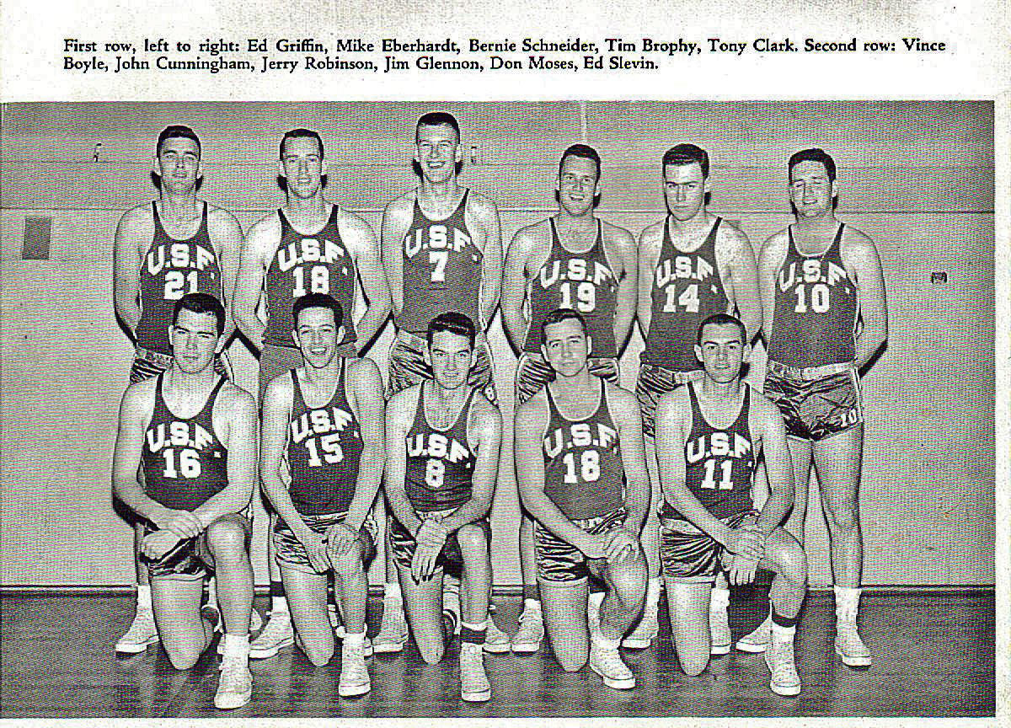
I couldn’t find a photo of our freshman team, so I’m substituting a picture from my sophomore year: the USF Golds (varsity reserve) team. Just to prove I actually had a uniform (16).

When the spring rains came to San Francisco, my name still stood at the top of the sign-up list for track, and I learned that thirty-three others had signed up. One of them was another freshman, my good friend Tim O’Leary, who had been one of Northern California’s top quarter-milers when we ran for Riordan High, so maybe we would have some proven talent. With thirty-four athletes, we should have sufficient numbers to compete well in most of the many track and field events. This would be my one chance at that forest-green sweater with the gold chenille SF on the pocket.
We had only 1,200 students. We didn’t have a gym on campus, and we didn’t have a track. But St. Ignatius High School, the Jesuit prep school, was right across the street. The basketball teams practiced either in the SI gym or a few blocks away in Golden Gate Park, at the pavilion attached to Kezar Stadium. The track team was to use SI’s packed-dirt oval. On the March afternoon when we met Bill Magner on the SI infield for our first practice, I was excited, but I could sense his disappointment. Instead of thirty-four, only a dozen actually appeared. None of us, except maybe Tim O’Leary, had that long, lithe look of the record-breaker. A couple of people had no previous track experience. Two men were Korean War vets in their mid-twenties—both of them beefy guys who wanted to put the shot and throw the discus. I suspected that Magner had gone through the sports pages of the previous few years to see what sorts of performances we had previously turned in, for he told us at the outset that at the small college level (no scholarships and no meets against UCLA, USC, California, Stanford, or San Jose State) times and distances were not much better than good high school results. He knew at a glance that, Olympic year or not, he was not looking at any future Olympians sitting there on the grass at the St. Ignatius High School track. The best he might hope for was an older version of his good high school teams. I could tell that we didn’t have the numbers to win many events, let alone meets. But I liked the challenges of running and jumping, and competing gave me the chance to score enough points to qualify for a letter.
Thus began one of the best educational experiences of my life—one that helped me learn how I learn. With better athletes—or even more warm bodies—on his team, Bill Magner may not have had time to treat me as “a project.” But I was his only hurdler. So, by default, he went to work on me. A few days before our first track meet, however, Magner suddenly found himself with a project grander than neither he nor anybody sitting on the grass at SI that day could have anticipated. And it wasn’t me.
II
First, though, a digression about me.
Until the last three weeks of my senior season at Riordan High (now Archbishop Riordan), I had done no serious hurdling, but unforeseen circumstances suddenly pressed me into service as a hurdler. Overall, our 1955 team was very strong and very experienced. (In 2010, the school installed the team in its Athletics Hall of Fame.) Coached by the legendary Ed Fennelly, it had two top-rated stars, Bob Harrington, who went east to Holy Cross for college, and Don Chesarek, who starred at Stanford and captained the Stanford track team in his senior season. But the team also had great depth, especially in the sprints and middle distance races, the throws, the jumps, and the relays. Fennelly could count on plenty of point-winners to back up his stars—but not in the hurdles, where, except for Harrington, we were thin. Three weeks before the conference championship meet, Harrington, whose broad jump and high and low hurdle marks were among the best in Northern California, contracted mononucleosis and was hospitalized. Faced with the loss of sure-fire first-place points in the conference championship, and hoping to minimize the damage, Fennelly tapped me to try the hurdles on the off-chance that I could learn enough to place somewhere and salvage at least something from Harrington’s events.
In the next couple of weeks I picked up the rudiments, along with some nasty abrasions from the falls every novice hurdler takes, but it was pretty much catch-as-catch can. Our star did return for the conference championships, winning the high hurdles, low hurdles, and broad jump. I took second in the highs, third in the lows, and third in the broad jump, so we ultimately captured some extra points there on our way to the championship. A week later, Riordan won the North Coast Section meet, and I qualified to advance to the regional championships at the University of California’s Edwards Stadium. On that afternoon at Berkeley, a big kid named Rafer Johnson won both hurdles and the broad jump. To nobody’s surprise, I didn’t come close to placing that day.
I didn’t want to show it, but I was afraid when I first saw the 120-yard high hurdles set at the college heights. Although the high school and college distance remained the same, with the first of the big, wooden hurdles placed fifteen yards from the starting line and the remaining nine hurdles placed ten yards apart, the college high hurdles were three inches higher than those used in high school: 42 inches instead of 39 inches. I stood 6-1, but “split low,” with a long torso, short, powerful legs, big feet, and a big butt. The first time I saw the college hurdles, they looked to me like high-jump standards. I worried that my short legs and 200 pounds couldn’t handle the extra three inches and that I would crash and sprawl flat on my nose in a bloody mess on the SI track. How I envied the classic hurdler’s build—rangy guys “split high” with long legs and short torsos. The first time I tried a flight of hurdles in front of Magner, I ran in sheer terror, hitting number one with my front foot and knocking down about five others before flailing my way across the finish line. I felt grotesque. I was tempted not to return to the starting line but to sprint wildly across the track, up the hill, across the street, across the campus, down to the locker room, There I would throw off my spikes, jump into my clothes, and never see Bill Magner again. But that picture of the green sweater popped into my head, and I shuffled, head down, back to meet the coach.
When I glanced up at his face, it was expressionless.
“Good glutes,” he said.
My puzzlement must have shown on my face, for as he turned away he said, “You have the gluteus maximus muscles and big thighs of a sprinter. I don’t want you to think like a hurdler. I want you to think like a sprinter. For you this isn’t a hurdle race but a 120-yard dash with pesky obstacles in the way. I’m going to teach you hurdling technique, but I want you to develop the mentality of a sprinter. What position did you play in football?
“Fullback,” I replied.
“Perfect. You aren’t going to be some lanky end showing off his style. You are used to attacking. You’re going to be a fullback attacking each hurdle as if it were a linebacker in your path. You might not look pretty, but you will be effective.”
Instead of emphasizing the negative—“You aren’t built like a hurdler” or “You run like a drunk”—he had taken what I had considered my deficiencies and converted them to assets: my big butt, he told me, gave me “good drivers”; my short legs gave me good balance. I knew I was fast, but I had never thought of myself as a sprinter. I was the blocking back who could also get you a first down. I was the bench-warmer on the freshman basketball team. But with a great air of authority he assigned me that definition. With my power, I could handle the extra three inches with ease, once I learned how to do it and gained confidence. And he would teach me how to do it, if I wanted to learn.
Did I ever.
With Magner, it wasn’t just how; it was why. He quickly figured out that unlike some highly gifted athletes, I cannot automatically make my body mimic what my eyes see. (It didn’t help that I was nearsighted but, in the days before contact lenses were affordable, I played all sports without glasses. I didn’t let on that I was hurdling over blurs.) “Watch me and then do what I do” doesn’t work well with me. I’ll watch, but that’s no guarantee I’ll instantly “get it.” Instead, I learn by breaking complex actions into their constituent parts and practicing them individually until I have each step under control, then gradually assembling them into the whole sequence and repeating them until I have the idea of the whole and my muscles remember the feel of the action done correctly. I think my way through until I can feel it without thinking. With me, you need to say, “Watch me. I do this; then this; then this, then this.” But that’s not enough. You also have to say, “And here’s why I do each step this way and not that, why you need to do it in this order and not in that order.” There has to be a reason. I need to see the logic of the operation, how it all fits together into a pattern. In high school I taught myself how to high jump by getting a book out of the library. That’s also how I taught myself to dance. I admit that it’s also how I figured out sex. I wish I weren’t so mechanical, that I were more instinctive, a natural athlete, a better mimic, but I am not. Magner had me figured out during that first day, and he tailored his instruction to my way of learning. Maybe it was his way of learning as well. I don’t know. I do know that I loved it. Couldn’t get enough of it.
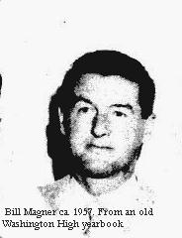
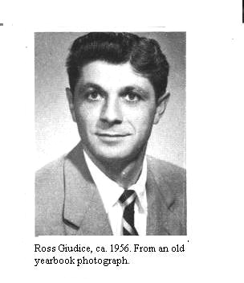
Amazingly, my freshman basketball coach, Ross Giudice, had the same kind of gift. Everything we did in practice we did for a reason. We did nothing just because the coach told us to. Giudice gave us reasons. We did everything, even the smallest things, because the USF way, from stopping on the court to shooting the ball, is the correct way—and here is why it is correct. We drilled repeatedly on each successive element. Everything, including the most basic fundamental, was thought out, and the whole system, offensive and defensive, was elegant. You come to a jump stop with your inside foot at exactly seventeen feet from the basket (not sixteen-ten or seventeen-two) so that your teammate coming around you has just enough room to get to the corner but not so much room that his defender can easily go with him. Moreover, if your inside foot is at seventeen feet, the forward on the other side of the court can watch your inside shoulder and make his cut across the lane when your shoulder starts to turn toward the basket. If the forward breaks on the turn of your shoulder, the spacing and timing will insure that he comes free on the low block for a lay-up. And by God, Giudice was right! It all made sense. More instinctive, gifted players probably felt restricted, held back, but it liberated me. Once I understood how everything fit together, I started to play basketball with a kind of joyful confidence that I had never before experienced in sports. And I got a lot better. I guess I was truly a student-athlete.
Similarly, Magner broke down hurdling into its successive stages. He measured everything. He measured me and calculated exactly how many inches behind the starting line I should place my blocks. He worked out several formulas for the placement of my feet in the blocks and the angles of my legs and knees. Then he ran a series of timed experiments to see which produced the fastest first step. He smoothed the dirt on the track and then measured my stride length on each of the eight steps to the first high hurdle and each of the three steps between hurdles. I got down on my hands and knees with him and his tape-measure, and I saw the spike marks where my stride was uneven and by how much. He explained to me the physics of arm and lead-leg action based on Newton’s laws of motion. He explained Bud Winter’s “loose-hands, loose-jaw” sprinting form. And he constantly insisted that when I mastered proper technique could I run relaxed and confidently explode down the track with the aggressiveness of a fullback or a 100-yard dash-man.
He also put me in the 220-yard low hurdles (30 inches high, twenty yards apart), not only to improve my hurdling and sprinting stamina but to force me to develop an even, consistent stride that would help me in the broad jump (today we call it the long jump). I practiced stretching those short legs into the longest stride I could manage over 220 yards, and my hips and pelvis screamed back at me in pain. He had me sprint down hills to lengthen my stride. But I had a clear understanding of why an even, consistent stride was crucial in the low hurdles and in the run-up to the broad-jump take-off board. You could calculate the exact length of your approach. If you had confidence in your stride, you could go at relaxed high speed without worrying about stepping over the board or short of it. Instead, you could concentrate on exploding into the air in the jump itself. He broke down the complicated technique of “walking in the air” in the broad jump by showing me training films and then freezing the picture at each stage while the two of us talked about what was going on with each movement. Through incessant repetition, I slowly got the feel of doing it right. Then I could perform the entire movement without thinking about each constituent element.
By the end of the season, I was running the college 120-yard high hurdles in 15 seconds, I’d broken 25 seconds in the 220 low hurdles, and I had gone over 21 feet in the broad jump—enormous improvements over my high school marks. Of course, I was older, bigger, and stronger as a college freshman than I had been as a high school senior, but the improvements were too substantial to attribute solely to maturation.
I had come under the tutelage of an exercise scientist, and in me he had encountered a willing—if not naturally an able—subject. If to my coach I was an interesting challenge combining physics, kinesiology, and psychology, to me the experience took on a different dimension. To be sure, I wanted to win competitions for dear old San Francisco, though I understood that my wins, and our team’s wins, would be pitifully scarce that season. And even more—though I kept the secret to myself--my prize was that green sweater emblazoned with the gold SF that would mark me as somebody on our little campus. In my past, I had always managed to become somebody important in my school, and the itch of ambition had accompanied me to college. I understood, of course, that despite our fame in the world of sports, being somebody at USF didn’t carry the same cachet in the great world of the Bay Area as being somebody at social-climbing California or ritzy Stanford. Our small, urban campus, though it sat on a hill, was neither graced by the Strawberry Canyon amid Berkeley hills nor shaded by the palm trees of Palo Alto; its buildings squatted around an asphalt parking lot shrouded in fog in the midst of our achingly beautiful city.
Ambition notwithstanding, however, at a deeper level this was an experiment in aesthetics. I kept silent about this idea, of course, not risking incomprehension from some of my acquaintances and derision from others. Nevertheless, I was excited by the possibility of the art form of athletics, the possibility that I, not blessed with natural beauty and instinctive grace, could somehow master a complex, demanding technique well enough to perform it beautifully, brain and body cooperating at full-throttle speed, feeling the exultation of hard running and smooth hurdling, facing disaster awaiting at every third stride yet skimming the barriers swiftly and cleanly, glimpsing and hearing on my left and right the music of muscle and speed and courage as seven fellow artists performed this ferocious dance on a stage that stretched for 120 yards. I supposed the thrill of such an experience might register with symphony musicians, dancers, and great ensemble actors, but it was not something an Irish-Catholic city boy talked about in the locker room, even with his English major friends. From Giudice and Magner I gained that year what no other coaches had ever given me: a sense of elegance and coherence in the kinesthetic world that I longed for but had hitherto had discovered only in the aesthetic world of poetry, the intellectual world of grammar and logic, and the spiritual world of the liturgy.

III
Magner’s surprise challenge during that spring track season involved basketball. And it asked him to adjust his whole way of thinking to an utterly new, unexpected situation. I had a part in it as well, as, I suppose, what would be called today “a participant-observer.” I watched how he handled it, and I learned. Like the broad jump, it had a long run-up, and that run-up involved what we now call March Madness.
March 1956 was an enormously exciting time for the entire city of San Francisco. In 1949, USF had become the first San Francisco team to win a national championship of any kind when it won the then-highly-prestigious National Invitation Tournament in basketball. Six years later, USF won the 1955 NCAA basketball championship, and this year the undefeated team had set a new record for consecutive wins. The idea of successive national championships was heady wine indeed for the people of the Bay Area—everyone seemed to be talking about it--but particularly for what we grandly called “The City.” The crucial tests were beginning: the NCAA play-offs, with the Far West Regional tournament at Oregon State, in Corvallis, Oregon—600 miles from San Francisco. Our freshman season had ended, of course, but I had been so closely involved with all the players and the coaches that I desperately wanted to see the tournament. (Televised events were rare.) These were my friends, not some entertainers hired by the university. I couldn’t consider myself “just a fan.”
Alas, I was short of cash, and on the following Monday I had a paper due for Father John McGloin’s history class. But I played the trumpet, and my trumpet would get me to Oregon. I talked a buddy who played in the USF pep-band into letting me sit in with the band at the tournament. I cashed a savings bond I had received for high-school graduation and bought a one-way, overnight, Greyhound ticket. Aboard the bus, I worked all night on the paper, got to Corvallis, bummed a bunk at an Oregon State frat house, played in the band during USF’s dramatic victories over UCLA and Utah, sneaked onto the chartered train hauling the booster club back down the coast to San Francisco, hid from the conductors, and submitted my paper Monday morning. Quite a weekend; knowing that I couldn’t go to Illinois, I had crammed as much as possible into three days in Oregon.
Though a few students hocked just about everything they owned to scrape up the money for the trip across the country to the Final Four tournament at Northwestern University, most of us crowded around our radios in San Francisco to listen as USF ran past Southern Methodist in the semi-final game, 86-68. But we agonized at the start of the championship game when USF fell behind the Big Ten champion, Iowa, 15-4. Would the great green balloon burst after all? Then we danced and hooted as the Dons attacked Iowa with USF’s terrifying full-court press. Bill Russell blocked three consecutive shots, and USF eventually pulled away to win, 83-71. Russell scored 26 points, snagged 27 rebounds, and blocked 12 shots in that game. Phelan Hall dormitory, and later the streets of San Francisco, were arenas for much merriment that evening.
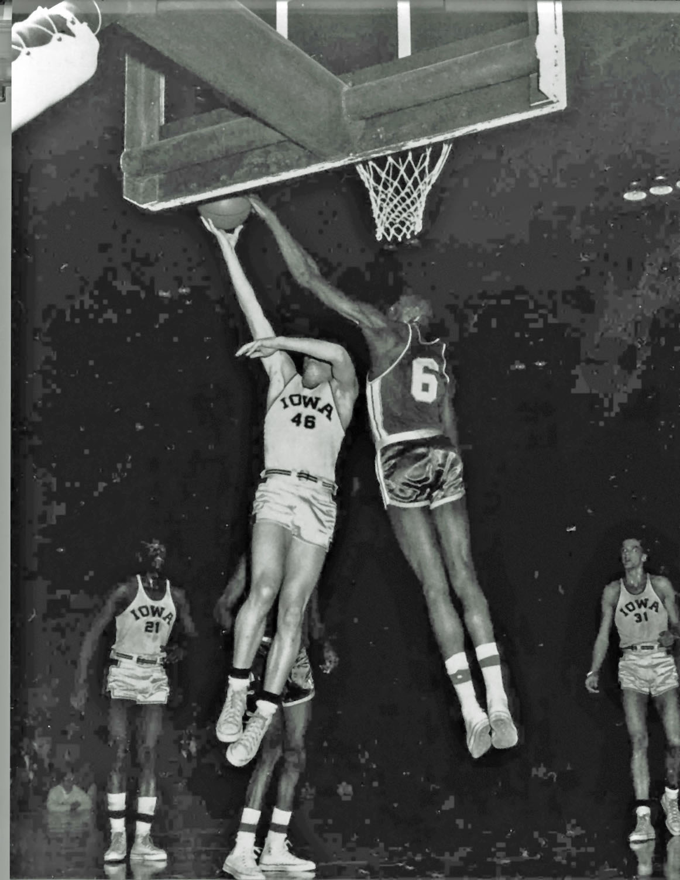
Bill Russell (6) making one of his 12 blocks, 1956 national championship game. He also scored 26 points and took down 27 rebounds. The rebound total still stands as the NCAA final game record.

The excitement in San Francisco continued for a couple of weeks. I wangled a ride in a convertible during the ticker-tape parade downtown, pretending to be a star and waving like a maniac to the crowds on the streets and in the office buildings, but I knew that reality awaited me and that I also had to shift my focus to the track team.
Our first meet was in April, a Saturday-night triangular at Davis, California, just outside Sacramento. We competed in the valley’s heat against the University of California, Davis, and Humboldt State College. Humboldt won, and we finished a distant third, with our only first place earned by our discus thrower, Leon Renauld. I loved running in the hot weather, and I surprised myself by doing pretty well in the high and low hurdles. But it was clear that we didn’t have the numbers or the talent to challenge anybody in a serious way.
On Monday afternoon, however, our numbers increased a little, and our talent increased exponentially. When we gathered for practice at St. Ignatius track, Magner called us all together in the infield.
“Well, fellows,” he said, “I have some news, and I need your opinion.” My buddy Tim O’Leary and I exchanged puzzled, sidelong glances. What is this all about?
“Bill Russell would like to come out for the team.”
It took me a moment to comprehend what Magner had said. Then I sprang to my feet and punched my fist at the air.
“Yes! Yes! Yes!” I screamed. “This is great! Just great!”
“Wait,” Coach Magner said, “there’s more to it. He was on the last track team USF had, back when he was a sophomore, and he learned something about high jumping. He says that he is willing to jump in meets, but he believes he is just too worn out from basketball to come to track practice. He’s been going to basketball practice every day since October, he had to play in the post-season All-Star games, and he just got back from the basketball Olympic trials. He needs time to rest and to catch up on his class work, and he has a part-time job in the afternoons. He said he loves high jumping and running, but not if it turns into a job. He wants to do it for fun. I told him that I would have to check with the team to see if they would agree to this arrangement. It’s up to you men.”
I was still standing. I said, “Look. I played basketball against him all season. He is in terrific shape. He is an unbelievable jumper. He can outrun anybody. Even if he doesn’t come to practice, with him we’re going to be better than we are. Besides, a chance to be on the same team with Bill Russell? He was just named national player of the year. This is one of the greatest athletes in the world. I don’t care if he doesn’t come to practice. We’ve got nothing to lose. Let’s do it!”
By this time everybody was up and jumping around in a babble of voices.
“I take it,” said Magner, “that the answer is yes. By the way, two other basketball players are coming out—and they are willing to practice. Mike Preaseau and Jack King will be here this afternoon.”
“Mike Preaseau!” I yelled. "He’s six-five! And King is really fast! What are Preaseau’s events?”
“He’s also a high jumper. He tells me he regularly jumped over six feet in high school.”
“Wow!” I yelped. “We already have two six-foot high jumpers on the team, and now we will be great in the high jump.” (I had cleared six feet, and our teammate Bob Durkee had also been a six-foot high jumper at Bellarmine Prep.) “This is just terrific.”
And suddenly our woebegone little track team was a lead item on the sports pages of the San Francisco dailies, the Examiner, the News, the Call-Bulletin, and the Chronicle. BILL RUSSELL TO HIGH JUMP FOR USF.
IV
We became more of an item on April 22 when Russell showed up across town at San Francisco State College for his first meet, a triangular with San Francisco State, USF, and Cal Poly. Tim O’Leary and I were there early, warming up on the thick turf of the infield at State’s beautiful Cox Stadium. We recognized the sports reporters from the newspapers. They had been around every day during basketball season. But we didn’t recognize some of the other men standing around the track, chatting and taking notes as the athletes began to gather in the corners of the infield. They all had stopwatches bobbing on their chests like pendants on a necklace. And some spectators were taking seats in the stands. Our first meet had drawn parents, a few buddies, and some girl friends of the athletes. Nobody else cared very much. This competition looked and felt different.
Suddenly, all those men in suits began trotting toward a gate at the far end of the track, and we all stopped and turned to see what was happening. Walking through the gate was William Felton Russell and his best friend and dorm roommate, K. C. Jones.
Russ had an unerring sense of the dramatic, and K. C., always deadpan, always aware of everything happening around him, and always quietly amused, played along with Russell’s theatrics. Russell showed up in an outfit calculated to draw attention and demoralize all opponents. I loped to the gate and looked him over from top to bottom. At the top of his six-feet, ten-inch body he wore a hat we called a “rooter’s cap”: it looked like the kind of golf cap Ben Hogan wore, or one worn by a stevedore down on the San Francisco docks, but it was in the school colors: deep green with gold stripes; it had a little gold button on the top and a short, green-and-gold striped visor. Then came the sunglasses. And then, draped languorously round his neck, the longest woolen scarf I had ever seen—also green and gold. It swept down across the chest of his green varsity letter-jacket, the one with the gold leather sleeves, the USF stitched across the right chest, and stitched above it the huge red-white-and-blue chenille shield, patterned after the American flag, boldly proclaiming in fancy lettering:

NCAA
Basketball
Champions
He was wearing USF green sweat pants—a bit short—and basketball shoes. In his hand he carried a small green equipment bag and his black, size-fifteen track spikes. K. C. was hatless. He also wore his green-and-gold letter jacket with the big NCAA emblem, but otherwise he was dressed in the standard student uniform of blue jeans and gym shoes. Bill had arrived at Cox Stadium ready to have some fun, to run and jump just for the hell of it, and had dressed appropriately for the occasion. Everything had stopped as he made his grand entrance. All the athletes from USF, SF State and Cal Poly had drifted down toward the gate to see why such a crowd had gathered there.
Except one. I had been in the high jump area, and as I trotted over to see Russell I noticed a short, slender, black fellow from SF State ignoring the whole circus and remaining in the high jump area, where he continued his stretching exercises. The guy looked awfully familiar somehow, but I was more interested in greeting my new teammate to think about where I had seen him before. And out of the corner of my eye I saw Coach Magner, standing alone in the middle of the infield. He had a clipboard and some papers, and after looking up at the commotion, he dropped his eyes again and studied the papers on the clipboard.
Because the first event was the 120-yard high hurdles, I had to stop being a spectator and get warmed up to run. So I couldn’t eavesdrop on the conversation Russell and Magner held over in the area near the fence where our small team had placed its gear and organized our “bullpen.” But as the meet announcer was making the calls for the hurdles, Magner assembled us and told us that Russ wanted to enter the broad jump and the javelin as well as the high jump. All these events would get underway very shortly. I was in the broad jump and not the high jump, but my main focus was on the hurdle race just ahead.
I did okay in the high hurdles. Didn’t win, but got a point for the team. Then I went over to the broad jump runway, took some run-throughs, and waited for my name to be called. I was pretty nervous, but I got off a fair jump and reached twenty feet. Then the broad jump official said, “Russell, USF.”
Russell unwound himself, took off his cap, jacket, and sweatpants, and stood at the end of the runway in his shorts and singlet, the tallest person I had ever seen in a track uniform. My eyes went first to those lean legs, with the musculature powerfully defined like black cables. I then looked at his face. I had seen that look before. It was his business look. The game is on, and there is no more screwing around. Suddenly, he dropped his head and shoulders and took off down the runway. I have had it in my head for years that I counted his strides, and he took only nine to reach the take-off board. That seems impossible, but that is what I remember. I do know that he did not reach the take-off board. His jumping foot landed at least a foot behind it, so he jumped anyhow. The official measured the jump from the board at just over 22 feet, six-and-one-half-inches. Russell could see in the runway the mark his spikes had made at takeoff, so he asked the official to measure the jump from those spike marks just to see how far he had actually gone. Officials are ordinarily very reluctant to take such unofficial measurements and aren’t really permitted to do so, but all the track writers also wanted to know. The officials stretched the tape out to 23’-7” from take-off to landing. It was his first broad jump in two years, and—though unofficial—his jump of 23’-7” was one of the young season’s best in the USA. He had no form in particular; he just flung himself into the air and stretched out those legs on his landing. Nobody today was going to beat his mark. A first place for USF. I was delighted, but I wasn’t absolutely surprised.
I could hardly wait to learn what he would do in the high jump. I had heard stories that he had won a bet for K. C. Jones, who had said that Russell could touch the top of the backboard. Somebody got a ladder and put a quarter on the top. Russell started at the free-throw line, bounded to the backboard, launched himself high above the rim, and plucked off the quarter. Landing, he cut loose with his shrieking cackle of a laugh and flipped the quarter to Jones, who smiled dryly and shrugged as if to say “I told you so.” I had seen him practice jumping straight up so that his eyes were above the ten-foot rim, and I had seen him kick high enough to touch the net with his foot, so I was prepared to believe the stories about the bet. But even with this inside information about his spring, I was astonished at what happened next.
The officials started the jumping at 5’6,” and when Russell, again wearing his cap, jacket, scarf, and basketball shoes, sat on a blanket just beyond the apron of the high jump area. When the marshal called his name, he unfurled himself, strolled to the edge of the apron, paused for two or three beats, and then, scarf trailing behind, loped to the bar and hopped over it into the landing pit of wood shavings and sand the way you or I would hop over a stone on the side of the road. Carefully brushing off the wood shavings from his sweatpants and scarf, he walked majestically back to his place. His face was absolutely expressionless, as if he had just done nothing more unusual than getting in or out of a car. The other jumpers, for whom 6’ would mark a considerable achievement, exchanged glances. It was a vintage Russell mind-game. I had seen him mess with the heads of many basketball players, and I knew immediately that he had already defeated his jumping competitors mentally. It was just a matter of time today before he beat them physically.
Except for one—the skinny, short guy representing San Francisco State. He was stripped down to his track uniform, and I could see then that he was more slender than skinny, with leg muscles like twisted rope. But he was really short. When the marshal called his name, he walked from the right side of the apron to the bar, eyed it, and then turned his back on it and walked carefully back to a mark he had placed in the grass far beyond the apron. He had to glance up to see the bar, set at 5’6”. Suddenly, his name registered with me, and I realized why he had seemed familiar. His name was Mathis. He was the college student who was getting written up in Herb Caen’s column in the San Francisco Chronicle as a spectacular new pop singing star at Ann’s 440 Club in North Beach. And I remembered that I had seen this pre-jump routine before. As a sophomore in high school I had seen him jump when he was a senior at George Washington.
These memories coalesced, and I whispered to Mike Preaseau, “That’s Johnny Mathis. This guy is good.”
“He can’t stand more than five-seven,” Preaseau said. “He has to start off jumping over his head--or right at his own height.”
“Just watch,” I whispered. “I’ve seen him jump before.”
Mathis took a deep breath and then began the fastest, longest run-up to the bar that I had ever seen. He sprinted to his take-off point, nailed it perfectly, and snapped up and over the bar in absolutely flawless “straddle” form, landing lightly in the wood-shavings and bouncing out of the pit with a regal air.
I looked over at Russell. He was grinning broadly and nodding his head with the kind of admiration one artist reserves for another. I had a hunch that we were in for quite an afternoon.
By the third round, only four jumpers remained: Russell, Mathis, Preaseau, and a good Cal Poly jumper named Sullivan. Russell had removed the scarf and jacket at 5’8”, the cap and sweatpants at 5’10”; he had cleared all three heights on his first jump. As he progressed, his form changed from the “hop” at 5’6” to something resembling the traditional, and at that time still widely-used, “western roll.” In the classic western roll, the jumper approaches from a 45-degree angle, leaps at the bar with a lead-leg in a high, kicking motion, and clears the bar by turning to the side and snapping the take-off leg up under the straight lead leg in a bent position, with the hands and shoulders folded against the body almost in an attitude of prayer, as the body rolls over and clears the bar. The jumper lands face-down, breaking the fall in the pit of wood-shavings and sand with the hands and arms. (Big rubber landing mats—and with them the possibility of flopping over the bar backwards—came along much later.) Russell, however, kept both the lead-leg and trail-leg bent, and he looked more as if he sailed over the bar than rolled over it. It was a western roll of sorts, but it got him cleanly over the bar.
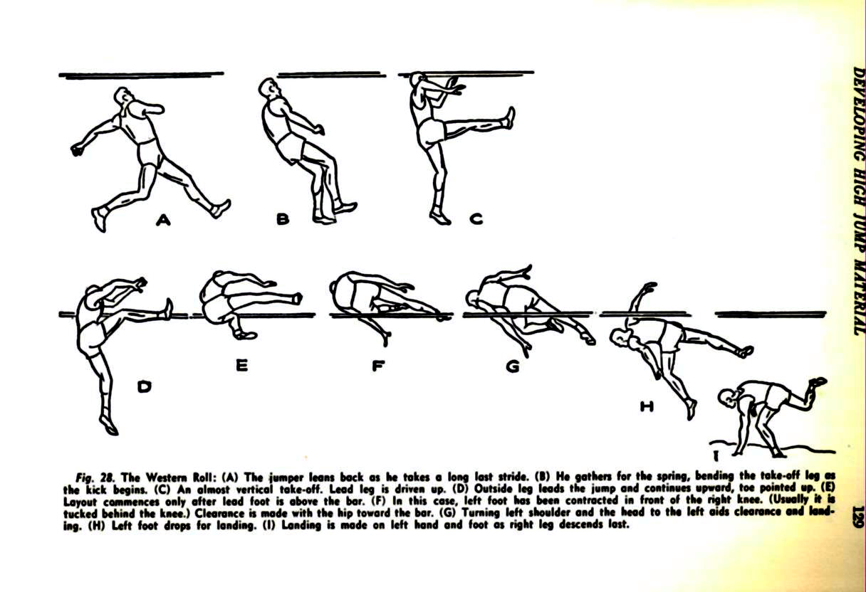
Line drawing from Brother G. Luke, FSC, Coaching High School Track and Field, Englewood Cliffs, N. J (Prentice Hall, 1958)

Preaseau, Sullivan, and Mathis used the newer “straddle,” or “belly-roll” technique. The name suggests the way the jumper looks going over the bar, turning face down on it, straddling it in the air with one leg on each side, and then lifting the trail-leg as the body rolls over the bar and into the pit, landing more on the jumper’s side or back than on the hands and knees. Jumpers around the world had found it more efficient than the western roll, and increasingly it replaced the western roll. Preaseau and Sullivan were good at it, Mathis superb. I had never seen better technique, except for the long, sprinting run-up, and since then the only technique I have seen to match it was that of the great Soviet athlete and world record holder, Valery Brumel.

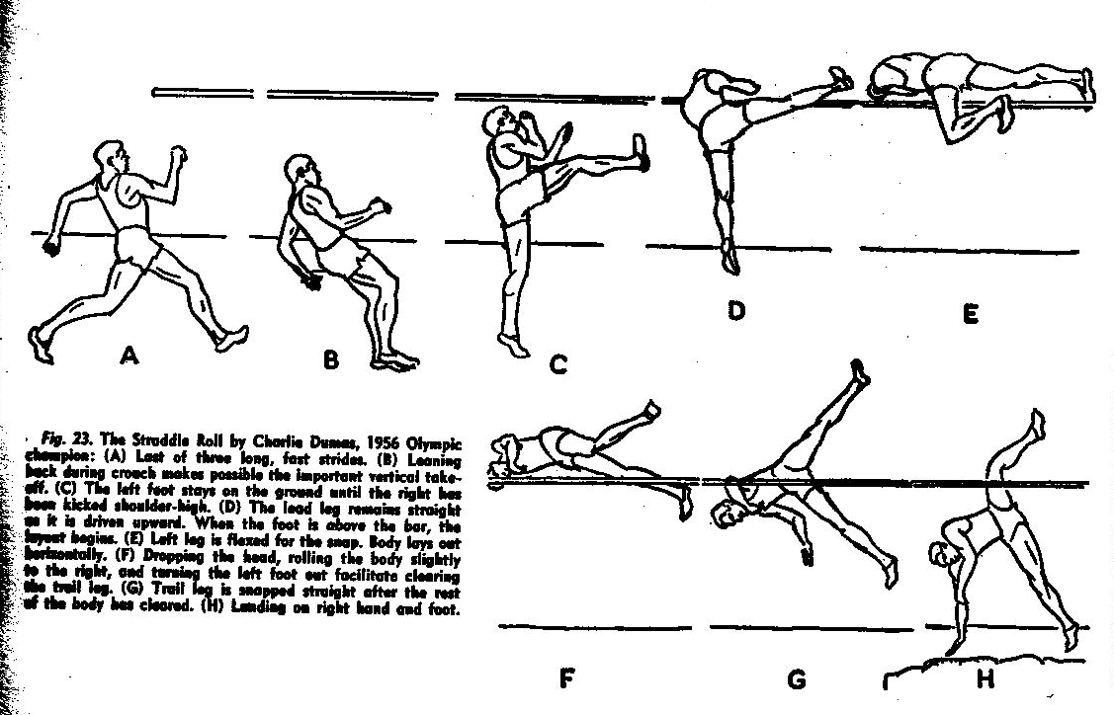
Line drawing from Brother G. Luke, FSC, Coaching High School Track and Field, Englewood Cliffs, N. J (Prentice Hall, 1958)

They raised the height to 6’0.” Russell sailed over again. Mathis, now jumping five inches over his head, ticked the bar but cleared it. Sullivan and Preaseau made it on their third, final attempts. The official raised the bar an inch. Mathis, then jumping with no shoe on his lead leg, just nicked the bar all three times, but it fell each time. He finished, having barely missed six-one (an off-day for him (the previous year he had reached 6-5 ½), and I was shaking my head in wonderment as I saw him jump nearly half-a-foot higher than his head. Sullivan and Preaseau, a rangy six-feet, five inches in height, got over 6’1” but couldn’t manage 6’2”.
That left Russell alone, having won the competition but by no means through for the day. He was warmed up and rolling, so he told the marshals to raise the bar two inches. He made 6’4” and asked for two inches more. He made 6’6”. Then two inches more. By now everyone not involved in a race had congregated around the high jump, for the word had spread that Russell was going for 6’8” and closing in on Walt Davis’s world record. Three years earlier, Davis, jumping for the Santa Clara Valley Youth Village AAU team, had come excruciatingly close to the magic mark of seven feet when he had leaped 6’11 ½”. Nobody had ever officially jumped seven feet, and until Davis nobody had come that close. We all knew that during the past couple of years the seemingly impossible marks had started to tumble: Roger Bannister had run a mile under four minutes; Parry O’Brien had put the shot more than sixty feet. Maybe in some major meet this year Davis would climb that extra half-inch to set a new record and conquer the seven-foot barrier. Nobody expected a little small-college track meet in April to produce a threat to the world record—indeed a challenge to the magical seven-foot high jump—but this was getting serious. Maybe it would happen today.
I crouched down at the edge of the high jump area, slightly behind and slightly to the right of the landing pit. I could see his eyes as he gauged the height and distance, and I saw that look. Russ was out for an afternoon’s fun and exercise, but he wanted this one. Then he was coming at the bar, bounding toward the take-off area. As soon as I saw him spring, I thought, “Too far away from the bar.” As a western -roll jumper myself, I was sure he would reach the peak of the jump in front of the bar and hit it on the way down. He was too far away; he did reach the peak in front; but he did not hit it on the way down. I gasped as I saw his hips clear the bar on a downward plane and clear by at least the width of a fist. He came sailing over, right at me, and he landed in a spray of wood-shavings. Everybody started clapping and jumping up and down. My Lord, I saw the daylight in his clearance, and it wasn’t even close.
Realizing that if Russell kept going that way, he could break the world record and they would need careful certification, the meet officials had huddled before that jump and had assembled several tape-measures. Russell wanted to go immediately for 6’10”, and I felt sure that if he cleared that height he would ask to have the bar raised to seven feet so that he could try both for a new world’s record and for the first seven-foot jump. But the officials decided at this point that they needed to take exact measurements. Russell stood off to the side with K. C. Jones, and I walked over there in time to hear him tell K. C. that he didn’t know how many jumps he had left in his leg, for he thought that he had bruised his heel on his take-off foot when he had made his winning broad jump. While they were talking, a sportswriter measured the distance from Russell’s take-off spot to the high jump standards and found that he had started his jump twelve feet away! Just then, after some fussing and consultation, the marshal announced that a couple of tapings had revealed that although the high-jump standards indicated 6’8”, the bar at the center point between the uprights measured 6’6”. Everybody’s spirits sank. The momentum had been arrested, and I thought perhaps Russ would call it a day right there.
Instead, he asked to have the height raised two inches. He came close on three tries, but in each he did take off too far away, and he nudged it off the standards on his downward flight.
Sportswriters surrounded him, astonished that a man who had neither practiced nor competed in years could show up and turn in a world-class performance such as we had just seen. While this was going on, K. C. Jones and Johnny Mathis had met on the high-jump apron. When the sportswriters finished, Russell came over to Jones and Mathis to shake Mathis’s hand, and I saw Johnny Mathis at 5’7”, K. C. Jones at 6’1”, and Bill Russell at 6’10” forming a terraced gallery of all-stars. Mathis would go on to hold the Far West Conference high jump record at 6’5 1/2” and become a singing sensation, his vocal technique as pure and stylish as his straddle jumping form. Jones and Russell would win Olympic gold medals, strings of NBA championships, and places in the basketball Hall of Fame. They all came together on a cool April day in San Francisco, and I was an eighteen-year-old kid lucky enough to be there.
V
It was great fun the next day to spread out the Sunday San Francisco newspapers and find that we had made front-page news in the sports sections of the Chronicle and the Examiner. Darrell Wilson of the Chronicle opened his story this way: “Bill Russell, the nation’s basketball Player of the Year for 1955-56 at USF, walked on the track yesterday for the first time in two years and gave indication that he may be the high jumper of the century.” I read on: “After the meet, experts concluded that Russell stands only some practice sessions away from becoming the first jumper in history to clear seven feet. This is the big barrier for leapers, and the first man to reach it will always be remembered.” Once again, I thought, I’m the barnacle on the side of the flagship, and this is a ride I am going to enjoy taking. The San Francisco State coach, Ray Kaufman, told Wilson, “It’s hard to conceive that a man can have as much spring as Russell. I feel sure that with practice the seven foot mark is within his reach. I think he would have gone 6’10” if he had had a few sessions under Bill Magner.”
I smiled as I read that line. I could imagine Magner watching Russell’s performance and taking mental notes on smoothing out that approach, locating the perfect take-off point, getting Russell to straighten his lead-leg at the top of his jump and to roll over the bar instead of sailing over like an immense Frisbee. Just give the coach a solid week with this material and watch what happens. But Russell had made it clear that he didn’t want practice sessions. He would have to come to Magner for help, and I wasn’t sure that he would ask.
He did ask. We had a meet scheduled for Friday in Stockton against the College of the Pacific, and on Monday Russell showed up for practice. I knew how good Magner was, and I knew that his teaching methods would appeal to Russell, a very cerebral man who responded to logic. But Magner never got his chance. After Russell took two or three warm-up jumps, I could see that he was favoring his heel. That bruise had gone deep into the tissue, down to the bone. It was pointless to continue and risk aggravating it. Russell and Magner agreed to try again at the meet on Friday; in the meantime, Magner would get Russell a protective plastic heel cup to wear in his shoe when he jumped. And we got some more bad news: at the meet on Saturday, our 440-man, Tim O’Leary, had suffered a torn groin muscle and was lost for the season.
We awoke on Friday to a wild Pacific storm screaming in across Ocean Beach—the sort of day you don’t see on the San Francisco travel posters. The meet was postponed and rescheduled for St. Ignatius track the next Monday afternoon as part of a triangular with Nevada. That gave Russell’s heel a little more rest—and it transferred the meet to San Francisco, where the press coverage would be enormous. Unfortunately, it also transferred it to the worst facilities in the city. The SI high jump area was a mess. The approach area was loose and slippery, and the landing pit was so beaten down by wind, fog, and rain that landing in it was like falling off your bike onto the pavement. I hated jumping there, and I worried that the conditions, plus his bad heel, would burst the great balloon of excitement about Russell and send everyone away disappointed.
I was dead wrong. Even on a lousy surface and against a cold, strong wind, Russell cleared 6’8” and won the competition. Then he decided to go for the record. I took my crouched position toward the back of the landing pit to watch him take his three tries at 6’10”. On all three, he took off too far out, reached his highest point ahead of the bar, and just nicked it on the way down. Officially, they were misses. But I know that on that afternoon, I looked up and saw the first seven-foot high jump in competition. He was six inches above the bar before brushing it with his ankle on the way down. After his final jump, he scrambled out of the pit and called to K. C. Jones,
“Where do we go next?”
“To San Jose on Saturday for the big All-Comers meet,” K. C. replied.
“Good!” said Russell. “Now let’s go get a banana split.”
The newspapers loved that by-play between two All-Americans. The next day, pictures of Russell’s jump made the front page of the sports section, along with some other news: on the same afternoon as the meet, the pros had drafted Bill Russell and K. C. Jones for the National Basketball Association. It was a good day for me as well. I won the broad jump and took second in the high hurdles. I was on my way to earning enough points for a varsity letter.
(Scroll down for picture.)
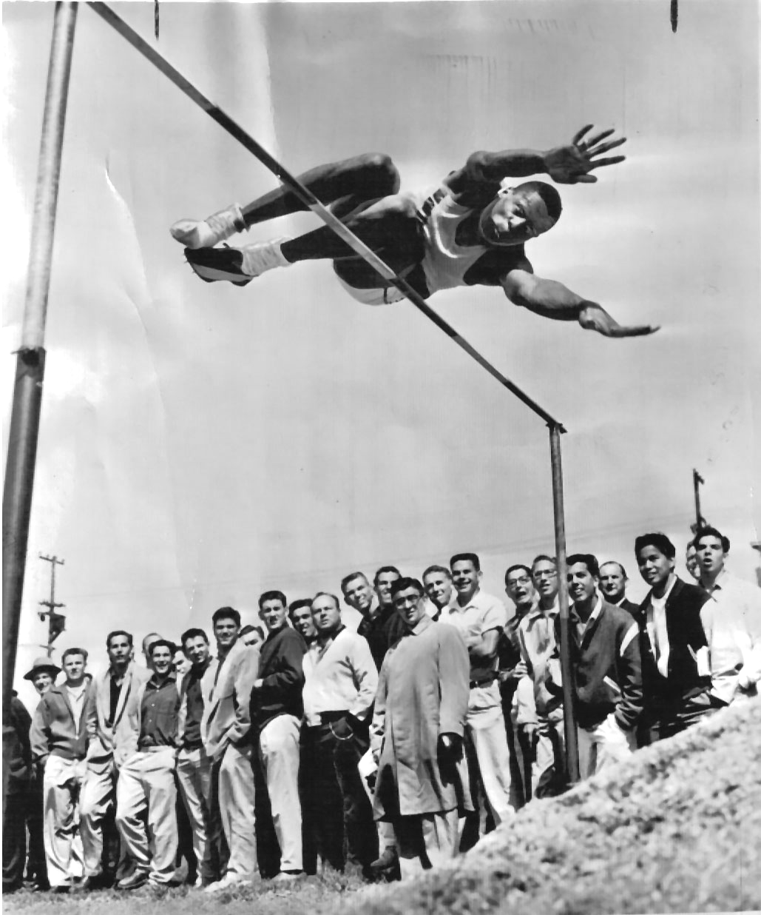
Bill Russell, USF, vs. University of Nevada & College of the Pacific, April 1956. St. Ignatius High School Stadium, San Francisco, California

Suddenly the season shifted. Little local meets be damned; all the promoters wanted Russell at the major meets, the world-class competitions leading to the Olympic Trials that summer. The top performers in the nation would gather at five of them in California during the coming few weeks: the All-Comers at San Jose State on May 5; the Fresno Relays on May 12; the Modesto Relays on May 26; the NCAA national collegiate championships on June 22; and the Olympic Trials on June 29.
At San Jose, Bill Magner decided to see what I had learned from him, and he surprised me by entering me in the 100-yard dash as well as the high hurdles, the broad jump, and the 220-yard low hurdles. I was to face major college and Olympic caliber competition for the first time. I got smoked, but in all these events I set personal records, running the 100 in 10.2, more than a half-second faster than ever before. I reached 21’1” in the broad jump, for my first time over 20’6”; Magner clocked me in the high hurdles at 14.8, a full second better than my previous best, and he timed me in the 220 hurdles in 24.9, beating my previous time by a second. One second, or even five-tenths, doesn’t sound like much, but for me those marks were enormously encouraging. Magner was busy with the Russell hoopla, but he took time to praise the progress I had made, and that little pat on the back was plenty for me. Russell, against three of the world’s best jumpers, took second place at 6’6”. His heel obviously bothered him, but I knew he would not let the pain stop him.
It wasn’t the pain that threatened to stop him. It was the racism. Early on the morning of May 10, I was sitting in the Green-and-Gold Room with my basketball teammate and close friend, Bernie Schneider. He was reading over his notes before our eight o’clock class; I was reading the green pages of the Chronicle sports section. Suddenly, I gasped and croaked to Bernie, “Bern, listen to this! Russ might not jump at Fresno on Saturday!”
“Is his heel acting up?” Bernie asked, still paging through his notebook.
“No. It says here that he has been flooded with poison-pen letters since the Chronicle ran those pictures of him last week. One guy wrote him and said he looked like a goat. I thought our basketball success would shut these bigots up, but they are getting to him. It looks as if he is going to quit the team.”
Bernie looked up from his notes. I saw on his face that look he has when somebody says something especially stupid. “You know Russell better than that.”

“But it says here . . . “
“Forget what it says there. Think. What always happens when you make Russell mad?”
“He destroys you.”
“Well, these idiots have made Russell mad. He is going to Fresno, and he will kick some butt. Relax.”
“I sure hope you’re right.”
“Of course I’m right. This is Bill Russell we are talking about.”
And we went off to class together.
Bernie was right, as he usually was. There was no point sending me to Fresno, but Russell went, took on Charles Dumas, the top jumper in the world, and pushed him to 6’9 ¼”. It was the best high jump in the United States up to that point in the season. After both had cleared that height, Dumas wanted to call it a tie, but Russell said, “What the heck. Let’s reach for the sky,” and asked the officials to set the bar at seven feet. I read the newspaper report the next day. Dumas missed badly on all three tries. “Russell,” the story said, “just nicked the bar with his knee on the way down on his first two tries, and he was over on his third try, but ticked the bar with his ankle after his body had passed over.” The bar shuddered, almost stayed up, and then fell into the pit. So much for quitting; so much for looking like a goat.
Our last USF meet was on May 19 against some AAU teams and service teams. I placed in the broad jump and both hurdles, and thus my personal season came to an end. I thought I had scored enough points to earn a letter, but I wasn’t sure. Russell went on to compete against Dumas at Modesto, jumping 6’6” to take second, but his heel clearly hampered him, and he couldn’t practice. I could only imagine the frustration Bill Magner must have felt. It seemed to me that the gods of sport were capriciously toying with him. Having given him this rag-tag collection of mediocrities, they then surprised him by sending him exactly the sort of once-in-a-lifetime talent every coach dreams of. But the hero they sent was Achilles, the guy with the bum heel. Russell never got the chance to bear down extensively with Magner, and Magner never had the chance to tutor Russell the way he had tutored me. It was catch-as-catch-can, with competitions piling up just a few days apart. Still, Russell competed. He took third at 6’6 ¼” at the Compton Relays on June 1, won at 6’8” at the Pacific AAU meet on June 2, and won again at 6’8” at the California AAU championships on June 10. Would he compete in the NCAA championships and the Olympic Trials?
The answer was no. The State Department had scheduled the USF basketball team for a good-will exhibition tour through Latin America beginning June 15. Russell said that he could not abandon his teammates in order to compete in an individual event. He had joined the track team just for fun and—here my heart skipped a beat—because he wanted a USF letter in track and the cardigan-style sweater that went with it. All his other letter-sweaters were V-neck. Despite his sore heel he had had an enormously good time competing against the world’s best, and he had scored enough points for a letter. As for the Olympic trials, he told the press that since he had already made the Olympic basketball team, it would not be fair for him to take a place on the track and field team away from another worthy competitor. So he would not try to return to the USA from South America in order to participate in the trials.
At the Olympic Trials in the Los Angeles Coliseum on June 29, 1956, Charles Dumas jumped 7’ ½” to set a new world record and become the first to clear seven feet. That night, Bill Russell was playing exhibition basketball outdoors in the rain on a court set up at the center of the Santa Maria Bull Ring in Bogota, Colombia. I read about it in the Chronicle. I was in the Sierra Nevada Mountains, working in the dining hall at a family camp run by the city of San Francisco. The paper also brought me the news that USF was again dropping track and field. Bill Magner would return to his teaching position at George Washington High School. It had been a one-shot deal, and he believed that the interest and talent did not warrant his continuing at the university. But he took this memory with him: at the end of the summer, Russell’s performance against Dumas had held up as the third-best American mark of the year.
My summer job kept me away from home until just after Labor Day. My parents had stacked my accumulated mail on my desk in my bedroom. Going through the letters there, I found one from the University of San Francisco notifying me that I had made the President’s Academic Honor Roll for both semesters. I also found a package from the Athletics Department. In it there was a large, gold, Block SF. I never did buy the sweater. I figured I’d look foolish walking around campus wearing a sweater with a letter from a sport that didn’t exist any longer. I had to find other ways to become a Big Man on Campus. Maybe earn a 4.00 grade-point-average.
But I kept the SF. It’s is in a box somewhere in my garage; I brought it with me to Minnesota forty years ago. I’ve carried that box around with me all these years, stashing it in the rafters wherever we have lived, here and there. I suppose the box and the story it triggers exemplifies a pathetic, adolescent, male fantasy life that I cannot quite surrender. Or maybe the unconscious displacement of libidinal energy. Or maybe a class-based grudge about lacking the funds for a fancy college. Maybe sentimental nostalgia for the mythical innocence of the 1950s, when athletes were actually students. I acknowledge all that. Of course, I would rather consider them what Hawthorne would call a lively emblem of some important lessons I learned about myself that year—or thought I did.
And I’ve carried those lessons about my own learning into my career as a teacher. Facing 285 students in an auditorium day after day or a dozen brilliant Ph. D. candidates in a weekly graduate seminar, each semester I have to produce a fifteen-week series of top-flight performances. I have learned that for me, great performances in the lecture hall or in the classroom, like those on the track, require a special mixture of high energy and relaxed assurance deriving from proper technique based upon hard-won mastery of the subject. Moreover, I see now that I think and learn like a structuralist—I need to find the underlying principles, the logic beneath the surface, the grammar of life, physical or conceptual. Without the structure, I’m lost; I flounder. When I present my subject to students, I know that inevitably I teach the way I learn, stressing the structures, the patient unfolding of the architectural principles undergirding texts and ideas. Yet those intense adventures of the young man also showed me that not everybody operates the way I do. You must not reward only those whose style suits your own and penalize the others. Experience has given me a high regard—maybe some envy--for those individual geniuses I’ve sometimes known and occasionally taught who say, “What the heck; let’s reach for the sky,” transcending the grammar and soaring along on prodigious daring, imagination, and sheer intuitive talent. Like Bill Magner with Bill Russell, I try to give them their head and let them be great.
And I have also carried this story around with me. Having finally written it out now, maybe I’m ready to dig a little, find that box, and look again at that big SF. I wonder if Bill Russell ever got his. I wonder if he kept it in a box somewhere—maybe near his Olympic gold medal, his eleven NBA championship rings, and his Boston Celtics jacket.
Probably not.

EPILOGUE
Years later, an item in the student newspaper once again put me in touch with Bill Russell. This time, the paper was the University of Minnesota Daily. One September day in the late 1970s, I was in my Lind Hall office preparing for the fall quarter when I opened the Daily and spotted the schedule of events for “Welcome Week,” the University‘s orientation program for new students. Noticing that Russell would speak at Northrop Auditorium that week, I immediately penciled the event on my calendar and planned to attend his talk. Russell had gained legendary fame as a superstar player and coach for the Boston Celtics, but he had also become increasingly prominent as a civil-rights activist. I had followed his career since my USF days, but only at a distance. I admired his athletic skills and his leadership, and his social activism impressed me, but after college, marriage, fatherhood (thrice), nearly three years in West Germany as an Army artillery officer during the Berlin crisis, four years of stressful study at a high-powered graduate school, a pyrotechnic year as a visiting professor at Stanford during persistent campus violence, and recently a dozen years getting tenured and teaching and writing at the nation’s largest urban university, I was at that point far beyond adolescent hero-worship. I was genuinely curious about what he might say, but that was about the extent of it. Welcome Week merely gave me a convenient opportunity.
I had seen him in person only once after he departed USF on his way to fame as a player in the Olympics and as a professional player and coach. During my last year of Ph. D. work at Stanford, I left Palo Alto for three months (reluctantly abandoning my wife there to cope with our three infant daughters!) and plunged into dissertation research at the Harvard libraries and other repositories in the Boston area. In Cambridge, I rented a room to sleep in but otherwise lived in the Widener stacks or in the Houghton manuscript collections. One freezing-drizzle night, however, bone-weary of eighteenth-century documents, I treated myself to a subway ride into Boston and a ticket to a Celtics game. Swept along with thousands of fans, I made my way from the “T” stop into the cheap seats at the top of the creaky Boston Garden and watched from afar as Russell and K. C. Jones worked together for a Boston victory the way they had worked together years before at Kezar Pavilion in San Francisco. Other than that night at the Garden, I had seen Russell only on television—both in Celtic games and on the evening news as a prominent activist in the Civil Rights movement. As I swayed from the subway strap on the crowded Red Line train back to Cambridge after the game, I thought briefly that I might have maneuvered my way to the players’ entrance at the Garden on the chance I could talk with Russell and Jones, but I hadn’t seen the value of making the effort. They wouldn’t have known me from the Man in the Moon, and I was very tired.
But this was a decade later, and I was curious about what message Bill Russell would bring to these young men and women just out of Minnesota high schools. I arrived early at ponderous but stately Northrop Auditorium and took a seat on the aisle, about halfway from the stage. Russell had drawn a big crowd, but it wasn’t like Boston Garden. The people filling the nearby seats to hear this famous Black man were young college freshmen and transfer students, overwhelmingly Midwestern, white, and Nordic, some of them urban but many products of a prairie world as remote from Oakland, San Francisco, and Boston as one could imagine. Seated on the far-right aisle, I was just one of their profs, forty years old and therefore automatically slotted into the older generation. And so, I wryly thought to myself, was my old teammate William Felton Russell. But now he was working in my territory, doing this morning what I did on a daily basis—trying to keep the attention of a large crowd of college kids and striving to get his ideas across to them in a way that would energize them. I’d had a lot of practice, and I knew I was very good at this. Let’s see, I thought to myself, how well old Number Six does in this arena.
Very well, as it turned out. Elegantly dressed in a dark business suit and sporting his familiar closely- trimmed goatee, Russell took center stage like a man accustomed to attention, and he commanded it. He developed two themes: the obligations of leadership and the responsibility of the fortunate educated class—the young people filling the Northrop seats-- to shape a better, healthier future for America. I recognized his style from the old days. He delivered these challenges with no flavor of preachiness but with a mixture of wit and weary worldly wisdom born of his deep personal experiences. A story he told about one of those experiences now bears directly upon my teaching of American literature.
If only because of his height, and surely for other reasons, Russell said, he attracts attention when he goes out in public. While traveling with the rest of the Celtics in airports, for example, inevitably someone would approach him and say, “Gee, you are really tall. You must be a basketball player. Are you a basketball player?”
And inevitably Bill Russell would peer down and reply, “No, I am not a basketball player.”
Naturally, the questioner would look baffled, but so, Russell said, would his Celtics teammates. “Bill,” they would say to him, “you’re a six-ten Black guy in the midst of a lot of very tall men. We’re all carrying Boston Celtics bags. We look like basketball players, and you’re a basketball player. Why do you deny it when these people ask you?”
“Because,” Russell would reply, “I am not a basketball player. I am a man who plays basketball. Understand the difference. If I answer ‘yes’ to that question, I allow someone else to reduce me merely to what I do for a living, and if I do that, I allow them to diminish my humanity. I will never allow someone to deny my manhood. To me, it’s no different from calling me ‘boy.’ I am a man who plays basketball, and I insist that ‘man’ takes priority.”
“But,” his teammates would reply, “the people who ask you that question don’t intend to insult your manhood. They don’t mean anything by it.”
“I believe,” he answered, “that I should not attribute to malice what I can attribute to ignorance. That’s why I answer with a puzzle. If I can make them think about why I answered in the unexpected way I did, then maybe that’s the first step toward educating them.”
As I heard this story, two thoughts flashed almost simultaneously into my mind. First, that’s the way the great teachers think. What your students have to figure out, they earn and remember. Second, that’s Emerson! That’s Man Thinking!
Just a few days earlier, when re-reading the assignments for the course in American literature that I was to teach that fall, I had studied Ralph Waldo Emerson’s classic essay “The American Scholar,” originally a lecture he had delivered in 1837 to the Phi Beta Kappa Society at Harvard College. It’s been called America’s intellectual declaration of independence, a counterpart in the 1830s to the political declaration of 1776. One paragraph from the first page of that lecture/essay had stuck in my head, and I instantly thought that Russell’s remark fit it beautifully. On that day when Emerson challenged the best and brightest young men at Harvard to stop imitating the Old World and to generate instead a distinctively American intellectual tradition, he opened his talk with a reminder of Plato’s fable: in the beginning there was Man, the “original unit,” the “fountain of power.” Over time, however, society has distorted the scheme of the gods. Man has been “metamorphosed into a thing, into many things.” Currently, Emerson said, “the members have suffered amputation from the trunk, and strut about so many walking monsters,--a good finger, a neck, a stomach, an elbow, but never a man.”
Consequently:
The planter, who is Man sent out into the field, is seldom cheered by any idea of the true dignity of his ministry. He sees his bushel and his cart, and nothing beyond, and sinks into the farmer, instead of Man on the farm. The tradesman scarcely ever gives an ideal worth to his work, but is ridden by the routine of his craft, and the soul is subject to dollars. The priest becomes a form; the attorney, a statute-book; the mechanic, a machine; the sailor, a rope of a ship.
In this distribution of functions, the scholar is the designated intellect. In the right state, he is Man Thinking. In degenerate state, when the victim of society he tends to be a mere thinker, or, still worse, the parrot of other men’s thinking.
(My italics.)
As I heard Russell’s words and made this connection, I wondered whether he had read Emerson at USF, but it made no difference. To me the similarities clicked deftly into place. There it was: Russell was just updating the language to the late twentieth century. His distinction between the basketball player and Man playing basketball echoes Emerson’s the farmer versus Man on the farm, the mere thinker versus Man Thinking. If you define who I am merely by what I do, or by how I look, or by where I’m from, you displace my “true dignity”; you dehumanize me by reducing me to something non-human, merely an occupation, an object, a statistic, a walking monster. Instead, for Emerson and Russell, a proper society always puts “the human,” represented here in the language of the nineteenth-century as “Man” with a capital M, ahead of the particular role the human being happens to play at the moment.
When I had read Emerson’s essay a week or so earlier, I thought I understood his distinction, yet when Russell put it into contemporary racial/social terms, their shared insight sharpened the concept for me and brought it closer to home. I immediately resolved to smuggle his remark into my class discussion of “The American Scholar"; it would surely also bring the point home to my late-twentieth-century college students. Of course, at a moment when the existentialist formula “existence precedes essence” dominated philosophy, Emerson’s and Russell’s implicit premise indicated the reverse: some general condition essentially human, “Man,” “the original unit,” precedes the particular forms that existence takes, whether on the farm or on the court. I have no problem with an essentialist position, and I thought that if this formula sparks challenges in the classroom, so much the better. Nor in the late 1970s did I worry much about whether Emerson’s and Russell’s gendered language—“Man” as “original unit”-- would reduce the power of the underlying insight for my women students. Non-gendered language had then just begun to make political headway, and I had found in those years that most students, women as well as men, readily translated the paternalistic linguistic conventions of the earlier era into broader contemporary usage. I did wonder, however, as I have always wondered over the years in my ongoing struggle to understand Emerson, just how I would recognize this original unit, this “Man” who precedes the farmer or the basketball player, when I came upon him. Would he be Emerson’s notorious “transparent eyeball” uplifted into infinite space and proclaiming that everything material about him had vanished: “I am nothing; I see all”? In my San Francisco days I had known a few folks who tried every night to become transparent eyeballs, but personally I’d never managed to feel all that Transcendental, and the only picture Emerson’s phrases had left in my head was Christopher Cranch’s famous cartoon-parody of a see-through eyeball wearing a top-hat and a frock-coat. What happened next, however, took me some distance toward an answer I could live with.
As the talk neared its conclusion, I debated with myself about whether I should go backstage and say hello. At my age, did anyone really want to come on like some athletic Stagedoor Johnny? That’s pathetic. Moreover, Russell had just told a story about how he coolly treated intrusive people. I didn’t want to receive one of his little riddles. Still, it would be a novelty for him, running into a has-been-USF-jock/college professor away out here in the Heartland. That surely didn’t happen often. Not knowing what to expect, I finally decided that I couldn’t forfeit the moment. As the students strolled to the back of Northrop and out into the September sunshine, I walked down the aisle and made my way backstage.
Toward the rear of the stage, a small cluster of orientation organizers stood around Bill Russell, chatting. A few feet away, a young woman and a young man, he in a sharp navy-blue blazer, gray slacks, white shirt, and red tie, she in a dark, dress-for-success skirted suit with the requisite patterned blouse and little red tie, stood together, whispering to each other. I guessed that they were public-relations people charged with getting Mr. Russell to the newspaper and radio interviews his agent had scheduled for the day. I sidled to the edge of the cluster, and when I sensed a break in the conversation, I stepped forward, stuck out my hand, introduced myself—dropping the names USF and Ross Giudice to establish legitimacy—thanking Bill Russell for his visit and for his message to our new students. He was cordial and seemed genuinely intrigued to learn that I had become a college professor. Not wanting to ask him one of those questions he’d been asked a thousand times before, and would be asked again at every interview that day, I inquired instead about his older brother, Charlie Russell. Charlie, 6’4” and about 240 pounds, had been a star high school athlete in Oakland but had joined the Navy right after high school. He entered USF when he finished his Navy hitch, the year after Bill left. Charlie played on the 1957 basketball team that reached the semifinal game of the national tournament. Because I had played for the varsity reserve team during my sophomore year, I knew Charley through basketball, but I had known him better as a fellow English major. We had taken several classes together. Bill told me that Charlie had moved to New York, where he was trying to make a career as a writer—a playwright. I made a mental note to look up some information on big brother Charlie, and at that point the public-relations man approached and told Russell that “we really must be on our way.”
I walked beside Russell as we were steered to the back entrance of Northrop Auditorium. Stepping through the big doors there, I saw a dark sedan parked at the curb with its engine idling and its driver standing near the rear bumper. A few feet away, I noticed a blond young man, husky, square-jawed, dressed in khakis and a sports shirt and standing on the sidewalk. As we started down the concrete stairs toward the car, he stepped forward. In his hand I saw a copy of Russell’s as-told-to autobiography, Go up for Glory.
“Mr. Russell,” he said, “I have your book. Would you autograph it?
Russell, two steps above him, looked down and said, “I’m sorry. I don’t sign autographs.”
I saw the young man instinctively draw back, and I felt a swift twinge of embarrassment and pain for him, flashing to a similar moment in my own life when, as an eleven-year-old kid in Pittsburgh, I had stayed around Forbes Field for two hours after a Pirates game, hoping to get the autograph of Dodger manager Leo Durocher. When he finally appeared, he said, “Get the hell out of here, kid.” You remember moments like that. They sting.
But only an instant passed before Russell stepped down to the sidewalk, reached out his enormous hand, and said, “But I’d be proud to shake your hand.”
Startled, the young man awkwardly shifted the book to his left hand and grasped Russell’s right hand with his own. From behind him, the public-relations man said, “Mr. Russell. We really must be on our way.”
Russ gave his left shoulder a quarter turn. He glanced at the public-relations man with a look I had seen him give referees. “I’m busy now,” he said over his shoulder. “This man and I are going to take a walk.”
Then he pivoted to his left and the young man followed. They started walking together down the sidewalk toward the corner, a half-block away. Before they left my earshot, I head Russell ask,
“Can you tell me something about yourself?”
I’m not sure how long they stood at the street corner and chatted. I would guess about four minutes. I know that the public-relations man went to the side of the sedan and stood there, drumming his fingers on the roof with one hand and occasionally glancing at his watch on the other wrist. The public-relations woman was pacing around on the Northrop steps like someone with a full bladder. Eventually, the two men turned and walked back to our group. They shook hands again, and the young man walked up the street in the opposite direction. The driver jumped into the car. The public-relations fellow swung open the passenger-side door. Russell went to the door, looked up the stairs, caught my eye, nodded, and then folded himself into the front seat. The public-relations man and woman clambered into the rear seats. The driver drove to the corner, turned right, and headed for downtown Minneapolis and the parade of interviews that Russell would give there for the rest of the day. I walked slowly down the Northrop steps and turned toward Lind Hall.
On Northrop Mall, I found a bench and sat for a few minutes, looking out at the grassy quadrangle and trying to interpret the little drama I had just experienced. I knew I had just seen our honored guest receive an unexpected challenge to what he had said inside the auditorium a few minutes earlier. He had spoken of the riddle he tells bystanders in the airport, illustrating the difference between the mere “basketball player” and “the man who plays basketball.” Outside the auditorium, only a few minutes later, one of those very students approached him for his autograph--and at that instant Russell made a choice. It reminded me of something out of a Henry James novel, turning as it did on a gesture withheld and a gesture made. Bill Russell could have made the mechanical gesture, putting his hand to the pen, scribbling his name, and driving away. Many superstars would have done just that, never needing even to look at the face of the person standing before him. But doing so, I thought, would have contradicted what he had just said to the Minnesota students. Russell, the man who plays basketball, would have reduced himself to the mere basketball player. Even more: he would have allowed himself to become a mere autograph, not a man. How had Emerson put it? “The priest becomes a form; the attorney, a statute-book; the mechanic, a machine; the sailor, a rope of a ship.” Moreover, he would have also defined the young man merely as a label, as Autograph-Hound. So, quite deliberately, I thought, he firmly rejected the mechanical gesture—“I don’t sign autographs”-- substituting for it a superior gesture, a living one, the human gesture. “But I’d be proud to shake your hand.” Not pen to paper but flesh to flesh, man to man. The human gesture demands more, asks for that extra step of reaching out, even making yourself vulnerable. And it delivers more; it acknowledges that the person across from you is not just “a student” but Man Studying.
Yet it seemed to me that he also took the gesture to a deeper level of signification. “I’m busy now. This man and I are going to take a walk.” Taking the walk, talking together apart from the crowd, closed the circuit, I thought, making the connection, establishing a kind of electricity between two people that neither writing your name nor even shaking your hand can truly accomplish. Four minutes of conversation can fix the moment for a lifetime. It seemed right to me, consistent, a form of integrity with no conflict between what one professes and what one actually, habitually, does.
Of course, I was thinking like a professor. Maybe the young man would have much preferred Bill Russell’s signature on his book to his handshake and four minutes of genuine conversation with him. Maybe he didn’t realize the significance of what had happened until he was forty and had already donated the book to Goodwill. Maybe he never realized it at all, for it was not there for him. There’s no way for me to know. Nor have I any idea how Russell interpreted our little curbside drama. I choose to read it symbolically because that is how I saw it and how I remember it. At this stage of my life, I suppose, I am free to construct from it whatever meaning I choose. I’m even free, for the sake of the story, to commit the sin of stereotyping those publicity agents by what they did instead of who they truly are. (In their case, since they drove away, I’ll call it a venial sin.) But when I left my seat on the Mall and crossed over to Church Street, I felt that I had gained that morning a genuine understanding of what it meant to be Man Thinking as well as Man Playing Basketball. A few weeks earlier, I had wondered if I could ever recognize it when I saw it, and I believed that today I had recognized it. I knew that Mr. Russell had given me a real-life example that I could use as a teacher, a story I could tell to illustrate an important point. I have done so every fall for three decades.
- - - - - - - - - -
Yet Bill Russell and I are getting along in years. I’ve heard that he’s retired and living on an island near Seattle. I catch sight of him every so often when the television cameras pan the crowd at a national championship game or at some awards presentation. He still looks long and trim, though his scraggly white beard ages him more than it should. In 2005 and 2006, the press paid some attention to the 50th anniversary of the great USF teams, so I read some quotes from him in the write-ups. I’m always glad to see him and read about him. I’ve even written a few pages about him—if only for myself and a few friends.
Still, I wonder if I should continue to use this anecdote when I teach Emerson. For my students at the University of Minnesota, Bill Russell’s name is no longer a household word. Most members of the current first-year class at Minnesota were born only eighteen years ago, and they retain only faint memories of anything that happened before they were seven or eight. That gives them a ten-year frame of reference, most of it in the twenty-first century. If they have ever heard anything about Bill Russell, they heard it from their grandpa. I’m fifty years older than they are--pretty close to the age of their grandfathers. Do they hear my story about Bill Russell the way they hear another of gramp’s yarns about some guy he knew growing up in the old neighborhood: tune out but pretend to listen? Can it still have any effect?
How does a man fifty years older than his students reach them, move them, engage to learn and excite them to study when his frame of reference is so different from theirs? How does he find some commonality between himself and them? I think about these challenges all the time. I’ve had profs, and a few colleagues, who would teach the same stuff the same way on the same day and at the same hour every semester. I don’t do that. I revise everything, and each year I completely reorganize one course that I have taught in the past.
So, to be consistent with my urge to stay current, is it time to drop the Russell anecdote from my discussion of Emerson? I fret about that, but I think I'll keep this one. Pedagogically, it’s sound. It adds character, plot, setting, and drama to an abstract idea. Student evaluations over the years suggest that they do remember it and understand it. I don't think the name of the player is absolutely crucial to making the story work, though I could never bring myself to substitute the name of a current star for “Man Playing Basketball.” Can one even imagine Kobe Bryant, Stephon Marbury, or Allen Iverson in Bill Russell’s role? Not a chance.
Moreover, I realize now that the process of writing it out for the first time has changed it. It’s not the same, tired story trotted out with the dust blown off the covers. Putting it on paper has made it fresh and alive for me again. If so, perhaps keeping it in my repertoire doesn’t truly violate my principle of updating, discarding the outdated and connecting what the students know to what they don't know. I recall that our friend Emerson taught that “a foolish consistency is the hobgoblin of little minds.” I suspect that discarding the story would constitute a foolish consistency. Finally, while I ruminate on the challenges facing the older teacher, I have to remind myself that experience counts. The years have made me a very good teacher. “Trust thyself; every heart vibrates to that iron string,” wrote Emerson, and I think I can trust myself to make the story work, to keep it lively and effective, to find the best spot, the right moment, to use it, and to know the right way to perform it in the classroom.
Like the other one, I carried this story around with me for a long time before writing it down. I still like it.
Yes, I believe I'll tell it again, somewhere, sometime.
Edward M. Griffin/ September 2006, February 2012

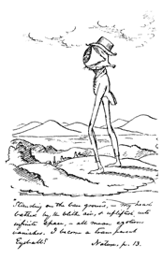
Note: Christopher Cranch’s cartoon illustrating Emerson’s “I become a transparent eyeball passage from Nature (1836)

Note: Charlie L. Russell’s play Five on the Black Hand Side premiered in 1969 in New York at the American Place Theater. His 1973 film adaptation, with the same title, was directed by Oscar Williams. It won the NAACP Image Award for best screenplay. Ebony magazine lists it as one of the ten best African American films of all time. Among Charlie Russell’s other works are a novel, A Birthday Present for Katheryn Kenyatta, a recent (2002) collection of stories (The Worthy Ones), and a collection of essays. His short story "Quietus" is anthologized in Langston Hughes’s collection Best Negro Short Stories. I would like to have coffee with Charlie Russell some day.

Like all memoirs, this one depends on memory—not only what I remember but how I remember it. But I have been trained to look things up. So here and throughout the essay, I have tried whenever possible to confirm my memories with printed evidence-- newspaper accounts, yearbooks, correspondence with participants, and so forth--that could give me the specific details I had forgotten or misremembered. The Johnny Mathis episode at the 1956 San Francisco State meet presented a problem for me. For years, I have vividly remembered those events as if I were watching a film of them. But now that I have come to write about it, I haven’t located the printed evidence for it. I decided to include the story anyhow with this notation that to the best of my recollection it happened, and it happened just this way.

