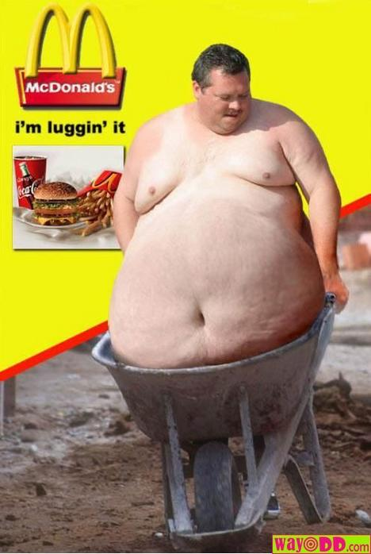
A Runners Diet

Runners are the gods of high metabolism. They are able to consume a whole pizza and then run five miles without any issues. Any and all calories ingested by a runner simply evaporate from their body the moment they step on the track. And all calories they ingest are the same whether they’re from McDonalds or Whole Foods: they all help runners be healthy and run as fast as they can. Oh, and pigs can fly.
I know a few runners on track will get a nice burger for lunch and still be finishing up their last few fries as they dash into practice. Most people know better, but almost all runners are left in the dark about exactly what they should be eating to put themselves in optimum condition. The answer: everything that everyone has been telling you is good for you for all your life.
I must say I was disappointed to learn that trackers that are unprofessional and run for their high school sports teams don’t need to worry about diet any more than a non-athlete. Runners should just eat more vegetables and leafy greens, whole grain bread and pasta, low-fat yogurt, almonds, tomatoes, salmon, sweet potatoes, etc. These are ingredients for a healthy, happy, successful body.
Eating more oranges and other fruits is a great way to start. Supposedly oranges are another great food choice for runners because they have over a hundred percent of the daily value for vitamin C, a vitamin shown to alleviate muscle soreness when eaten before exercise.
Now what about those fries for lunch? Eating well is a simple matter of going to the right places for lunch, or making healthy food at home. Most sandwich places are a better option than burger joints because their food has less fat and more actual vegetables. The healthiest of all of them would probably be Subway because they have fewer calories and more nutrition. Chipotle is the next best option for lunch fare because the food is fresh and good for you. Just make sure not to overeat because it will slow you down. Sushi is a good lunch as well as long as it is consumed in moderation. Basically anything that is small and low in fat and lots of carbohydrates will be good fuel for track.
Another perceived notion about runners is that to be good, they must consume all of the energy drinks, energy bars, energy gels, energy powders, energy inhalants, energy shots, en possible. Some of these options are obviously bad. Will a snickers marathon bar really help you get through track practice as well as a turkey sandwich? Probably not. But a Power Bar a half hour before a race is okay, right? Well, not really. This is where things get tricky. Usually it’s not a good idea to eat anything big an hour before a race, but if you’re really hungry it might be okay.
But now lets look at the big picture. Are you the next gold medal Olympic star, or are you just a hardworking runner in between school and all your other extra-curriculars? If it’s the latter, you probably don’t need all that energy stuff, and it’ll just be extra calories that will weigh you down. And if you really are Nike (the greek god, not the company!) in human form, take a look at the energy bars you’re packing down. Do they really have the protein and carbohydrates you want, or are they just candy bars hiding behind cheap protein powder? If your chosen form of energy lists corn syrup or sugar or something else suspicious as higher than the sixth ingredient, switch to a better form of running nutrition.
Happy Eating!

