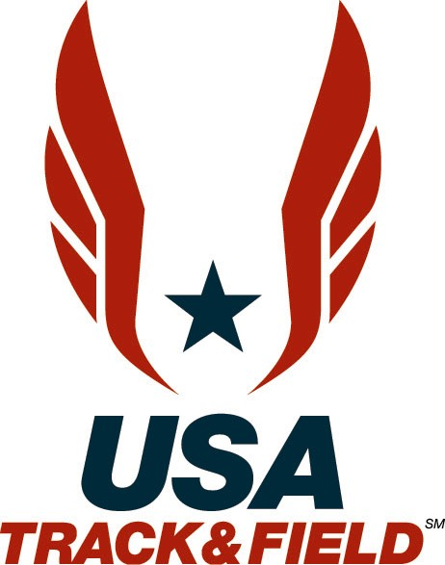
USA Track & Field
2007 Programs for Youth and Junior Athletes

Track & Field
Cross Country

The USA Junior Outdoor Track & Field Championships are the premier track & field meet for the elite junior aged athlete. Eligible competitors are aged from 14 to those not turning 20 in the year of competition. The United States Junior Team is selected for the Pan American Junior Championships (conducted in odd years) or the IAAF World Junior Championships (conducted in even years) at this meet. Athletes selected for those trips have the honor of representing their country and receiving the official USA Track & Field uniform given to the team members-along with an expense-paid trip to the international competition of that year.

Athletes must meet qualifying standards in order to attend this meet. Standards are established at the Annual Meeting in December. Entry information is available on our website after March 1st.

As the National Governing Body for the sport, USATF is the only organization that offers that “next step” in an athlete’s career – international competition at the highest level!

These are the types of programs that maintain the USA’s status as the “World’s #1 Track & Field Team” and ensure that the future of our sport remains sound.

The USA Winter Cross Country Championships serves as the selection meet for the IAAF World Cross Country Championships. The junior division is open to athletes aged from 14 to those not turning 20 during the year of competition. The junior race distances are 8,000 meters for the men and 6,000 meters for the women. Those athletes who make the World Cross Country team will be provided with the United States team uniform along with transportation to the World Championships.

Youth & JO’s

USATF also conducts annual national championships in five different age divisions: Bantam (10-under); Midget (11-12); Youth (13-14); Intermediate (15-16) and Young Men/Women (17-18).

The USA Youth Outdoor Track & Field Championships (Youth Athletics) attracts some 3,000 athletes. The culmination of the progressional Association and Regional Junior Olympic Championships, the National Junior Olympic Championships, draws more than 6,000 athletes to the competition.

These competitions are the primary selection meets for the World Youth Championships, for athletes aged 14-17, which occurs every two years!

2007 Youth and Junior Championships Schedule:
February 10 | USA Cross Country Championships | Boulder, CO
March 24 | IAAF World Cross Country Championships | Mombasa, Kenya
June 20-23 | USA Junior Outdoor Track & Field Championships | Indianapolis, IN
Mid to late June | Association Junior Olympic Track & Field Championships | Various Cities
July 3-8 | USA Youth Outdoor Track & Field Championships (Youth Athletics) | Lisle, IL
Early to mid July | Regional Junior Olympic Track & Field Championships | Various Cities
July 6-8 | Pan American Junior Championships | Fortaleza, Brazil
July 24-29 | National Junior Olympic Track & Field Championships | Walnut, CA

USA Track & Field: See it. Feel it. Experience it.
For more information, please check out our website at www.usatf.org for the latest news of the sport, USATF merchandise, and special members-only offers.

2007 USA Junior Outdoor Track & Field Championships
June 20-23, 2007
IU Michael A. Carroll Track & Soccer Stadium, IUPUI – Indianapolis, IN
Selection meet for the Junior Pan American Championships
July 6-8, 2007 Fortaleza, Brazil
If you are trying to qualify for the Pan American Junior Championships, you must bring your passport with you to the meet in order to be considered.
IF YOU DO NOT HAVE A PASSPORT WITH YOU, YOU CANNOT MAKE THE TEAM!

Junior Men’s Standards |  |  |  | Junior Women’s Standards
100m | 10.64 | high jump | 2.09/6- 10 ¼ | 100m | 11.84 | Discus | 45.00/147-8
200m | 21.44 | pole vault | 4.95/16- 2 ¾ | 200m | 24.44 | Hammer | 48.00/157-6
400m | 47.84 | long jump | 7.28/23- 10 ¾ | 400m | 55.94 | Javelin | 40.00/131-3
800m | 1:53.04 | triple jump | 14.65/48- ¾ | 800m | 2:13.64 | Heptathlon | 4200 FAT
1500m | 3:58.14 | shot put -6kg | 17.60/57- 9 | 1500m | 4:40.14
 |  | shot put -12lb | 18.11/59- 5 | 1600m | 4:58.15
5000m | 15:05.00 | shot put - 16lb | 16.15/53- 0 | Mile | 5:00.14
1500m | 3:58.14
1600m | 4:13.94 | discus-1.75kg | 53.12/174- 3 | 3000m | 10:15.14
one mile | 4:15.24 | Discus- 1.6kg | 56.40/185- 0 | 3200m | 10:55.14
3000m | 8:40.00 | Discus- 2kg | 49.96/163- 11
3200m | 9:15.00 |  |  | 100m H (33”) | 14.34
 |  | hammer -6kg | 52.00/170- 7 | 100m H (30”) | 14.04
10000m | 32:45.00 | hammer -16lb | 49.00/160- 9
1500m | 3:58.14 | hammer -12lb | By appeal only | 400m H | 64.14
1600m | 4:13.94 |  |  | 300m H | 44.14
One mile | 4:15.24 | javelin -800 | 58.00/190- 3
3000m | 8:40.00 |  |  | 3000SC | 10:50.14
3200m | 9:15.00 | decathlon | 6050 | 2000SC | 7:05.14
5000m | 15:05.00 | decathlon HS | 6150 | 1500m | 4:40.14
 |  |  |  | 1600m | 4:58.15
10000m RW | 55:15.00 |  |  | One mile | 5:00.14
3000m RW | 15:00.00 |  |  | 3200m | 10:55.14
5000m RW | 25:30.00 |  |  | 5000m | 17:55.14
110 hurd-.995 | 14.64 |  |  | 10000m RW | 59:45.00
110 hurd- 42” | 14.80 |  |  | 3000m RW | 16:30.00
 |  |  |  | 5000m RW | 28:30.00
400m H (36”) | 53.94
400m H (30”) | 53.70 |  |  | High Jump | 1.72/5-7 ¾
300m H (36”) | 37.60
300m H (30”) | 37.10 |  |  | Pole Vault | 3.90/12-9 ½
3000 SC | 9:38.00 |  |  | Long Jump | 5.90/19-4 ¼
1500m | 3:58.14
1600m | 4:13.94 |  |  | Triple Jump | 11.80/38-8 ¾
One mile | 4:15.24
3000m | 8:40.00 |  |  | Shot Put (4kg) | 13.60/44-7 ½
3200m | 9:15.00
5000m | 15:05.00
**Those events listed in bold will be contested at the Championships, all others are alternate qualifying events and times/distances.**
**In addition to these qualifying standards there are important qualifying guidelines that can be viewed on the USATF website.**

For entry information please visit us at www.usatf.org

