Press Release - All-Comer’s Track Meets Slated @ Diablo Valley College – January 6, 13, 27
Where: | Diablo Valley College (1/8” spikes only!) | 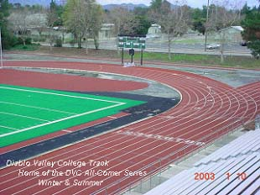
When: | JAN 6, 13, 27
Time: | 2:00pm Field Events, 2:30pm Running Events
Who: | OPEN, COLLEGE, MASTERS, HIGH SCHOOL AND YOUTH; BOYS & GIRLS; MEN AND WOMEN
Entry Fee: | $5.00 PER ENTRANT, ALL TEAMS WITH 10 OR MORE ENTRANTS, DISCOUNT $4.00 PER ATHLETE, $3.00 SPECTATORS
Contact: | Head Track Coach, Daniel Cruz (925) 685-1230 X2258 e-mail, dcruz@dvc.edu
cc: | ALL COACHES AND ATHLETES
DIABLO VALLEY COLLEGE WILL HOST THE 6TH ANNUAL WINTER ALL-COMER Track & Field SERIES beginning January 6th. Series will feature steeplechase.
There will be a Special 5 & 10 Mile Relay event on January 27th before the all-comer’s meet. Relays begin at 1:00pm.
Winter all-comer track meet series is slated to begin with three (3) meets in JANUARY, beginning January 6th. Meets will begin at 2:00pm with field events, 2:30pm running events. DVC Head Coach Daniel Cruz has announced that DVC will host an all-comer track & field series. The Men and Women's Hammer Throw may also be contested (if other activities on campus, may not conduct Hammer Throw if not safe) Coaches of HS and Club teams are encouraged to bring 10 or more entrants to receive a discount on entry fees.
Order of Events (Running and Field Events), FAT (Fully Automatic Timing)
2:15pm Steeplechase (2K, 3K) |  | Field Events, 2:00pm
 | 4 x 100R | LJ (Open Pit)
 | 1500, Mile Run (27th) | HJ
 | 65M HH | PV
 | 400 | Hammer
 | 100 | SP
 | 800 | Triple to follow LJ
 | IH (300) | TJ (Open Pit)
 | 200 | Discus (to follow SP)
 | 2 Mile, 5000 and 10,000 last meet
 | 4 x 400R

